UNIT 7: TRAFFIC
Lesson 1: Getting started – Meeting in the school yard
I. OBJECTIVES
By the end of this lesson, Ss will be able to gain:
1. Knowledge
- An overview about the topic Traffic
- Vocabulary to talk about means of transport
2. Core competence
- Develop communication skills and cultural awareness
- Be collaborative and supportive in pair work and teamwork
- Actively join in class activities
3. Personal qualities
- Develop awareness of travelling in town/city
- Be concerned to the local traffice
II. MATERIALS
- Grade 7 textbook, Unit 7, Getting started
- Computer connected to the internet
- Projector/ TV/ pictures and cards
- sachmem.vn
Language analysis
Form | Pronunciation | Meaning | Vietnamese equivalent
1. cycle (v) | /ˈsaɪkl/ | to ride a bike/bicycle | đạp xe
2. traffic jam (n.phr.) | /ˈtræfɪk dʒæm/ | a line of vehicles waiting behind something that is blocking the road | tắc đường
3. cross the road (v.phr.) | /krɒs ðə rəʊd/ | pass the road | băng qua đường
4. rush hour (n.phr.) | /ˈrʌʃ aʊə(r)/ | the time, usually twice a day, when the roads are full of traffic and trains are crowded because people are travelling to or from work | giờ cao điểm

Assumptions
Anticipated difficulties | Solutions
- Students may not be able to recognise means of transport and have experience of using them on the road.  - Students may not know how to work in teams. | - Give specific examples and ask questions to activate students’ knowledge.  - Give short, clear instructions and help if necessary.

Board Plan
Date of planning:……/……./2023.
Date of teaching:……/……./2023.
Unit 7: TRAFFIC
Lesson 1: Getting started – Meeting in the school yard
* Warm-up: Miming game
I. Vocabulary
- cycle (v) /ˈsaɪkl/: đạp xe
- traffic jam (n.phr.) /ˈtræfɪk dʒæm/: tắc đường
- cross the road (v.phr.) /krɒs ðə rəʊd/: băng qua đường
- rush hour (n.phr.) /ˈrʌʃ aʊə(r)/: giờ cao điểm
II. Practice
Task 1: Read the conversation and choose the correct answer.
Task 3: Write one word from the conversation to complete each sentence.
Task 4: Look at the pictures and write a word under each.
Task 5: Game: Find someone who …
* Homework

III. PROCEDURES
Notes:
In each activity, each step will be represented as following:
* Deliver the task
** Implement the task
*** Discuss
**** Giving comments or feedback

Stage -Stage aim | Procedure
- Warm-up  - To activate students’ knowledge on the topic of the unit  - To enhance students’ skills of cooperating with team mates | Miming game  * Teacher gives instructions  ** In groups, Ss  - One of the students in the group go to the board.  - Teacher secretly show 1 picture of a mean of transport to that student. He/She has to mime the picture and the other has to guess. Of course the other groups will also be allowed to guess.  - take turns go to the board until finish all the pictures.  **** Teacher checks and corrects if Ss pronounce the words incorrectly.
Vocabulary - pre-teach  To help students use key language more appropriately before they read and listen | 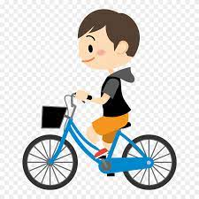  * T asks Ss to look at the photos and answer the question  1. What is he doing?  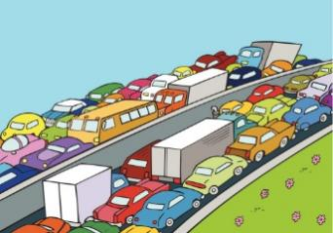  2. What is this?  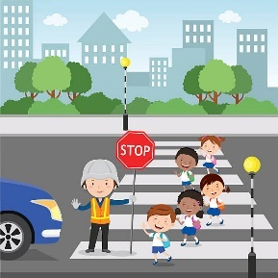  3. What are they doing?    4. Which time of the day usually has traffic jam?  ** Ss say the words.  **** Teacher shows and says the words aloud and asks Ss to repeat them.  * Teacher asks Ss to translate the word into Vietnamese.  Concept check: Slap the board
Lead-in/ pre-read and listen  - To get students interested in the topic  - To set the context  - To help Ss understand the main idea of the text | Task 1. Exercise 2 (p.74):  * Teacher asks Ss to look at the picture (p.73), answer the question:  + Where are they?  Read the conversation again and choose the correct answer:  1. How does Lan often go to school?  A. By bicycle.  B. By motorbike.  C. On foot.  2. It normally takes Lan ___ to get to school.  A. two minutes  B. ten minutes  C. twenty minutes  3. Lan and Mark agree to go cycling ______.  A. tomorrow  B. every day  C. at the weekend  ** Ss work out and answer questions in pairs.  *** Ss share their answers as a whole class.  **** T asks them to read and listen to the conversation to check their answers. T encourages students to explain where they have found the answers from the conversation.
Controlled practice  - To practise reading and listening for specific information  - To practise scanning  - To develop Ss' knowledge of vocabulary | Task 2: Exercise 3 (p.74): Write one word from the conversation to complete each sentence.  1. Last Sunday afternoon, Lan ______ round the lake near her home.  2. Mark says to Lan: “You ______ be careful, especially when you cross  the road.  3. Traffic ______ are a problem in big cities.  4. – ______ does your mum go shopping?  – She often walks.  5. This road is very ______ during the rush hours.  * Teacher asks Ss to work individually to read and listen to the conversation and find the words and phrases and then share their answers with their partners who sit next to them. (peer check)  ** Ss do exercise 3 individually  *** Ss share and discuss with their partners to write all words/ phrases down on the notebooks.  **** Teacher corrects their answers as a class.  Answers  1. cycled 2. should 3. jams 4. How 5. crowded
- To help Ss deeply understand the text  - To practise reading for details  - To practise scanning and intensive reading | Task 4: Look at the pictures and write a word under each.  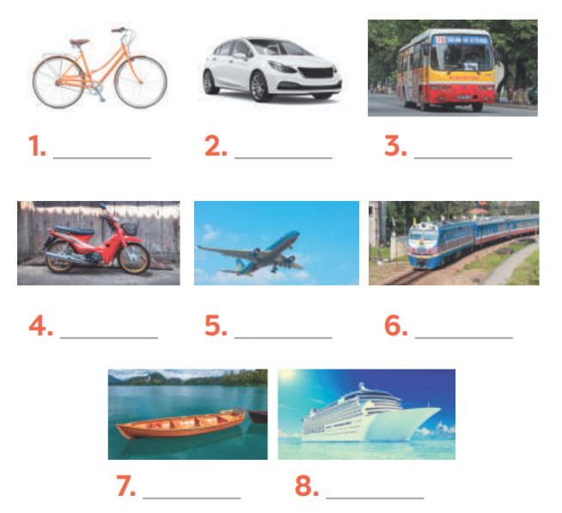  Suggested answers:  1. bicycle 2. car 3. bus 4. motorbike  5. plane/air-plane 6. train 7. boat 8. ship  *** Teacher nominates Ss to read the words aloud and  **** Teacher checks and gives the correct answers.
Less controlled practice  - To help Ss practising talking about how they go to school  - To practise team working  - To give students authentic practice in using target language | Task 5: Find someone who … Write your friends’ names in the blanks. Then report to the class  * Teacher gives Ss clear instructions in order to make sure Ss can do the survey effectively.  - ask students to look at the survey and think of the needed structures to ask their friends.  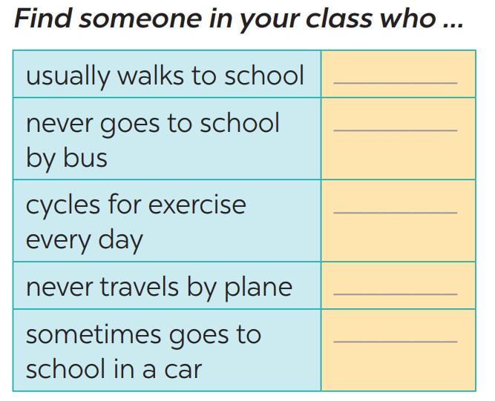  + Students goes around the class and ask at least 20 classmates and ask them (Do you usually walk to school? Have you ever gone to school by bus?…)  - observer Ss while they are role playing, note their language errors  ** Ss do as instructed  **** Teacher gives Ss feedback.  - choose some useful or excellent words/ phrases/ expressions/ word choices Ss have used to suggest other students use them  - choose some typical errors and correct as a whole class without nominating the students’ names
Wrap up  Homework  To help Ss memorise the target language and skills that they have learned | - Vocabulary of traffic and means of transport.  - Reading for specific information and details  - Scanning  Homework:  - talk about the traffic in your neighbourhood  - Exercises in the workbook

Date of planning:……/……./2023.
Date of teaching:……/……./2023.
UNIT 7: TRAFFIC
Lesson 2: A closer look 1
I. Objectives
By the end of this lesson, Ss will be able to gain:
1. Knowledge
- Vocabulary about the verbs to use means of transport
- Vocabulary to read the road signs.
- Pronunciation: /aɪ/ and /eɪ/
2. Core competence
- Develop communication skills and cultural awareness
- Be collaborative and supportive in pair work and teamwork
- Actively join in class activities
3. Personal qualities
- Develop awareness of understanding the road signs and obeying the traffic rules.
II. Materials
- Grade 7 textbook, Unit 7, A closer look 1.
- Computer connected to the internet
- Projector/ TV/ small boards, markers.
- sachmem.vn

Language analysis
Form | Pronunciation | Meaning | Vietnamese equivalent
1. road sign (n.phr.) | /ˈrəʊd saɪn/ | a sign near a road giving information or instructions to drivers | biển báo giao thông
2. cycle lane (n.phr.) | /ˈsaɪkl leɪn/ | a part of a road that only bicycles are allowed to use | đường đi riêng cho xe đạp
3. traffic light (n.phr.) | /ˈtræfɪk laɪt/ | a set of lights that controls the traffic on a road. | đèn giao thông

Assumptions
Anticipated difficulties | Solutions
- Students may not be able to recognise the road signs and have experience of using them on the road.  - Students may not know how to work in teams. | - Give specific examples and ask questions to activate students’ knowledge.  - Give short, clear instructions and help if necessary.

Board Plan
Date of teaching
Unit 7: TRAFFIC
Lesson 2: A closer look 1
* Warm-up: Jumbled words
I. Vocabulary
- road sign (n.phr.) /ˈrəʊd saɪn/: biển báo giao thông
- cycle lane (n.phr.) /ˈsaɪkl leɪn/: đường đi riêng cho xe đạp
- traffic light (n.phr.) /ˈtræfɪk laɪt/: đèn giao thông
II. Practice
Task 1: Match the words in A with the phrases in B.
Task 2: Look at these road signs. Then write the correct phrases under the signs.
Task 3: Work in pairs. Take turns to say which of the signs in 2 you see on the way to school.
Task 4: Listen and repeat. Pay attention to the sounds /aɪ/ and /eɪ/.
Task 5: Underline the words with the sound /aɪ/ and circle the words with the sound /eɪ/. Then listen, check and repeat

* Homework

Procedures
Notes
In each activity, each step will be represented as following
* Deliver the task
** Implement the task
*** Discuss
**** Giving comments or feedback

Stage -Stage aim | Procedure
- Warm-up  - To activate students’ knowledge on the topic of the unit  - To enhance students’ skills of cooperating with team mates | JUMBLED WORDS  * Teacher gives instructions  ** In groups of 5, Ss will be given a small white board and marker.  - Teacher show the jumbled words onto the screen one by one  - Students work in groups to make the correct words and write down onto the small boards. When they finish, they hold it up to show their answers to teacher.  - take turns to write until finish all the words.  Answers:  1- otba -> boat  2- itanr -> train  3- npeilapra -> airplane  4- rsotrpca -> sport car  5- otmiroekb -> motorbike  **** Teacher checks and corrects if Ss write the words incorrectly.
Vocabulary - pre-teach  To help students use key language more appropriately | * T asks Ss to look at the photos and answer the question  1. What are they?  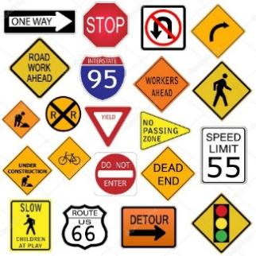  2. What is this?  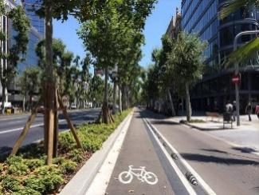  3. What is this?    ** Ss say the words.  *** Other Ss correct if the previous answers are incorrect.  **** Teacher shows and says the words aloud and asks Ss to repeat them.  * Teacher asks Ss to translate the word into English  ** Ss says the word
Lead-in/ pre-read and listen  - To get students interested in the topic  - To set the context  - To help Ss understand the main idea of the text | Task 1. Exercise 2 (p.74): Match the words in A with the phrases in B.  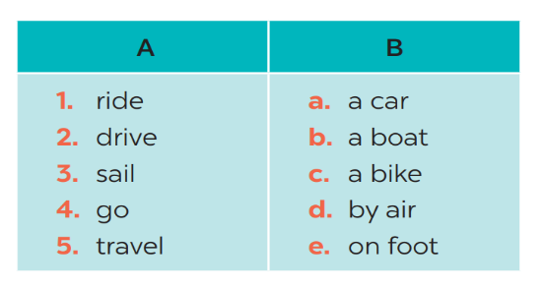  * Teacher asks Ss to look at the table (p.74), identify the form (verbs and nouns – means of transport):  Answers:  1- C 2 – A 3 – B 4 – E 5 – D  ** Ss work out and answer questions in pairs.  *** Ss share their answers as a whole class.  **** T asks them to to check their answers.  * Teacher asks students to make your own sentences with these phrases. Then tell share them to share their sentences with a partner and correct for them.
Controlled practice  - To practise identifying the meanings of road signs.  - To develop Ss' knowledge of vocabulary | Task 2: Exercise 3 (p.74): Look at these road signs. Then write the correct phrases under the signs.  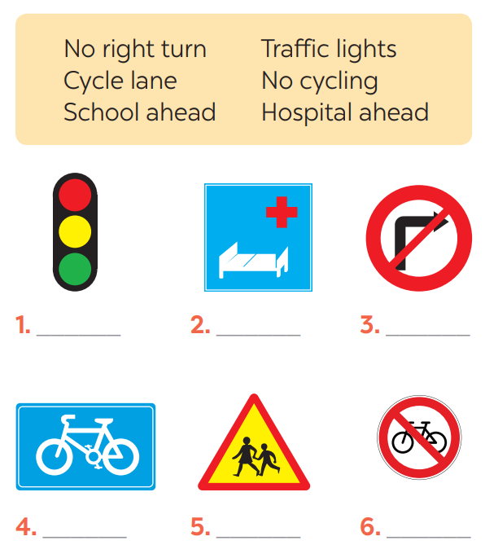  * Teacher asks Ss to look at the road signs and guess their meanings. Then work and share their answers with their partners who sit next to them. (peer check)  ** Ss do exercise 3 in pairs.  *** Ss share and discuss with their partners to write all words/ phrases down on the books.  **** Teacher corrects their answers as a class.  Answers  1. traffic lights 2. Hospital ahead 3. No right turn  4. cycle lane 5. School ahead 6. No cycling
- To help Ss deeply understand how to read the road signs  - To practise the targetted language in life context. | Task 3: Work in pairs. Take turns to say which of the signs in 2 you see on the way to school.  * Teacher gives suggestions and asks students to share their sentences.  *** Teacher nominates Ss to say the sentences aloud  **** Teacher checks and gives the corrections if they have mistakes.
Pronunciations  - To help Ss identify the and classify the sounds  - To give students authentic practice in using pronouncing sounds in common words | Task 4: Listen and repeat. Pay attention to the sounds /aɪ/ and /eɪ/.  * Teacher gives Ss time to listen and practice pronouncing the sounds individually and words.  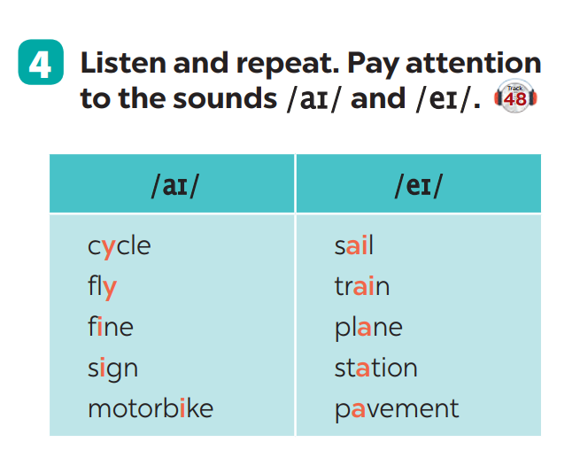  Task 5: Underline the words with the sound /aɪ/ and circle the words with the sound /eɪ/. Then listen, check and repeat  ** Ss do as instructed  **** Teacher gives Ss feedback.  - choose some common mispronounced words that contain the sounds and suggest students practise using them.  - choose some typical errors and correct as a whole class
Wrap up  Homework  To help Ss memorise the target language and skills that they have learned | - Vocabulary of verbs and road signs  - Pronuciation: : /aɪ/ and /eɪ/  Homework:  - Exercises in the workbook

Date of planning:……/……./2023.
Date of teaching:……/……./2023.
UNIT 7: TRAFFIC
Lesson 3: A closer look 2
I. Objectives
By the end of this lesson, Ss will be able to gain:
1. Knowledge
Know how to use:
- It to indicate distance
- should and shouldn’t
Structure | Examples
1. It to indicate distance | It is 4 kilometers from my house to school.
2. should | We should eat more vegetables and fruits.
3. shouldn’t | You shouldn’t stay up late everyday.
2. Core competence
- Develop communication skills and cultural awareness
- Be collaborative and supportive in pair work and teamwork
- Actively join in class activities
3. Personal qualities
- Develop awareness of understanding the road signs and obeying the traffic rules.
II. Materials
- Grade 7 textbook, Unit 7, A closer look 2.
- Computer connected to the internet
- Projector/ TV/ pictures.
- sachmem.vn
Assumptions
Anticipated difficulties | Solutions
- Students may not be able to know the distance between different places.  - Students may not know how to work in teams or fully understand the exercises and tasks. | - Give specific examples and facts to activate students’ knowledge.  - Give short, clear instructions and help if necessary.

Board Plan
Date of teaching
Unit 7: TRAFFIC
Lesson 3: A closer look 2
* Warm-up: Slap the board
I. Grammar
- It indicating distance
- Should/shouldn’t
II. Practice
Task 1: Write sentences with It. Use these cues.
Task 2: Work in pairs. Ask and answer questions about distances in your neighbourhood.
Task 3: Choose the correct option in brackets.
Task 4: Complete each sentence, using should / shouldn’t.
Task 5: Look at the pictures. Make sentences, using should /shouldn’t and the cues.
* Homework

Procedures
Notes
In each activity, each step will be represented as following
* Deliver the task
** Implement the task
*** Discuss
**** Giving comments or feedback

Stage -Stage aim | Procedure
- Warm-up  - To activate students’ knowledge on the topic of the unit  - To enhance students’ skills of cooperating with team mates | SLAP THE BOARD  * Teacher gives instructions and sticks some road signs pictures onto the board.  ** In 2 group, Ss will choose 1 student in each group to go to the board.  - Teacher says a road sign message.  - Student quickly run and slap onto the correct road signs.  - Students take turns until finish all of the signs.  Answers:  1- Cycle lane  2- School ahead  3- No cycling  4- No right turn  5- Schools ahead  **** Teacher checks and corrects if Ss pronounce the signs incorrectly.
Presentation  To introduce students the form of the key grammar and how to use them appropriately | IT INDICATING DISTANCE  - Teacher says: “This lesson today is going to tell you about “it indicating distance”  * Teacher draws students’ attention to the grammar point and the example  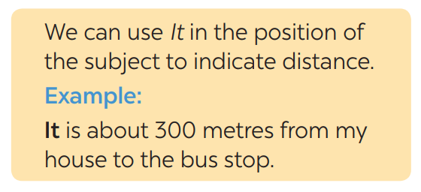  * Teacher asks Ss:  - What does the sentences tell us about?  Answer: Distance from his/her house to the bus stop  - What is the structure using in the sentence?  Answer: It be (about) + distance from A to B.  ** Ss read the grammar explicit and study the example.  *** Ss may discuss within groups/pairs before answering.  **** Teacher shows and says the sentences aloud and asks Ss to make similar sentences.
Practice/ Controlled practice  - To get students interested in the topic  - To set the context  - To help Ss understand the main idea of the text | Task 1. Ex 1: Write sentences with It. Use these cues.  * Teacher asks Ss to look at the example and the task.  ** Ss work out and answer questions individually.  *** Ss share their answers in pairs.  **** T asks them to to check their answers.  * Then tell share them to share their sentences as a whole in class and correct for them.  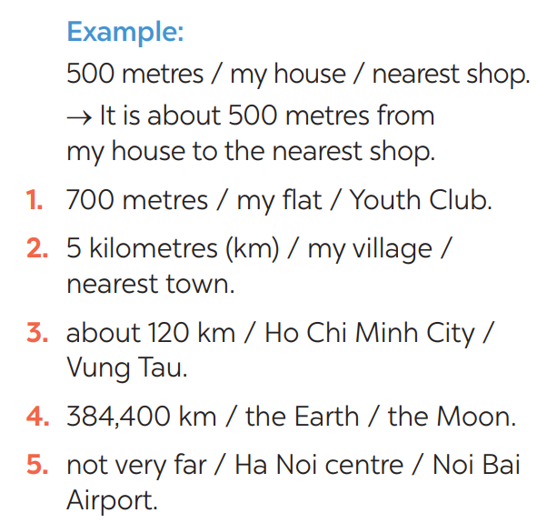  Answers:  1- It is 700m from my house/home to the Youth club.  2- It is 5 kilometres from my village to the nearest town.  3- It is about 120 km from Ho Chi Minh city to Vung Tau.  4- It is 384,400 km from the Earth to the Moon.  5- It is not very far from Hanoi centre to Noi Bai airport.
Controlled practice  - To practise asking and answering about distance. | Task 2: Exercise 2: Work in pairs. Ask and answer questions about distances in your neighbourhood  * Teacher asks Ss to look at the example and identify the structure of the question: How far is it from … to …?  Then work with their partners who sit next to them to make similar conversations.  ** Ss do exercise 2 in pairs.  *** Ss write all conversations down on the notebooks.  **** Teacher corrects their answers as a class.  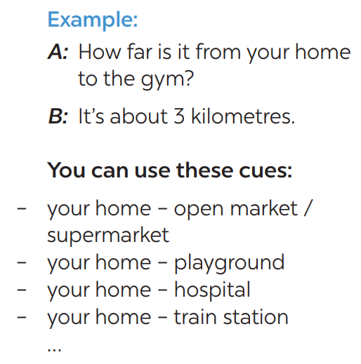  Suggested answer: 1.  - How far is it from your house to the open market?  - km.  …
- To practise the using should and shouldn’t. | Task 3: Choose the correct option in brackets.  * Teacher draws students attention to the remember box. Teacher asks them to study the examples and identify the structure: S + should/shouldn’t + Vinf  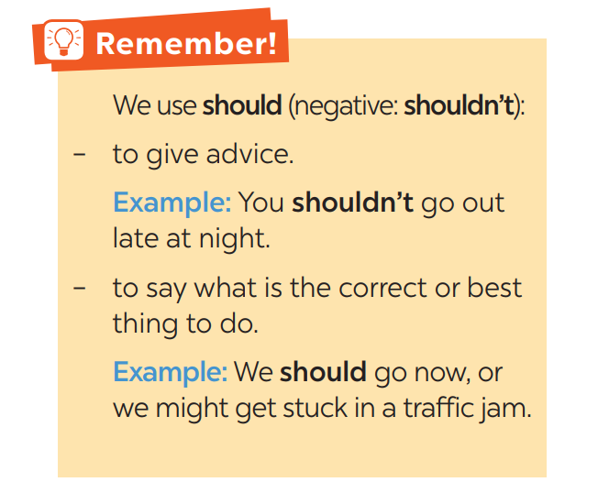  * Teacher gives suggestions and asks students to make some similar sentences using the structures.  *** Teacher nominates Ss to read aloud the sentences.  **** Teacher checks and gives the corrections if they have mistakes.  Task 4: Complete each sentence, using should / shouldn’t.  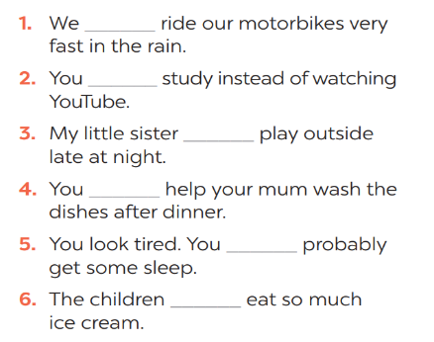  * Teacher gives Ss time to do the exercise individually and peer check with their partner.  *** Teacher nominates Ss to read aloud the sentences.  **** Teacher checks and gives the corrections if they have mistakes.  Answers:  1- shouldn’t 2- should 3- shouldn’t 4- should  5- should 6- shouldn’t  Task 5: Look at the pictures. Make sentences, using should / shouldn’t and the cues  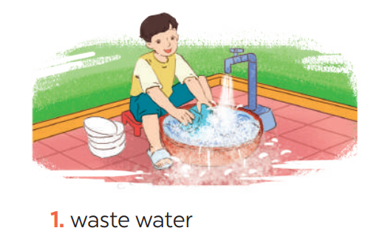  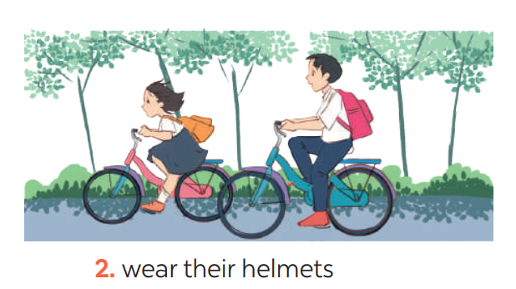  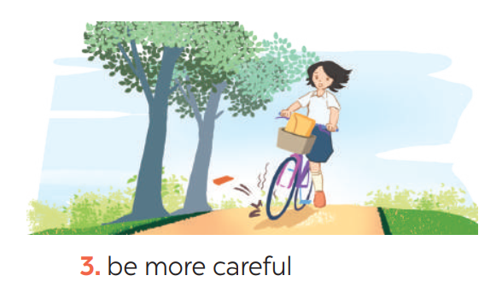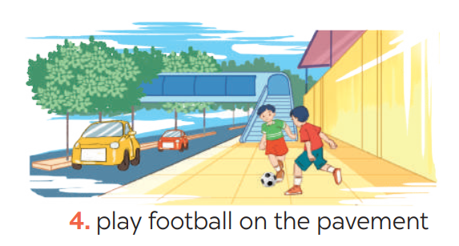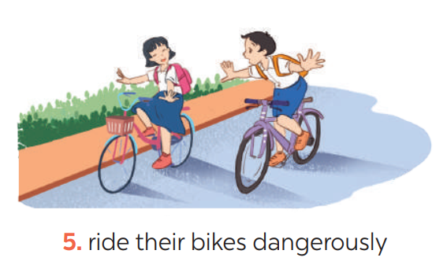  ** Ss do as instructed  **** Teacher gives Ss feedback.  - choose some common mistakes and suggest students how to avoid them.  - choose some typical errors and correct as a whole class  Answers:  1- He shouldn’t waste water.  2- They should wear their helmets.  3- She should be more careful.  4- They shouldn’t play football on the pavement.  5- They shouldn’t ride their bikes dangerously.
Wrap up  Homework  To help Ss memorise the target language and skills that they have learned | - It indicating distance  - Should/shouldn’t  Homework:  - Exercises in the workbook

Date of planning:……/……./2023.
Date of teaching:……/……./2023.

UNIT 7: TRAFFIC

Lesson 4: Communication

I. Objectives
By the end of this lesson, students will be able to:
1. Knowledge
- learn how to ask and answer about means of transport and some strange traffic rules.
- practise using some grammar points and vocabulary related to the topic.
2. Core competence
- Develop communication skills
- Be collaborative and supportive in pair work and team work
- Actively join in class activities
3. Personal qualities
- Be benevolent and responsible
II. Materials
- Grade 7 textbook, Unit 7, Communication
- Computer connected to the internet
- TV/ Pictures/ Projector
- sachmem.vn

Language analysis
Anticipated difficulties | Solutions
1. Students may lack knowledge about the topic. | Provide students with information about the knowledges they do not know.
2. Students may have underdeveloped reading, speaking and co-operating skills. | - Encourage students to work in pairs, in groups so that they can help each other.  - Provide feedback and help if necessary.
3. Some students might excessively talk in the class. | - Define expectation in explicit detail. Have excessive talking students practise.  - Continue to define expectations in small chunks (before every activity).

Board Plan
Date of teaching
UNIT 7: TRAFFIC
Lesson 4: Communication
*Warm-up
BRAINSTORMING
I. Everyday English:
Task 1: Listen and read the conversation, paying attention to the highlighted parts.
Task 2: Work in pairs. Take turns to ask and answer about the means of transport your family members use every day.
II. Practice: Strange traffic rules!
Task 3: Which countries below keep to the left? Tick the correct answers.
Task 4: Listen and check your answers in 3. Then listen again and complete the sentence with no more than THREE words
Task 5: Read, discuss which one do is the strangest rule?
* Homework

Procedures
Notes
In each activity, each step will be represented as following
* Deliver the task
** Implement the task
*** Discuss
**** Giving comments or feedback

Stage -Stage aim | Procedure
Warm-up  To introduce the lesson. | Game: BRAINSTORMING  HOW DO YOU GO TO SCHOOL?  * Teacher divides class into 2 teams and asks them to think of “MEANS OF TRANSPORTS” (even the strangest ones).  ** Ss have 1 min to think of the words related to the topic or they can discuss with their partners.  *** Each member from each team turn by turn run to the board and write one word.  **** Teacher corrects their answers.  - The team which has more correct words will be the winner  Suggested answers:  Motorbike, bicycle, train, bus, plane, helicopter,…
Lead in  To lead in the lesson. | Teacher leads students into the lesson by telling what they are going to learn: “We are going to learn how to ask and answer about means of transport and some strange traffic rules”.
Presentation  To let students know the structure to ask and answer about means of transport. | Task 1: Listen and read the conversation, paying attention to the highlighted parts.  * Teacher plays the record for SS to listen and read the conversation about means of transport. .  ** Ss listen and practice saying with their partners.  *** Teacher calls some pairs to read aloud.  **** Teacher corrects pronunciation if needed.  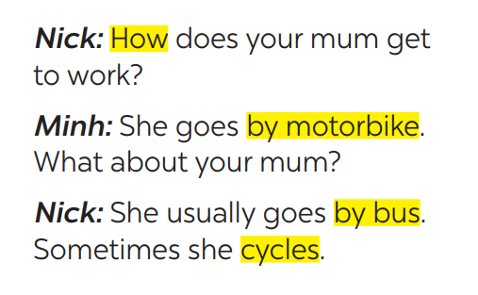  * Teacher asks Ss to pay attention to the highlighted parts and asks them some questions to elicit the new structure:  - Which tense do we use to ask and answer?  - Which question word do we use?  - …..  ** Ss answer teacher’s questions to find out new structure to ask anad answer about means of transport to travel to places  *** Some students give the new structure to the teacher.  **** Teacher corrects and writes on the board:  - Structure:  to ask:  - How do/does + S + go to …?  to answer:  - S + go/goes by …  - S + V
Practice  To help students practise  on how to ask and answer about means of transport. | Task 2: Work in pairs. Take turns to ask and answer about the means of transport your family members use every day.  * Teacher has SS look at the situation in Ex 2 to make similar dialogue:  ** Ss work in pairs to make similar dialogue.  *** Teacher calls some pairs to present it in front of the class.  **** Teacher gives feedback and some comments.  Suggested answers:  A: How does your father go to school?  B: He usually drives his car but sometimes he goes by bus. How about your father?  A: He walks because we live near his office.
- Presentation  - To provide students with more knowledge about strange traffic rules and help them practice the skill of listening for details. | Task 3: Which countries below keep to the left? Tick the correct answers.  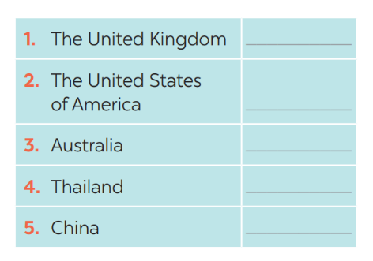  * Teacher asks Ss to discuss in pairs and tick.  ** Ss so the task in pairs  Task 4: Listen and check your answers in 3. Then listen again and complete the sentence with no more than THREE words.  * Teacher plays the recording twice.  *** Teacher calls some Ss to give their answer and explain it.  **** Teacher let Ss listen and confirms the correct answers.  Answer key: - United Kingdom, Australia  - same traffic rules/regulations
Practice  To help students know more about traffic rules around the world. | Task 5: Read, discuss which one do is the strangest rule?  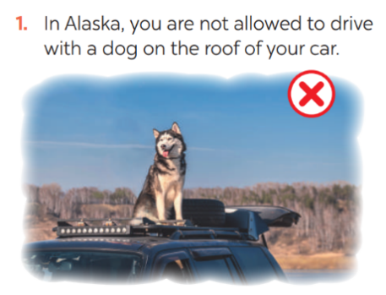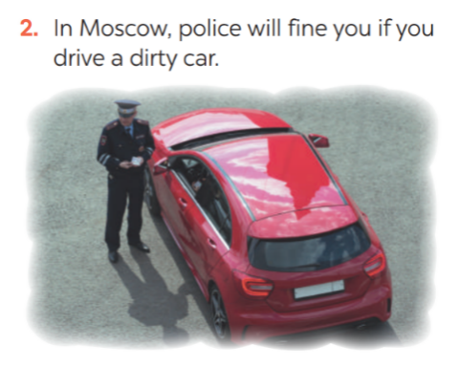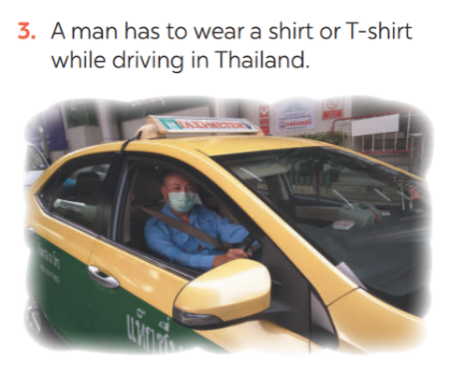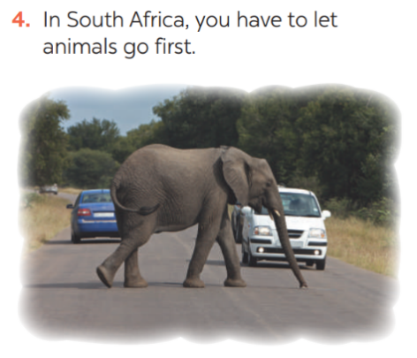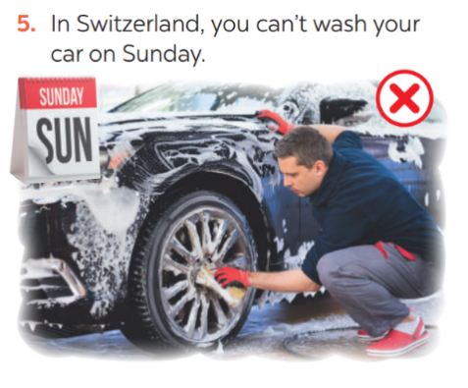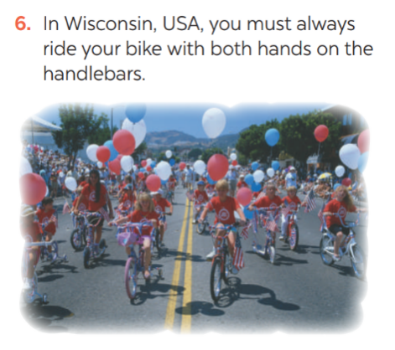  * Teacher has students work in groups to discuss which one they find strangest.  ** Ss work in groups.  *** 2-3 groups share their ides  **** Teacher encourages students to add more if they know.
Consolidation  To consolidate what students have learnt in the lesson. | Teacher asks students to talk about what they have learnt in the lesson.
Homework  To prepare for the next lesson:  Skills 1. | Do exercises in the workbook.

Date of planning:……/……./2023.
Date of teaching:……/……./2023.

UNIT 7: TRAFFIC

Lesson 5: Skills 1

I. Objectives
By the end of this lesson, students will be able to gain:
1. Knowledge
+ Reading:
- read for specific information about some rules about road safety
+ Speaking:
- talk about how to avoid traffic accidents.
2. Core competence
- Develop communication skills
- Be collaborative and supportive in pair work and team work
- Actively join in class activities
3. Personal qualities
Be benevolent and responsible
II. Materials
- Grade 7 textbook, Unit 7, Skills 1
- Computer connected to the internet
- TV/ Pictures, cards
- sachmem.vn

Language analysis
Form | Meaning | Pronunciation | Vietnamese equivalent
1. pedestrian (n) | a person walking along a road/street. | /pəˈdestrēən/ | người đi bộ
2. passenger (n) | a traveler on a public or private vehicle but not the driver, pilot, or crew. | /ˈpasinjər/ | hanh khách
3. (to) obey | comply with the command, direction, or request of (a person or a law) | / ōˈbā/ | tuân thủ
4. seatbelt (n) | a belt or strap securing a person to prevent injury, especially in a vehicle or aircraft. | / ˈsēt ˌbelt/ | dây an toàn

Anticipated difficulties | Solutions
1. Students may lack knowledge about some lexical items. | Provide students with the meaning and pronunciation of words.
2. Students may have underdeveloped reading, speaking and co-operating skills. | - Let students read the text again  (if needed).  - Create a comfortable and encouraging environment for students to speak.  - Encourage students to work in pairs, in groups so that they can help each other.  - Provide feedback and help if necessary.
3. Some students might excessively talk in the class. | - Define expectation in explicit detail.  Have excessive talking students practise.  - Continue to define expectations in small chunks (before every activity).

Board Plan
Date of teaching
Unit 7: Traffic
Lesson 5: Skills 1
* Warm-up
HANGMAN
I. Reading:
1. Vocabulary
- pedestrian (n) /pəˈdestrēən/: người đi bộ
- passenger (n) /ˈpasinjər/: hanh khách
- (to) obey / ōˈbā/: tuân thủ
- seatbelt (n) / ˈsēt ˌbelt/: dây an toàn
2. Discussion: Ex 1: Look at the picture. Can you see anything that is dangerous?
3. Practice
Task 1: Read the following text and choose the correct answer
Task 2: Read the text again and answer the questions:
II. Speaking:
Task 3: Work in groups. Ask and answer the following question. Make a list.
Task 4: Read the following sentences about these people. Then work in groups. Discuss who is being safe, and who isn’t
Task 5: Give the advices on dangerous situations on the road.
* Homework

Procedures
Notes
In each activity, each step will be represented as following
* Deliver the task
** Implement the task
*** Discuss
**** Giving comments or feedback

Stage -Stage aim | Procedure
Warm-up  To introduce the topic of reading. | Game: Hangman  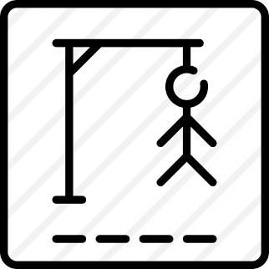  D A N G E R O U S  * Teacher divides class into 2 teams and asks them to think of the word which has 9 letters in it related the topic “ON THE ROAD”.  ** Ss have 1 min to think of the words related to the topic or they can discuss with their partners.  *** Each member from each team turn by turn guesses the letter in the secret word.  **** Teacher corrects their answers.  - The team which can find or guess the secret first will be the winner.
Lead in  To lead in the lesson about Skills 1. | READING  - Teacher leads students into the lesson by telling what they are going to learn: “We are going to read a passage about some rules about road safety.”
Pre-Reading (Pre-teach vocabulary)  To provide students with some lexical items before reading the text  To introduce words related to skin conditions to Ss and help Ss have a general idea of what they are going to read. | Vocabulary  - Teacher introduces the vocabulary by:  + Providing the synonym or antonym of the words.  + Providing the pictures of the words.  + Providing the definition of the words.  - pedestrian (n) /pəˈdestrēən/: người đi bộ  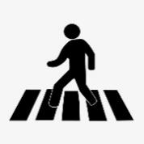  - passenger (n) /ˈpasinjər/: hanh khách    - (to) obey / ōˈbā/: tuân thủ  - seatbelt (n) / ˈsēt ˌbelt/: dây an toàn  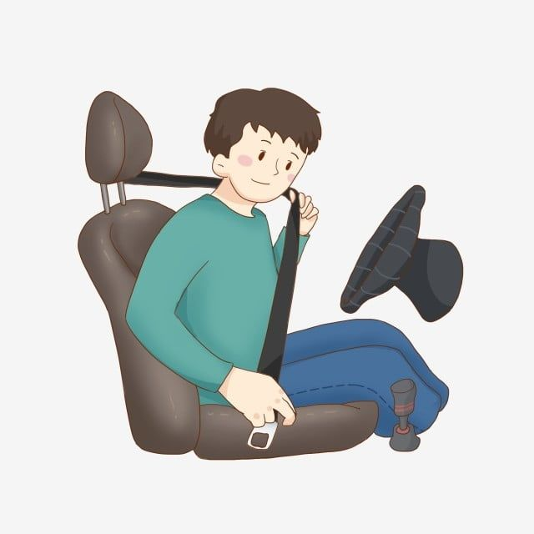  Concept check: Rub out and Remember  DISCUSSION  * Teacher asks Ss to work in pairs to look at the Picture in Ex1 and discuss on what they see that is dangerous?  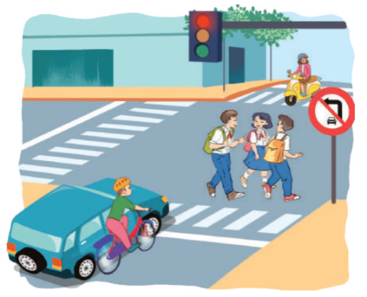  ** Ss work in pairs.  *** Teacher calls some Ss to check what they have discussed.  **** Teacher corrects.  Answer keys:  The students who are crossing the road  Because they do not walk on the right place and they are not careful.
While-Reading  To help Ss develop their reading skill for main ideas and specific information (scanning) and help them focus on the road safety rules  To help Ss further develop their reading skill for specific information (scanning). | Task 1: Read the following text and choose the correct answer.  This text is about ______.  A. rules for pedestrians  B. traffic lights  C. traffic rules  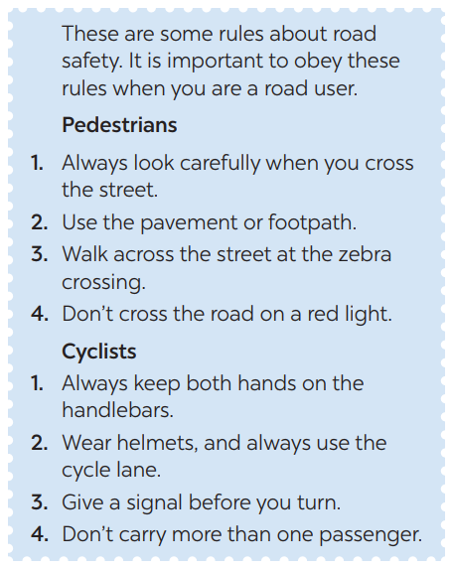  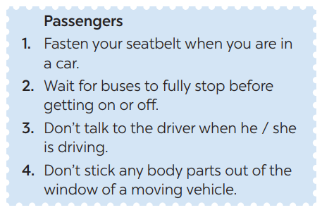  * Teacher has Ss read the first sentence of the text in detail to do the exercise and asks them how to do this kind of exercise.  ** Ss do the task independently  *** Teacher tells Ss to compare their answers in pairs before calling some of them to check.  **** Teacher confirms the correct answer and explains if needed.  Answer key: C  Task 2: Read the text again and answer  the questions:  * Teacher asks Ss: reading each question, locating where the information appears in the text, reading that part carefully and circling the correct answer.  ** Ss do the task independently.  *** Teachers has Ss compare their answers in pairs and call some Ss to give their ideas.  **** Teacher checks and confirms the correct answers.  Answer key:  1. They shoud cross the street at the zebra crossing.  2. We should always use the cycle lane.  3. We should give a signal before we turn while riding a bike  4. We must wait for buses to fully stop when you get on or off a bus.  5. We mustn’t stick any body parts out of the window when you are in a moving vehicle.
Post-Reading & Pre-Speaking  - To check students’ reading comprehension.  - To help Ss talk about how they apply the rules in the reading to themselves. | Task 3: Work in groups. Ask and answer  the following question:  “When you are a road user, what should you NOT do?”  Make a list in groups. Compare  your list with other groups’.  * Teacher asks Ss to work in groups and tells them to focus on the rules for road users in the text to talk about which one they have to obey everyday.  ** Ss work in groups. Teacher goes around and listens and gives help if needed.  *** Teacher calls on some Ss to share their answers with the class.  **** Teacher listens and gives comment.
While-Speaking  To provide Ss an opportunity to practise giving advices on dangerous situations on the road. | Task 4: Read the following sentences  about these people. Then work in groups. Discuss who is being safe, and who isn’t  * Teacher has Ss work in groups and asks them to take turns to discuss the situations.  ** Ss work in groups to do the task. Teacher goes around, listens and gives help if needed.  *** Teacher calls on some groups to share their answers with the class.  **** Teacher comments
Post-Speaking  To help students apply what they have learnt in real life context. | Task 5: Give the advices on dangerous situations on the road.  Structure: S + should/shouldn’t + Vinf  * Teacher has students give advices on how to avoid the dangerous situations on the road.  *** Teacher calls on some groups to share their answers with the class.  **** Teacher comments and corrects if needed.
Consolidation  To consolidate what students have learnt in the lesson. | Teacher asks students to talk about what they have learnt in the lesson.
Homework  To prepare for the next lesson Skills 2. | Do exercises in the workbook.

Date of planning:……/……./2023.
Date of teaching:……/……./2023.

UNIT 7: TRAFFIC

Lesson 6: Skills 2
I. Objectives
By the end of this lesson, students will be able to:
1. Knowledge
+ Listening
- use the lexical items related to the topic Traffic
- listen for main ideas and specific information about traffic problems in Mumbai.
+ Writing: write about traffic problems in your area.
2. Core competence
- Develop communication skills
- Be collaborative and supportive in pair work and team work
- Actively join in class activities
3. Personal qualities
Be benevolent and responsible
II. Materials
- Grade 7 textbook, Unit 7, Skills 2
- Computer connected to the internet
- Pictures
- sachmem.vn

Anticipated difficulties | Solutions
1. Students may lack knowledge and experiences about the topic. | Prepare some hand-outs.
2. Students may have underdeveloped listening, writing and co-operating skills. | - Play the recording many times if any necessary.  - Encourage students to work in pairs, in groups so that they can help each other.  - Provide feedback and help if necessary.
3. Some students might excessively talk in the class. | - Define expectation in explicit detail.  Have excessive talking students practise.  - Continue to define expectations in small chunks (before every activity).

Board Plan
Date of teaching
Unit 7: Traffic
Lesson 6: Skills 2
* Warm-up: BRAIN STORMING
I. Listening
Task 1: Discuss: What can you see in this picture? What is special about it?
Task 2: Listen to the recording and choose the correct answer A, B, or C
Task 3: Listen again and write ONE word or number in each gap
Task 4: Discuss: Compare traffic problems in Mumbai to the traffic problems in Hanoi.
II. Writing:
Task 5: Discuss and brainstorm ideas.
Task 6: Write a paragraph of about 70 words about the traffic problems in your town / city.
Peer check and cross check
* Homework

Procedures
Notes
In each activity, each step will be represented as following
* Deliver the task
** Implement the task
*** Discuss
**** Giving comments or feedback

Stage -Stage aim | Procedure
Warm-up  To activate students’ prior knowledge and vocabulary related to the lesson | BRAIN STORMING:  * Teacher writes on the board the word “Traffic problems” and asks Ss some questions:  + What does this word mean?  + What do we have to suffer from these problems?  + Can you name some traffic problems?  ** Ss think of these questions and discuss with their partners if needed.  *** Teacher calls some students to give their answers.  **** Teacher listens and give comments.
Lead in  To introduce the new lesson. | - Teacher introduces students the content of the lesson: “In the lesson today, we are going to listen to a person talking about traffic problems in his city - Mumbai.”
Pre-Listening  To help Ss brainstorm the topic and prepare for the listening text.  To help Ss develop their skill of listening for main idea | Task 1: What can you see in this picture? What is special about it?  * Teacher asks Ss to work in pairs to the problems they can find in the picture.  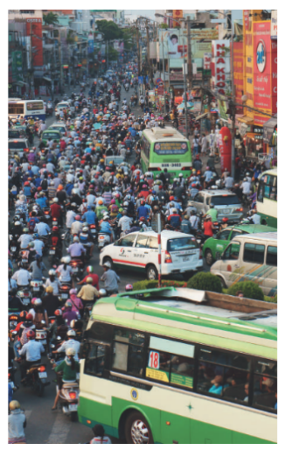  ** Ss work with their partner to do the task.  *** Teacher calls on some Ss to answer.  **** Teacher gives comments and leads Ss to task  Suggested answers: traffic jams, vehicle overload, people’s awareness about traffic rules…  Task 2: Listen to the recording and choose the correct answer A, B, or C  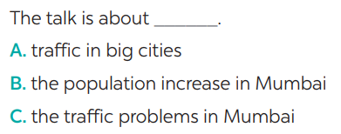  * Teacher asks Ss to read and underline the key words.  ** Ss work independently to guess then listen to the recording once to check their guess.  *** Teacher calls on some students to give the answers the have listened.
While-Listening To help students develop their skill of listening for specific information. | Task 3: Listen again and write ONE word or number in each gap  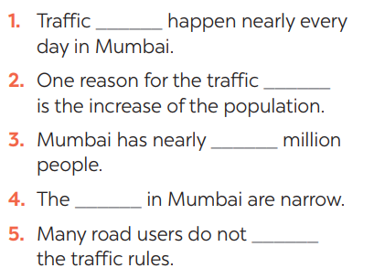  **** Teacher plays the recording again and confirms the correct answers for their prediction.  Answer key:
Post-Listening  To help Ss use what they have listened to life context. | Task 4: Discuss: Compare traffic problems in Mumbai to the traffic problems in Hanoi.  * Teacher tells Ss to work in groups to discuss and compare traffic problems in Mumbai to the traffic problems in Hanoi. Write down onto the notebooks in full sentences  E.g. The traffic jams in Hanoi is as serious and frequent as they are in Mumbai.  ** Ss work in groups. Teacher moves around and offers help if needed.  *** Teacher invites some Ss to share their answers.  **** Teacher corrects if needed.
Pre-Writing  To help Ss prepare ideas to write a passage. | Task 5: Tick the traffic problems in big cities in Viet Nam  * Teacher writes on the board “Your city’s Traffic Problems” and asks Ss to Tick the traffic problems in big cities in Viet Nam and asks them to give out more problems that they see in their city.  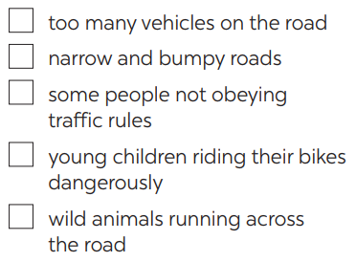  ** Ss think of it and can discuss with their partners.  *** Teacher calls on some Ss to raise their ideas.  **** Teacher listens and confirms.  Suggested answers:  Too many vehicles  Narrow roads  People’s awareness  …
While-Writing  To help Ss practise writing a passage about  70 words about the traffic problems in their town / city. | Task 6: Write a paragraph of about 70 words about the traffic problems in your town / city.  * Teacher tells Ss that they are going to write a passage about the traffic problems in your town / city.  ** Teacher reminds Ss of the structure of a passage and steps to make an outline for the passage.  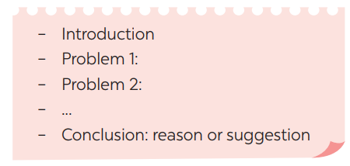  ** Ss work independently to do the task and try to use the notes from the previous tasks.  Teacher goes around and help if necessary.
Post-Writing  To peer check, cross check and final check students’ writing. | Peer check and cross check  *** Teacher asks Ss to share their writing with their partners. Then, call on some Ss to show their writing in front of the class.  **** Teacher checks ideas, grammar, vocabulary and gives comments.  Suggested answers:  The most serious traffic problem in our city – Hanoi is the traffic jams. Although the public transport system in Hanoi is quite modern and covenient, many people prefer using their own motorbikes. The reason for that is because most roads and streets in Hanoi are quite smalls and include many tiny lanes. Therefore, using private vehicles allows them to get there without walking long distance. The situation usually gets worse at rush hours when people all go to work or return home from work and schools. In conclusion, people should try to use public transport more often to reduce the traffic jams and exhaust.
Consolidation  To consolidate what students have learnt in the lesson. | Teacher asks students to talk about what they have learnt in the lesson.
Homework  To allow students finalize their passage after being checked by friends and the teacher. | Rewrite the passage on the notebook.

Date of planning:……/……./2023.
Date of teaching:……/……./2023.

UNIT 7: TRAFFIC

Lesson 7: Looking back & Project
I. Objectives
By the end of this lesson, students will be able to:
1. Knowledge
- review the vocabulary and grammar of Unit 7
- apply what they have learnt (vocabulary and grammar) into practice through a project.
2. Core competence
- Develop communication skills and creativity
- Be collaborative and supportive in pair work and team work
- Actively join in class activities
3. Personal qualities
- Be benevolent and responsible
- Develop self-study skills
II. Materials
- Grade 7 textbook, Unit 7, Looking back & Project
- Computer connected to the internet
- TV/ Pictures, A4 cards and colours
- sachmem.vn

Anticipated difficulties | Solutions
1. Students may have underdeveloped speaking, writing and co-operating skills when doing project. | - Encourage students to work in pairs, in groups so that they can help each other.  - Provide feedback and help if necessary.
2. Some students might excessively talk in the class. | - Define expectation in explicit detail.  Have excessive talking students practise.  - Continue to define expectations in small chunks (before every activity).

Board Plan
Date of teaching
Unit 7: Traffic
Lesson 7: Looking back & Project

* Warm-up
QUICK REVISION CHECK
I. Looking back
Task 1: Label each sign. Work in pairs. What does each sign tell us to do?
Task 2: Fill in each gap with one word to complete the sentences.
Task 3: Write complete sentences, using these cues.
Task 4: Choose A, B, or C to complete the sentences.
II. Project
Traffic signs
Task 5: Show the prepared signs. Make your own sign.
Task 6: Traffic signs exhibition
* Homework

Procedures
Notes
In each activity, each step will be represented as following
* Deliver the task
** Implement the task
*** Discuss
**** Giving comments or feedback

Stage -Stage aim | Procedure
Warm-up  To help students revise the vocabulary items they have learnt in the unit.  To enhance students’ skills of cooperating with team mates. | Quick revision check  * Teacher asks Ss to think of what they have learnt already in Unit 7.  ** Ss work in pairs to do the task.  ***Teacher calls some students to retell.  **** Teacher confirms and leads them to do all the exercises in books.
Looking back  To help Ss revise the vocabulary items (verbs) they have learnt in the unit.  To help Ss revise the vocabulary items (adjectives) they have learnt in the unit  To help Ss revise grammar points.  To help Ss revise the grammar points of the unit | Task 1: Label each sign. Work in pairs. What does each sign tell us to do?  * Teacher has Ss work individually.  ** Ss do this activity individually, then compare their answers with their partners.  *** Teacher asks for Ss’ answers. **** Teacher confirms the correct ones  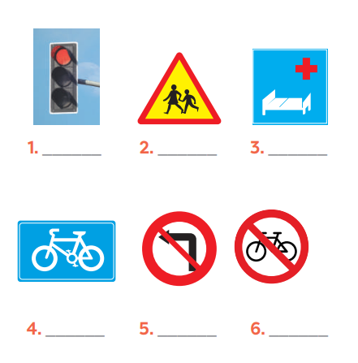  Answer keys:  1. traffic light  2. school ahead  3. hospital ahead  4. cycle lane  5. No left turn  6. Do not cycle  Task 2: Fill in each gap with one word to complete the sentences.  * Teacher has Ss work individually.  ** Ss do this activity individually, then compare their answers with their partners.  *** Teacher asks for Ss’ answers. **** Teacher confirms the correct ones  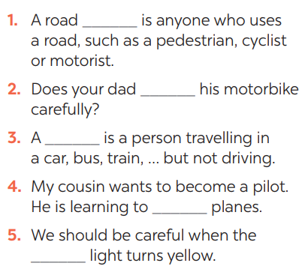  Answer keys:  1. user  2. ride  3. passenger  4. drive  5. see/notice  Task 3: Write complete sentences, using these cues.  * Teacher asks Ss to recall the structures of asking and answering about distance, and tell them to do Ex 3 in the book.  ** Ss do the exercise individually and swap with their partners.  *** Teacher calls some Ss to check their answer.  **** Teacher confirms the correct answer.  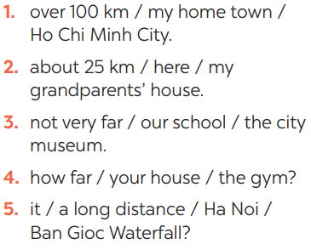  Answer keys:  1- It’s over 100km from my hometown to Ho Chi Minh city.  2- It’s about 25 km from here to my grandparents’ house.  3- It’s not very far from our school to the city museum.  4- How far is it from your house to the gym?  5- Is it a long distance from Ha Noi to Ban Gioc Waterfall?  Task 4: Choose A, B, or C to complete the sentences.  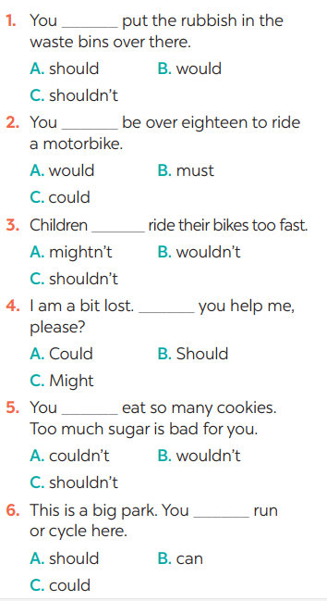  * Teacher asks Ss to do the task.  ** Ss work individually to do the task.  *** Teacher calls Ss to give out their answers.  **** Teacher checks and confirms their answer.  Answer keys:  1. C 2. B 3. C  4. A 5. C 6. B
Project  To help Ss identify common traffic signs and make their own road signs. | Task 5: Show the prepared signs. Make your own sign.    * Teacher asks Ss to show the signs they have prepared and identify the messages in each of the sign.  * Teacher also has Ss spend some time to make their own signs and practise presenting within their groups.  ** Ss discuss with their partners.  *** Some students raise their ideas and explain their answers.  **** Teacher listens and confirms.  Task 6: Traffic signs exhibition  * Teacher asks Ss to work in groups of 4 – 6 to stick their traffic signs onto the classroom’s wall and present about them.  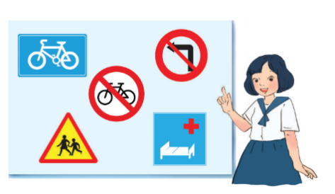  ** Ss work in group to do the task.  *** Teacher calls some groups to present their signs to the class  **** Teacher confirms and corrects.
Consolidation  To consolidate what students have learnt in the lesson. | Teacher asks students to talk about what they have learnt in the lesson.
Homework  To prepare for the next lesson. | Prepare for the next lesson: Unit 8 – Getting started.
Date of planning:……/……./2023.
Date of teaching:……/……./2023.
UNIT 8: FILMS
Lesson 1: Getting Started – Let’s go to the cinema tonight!
I. OBJECTIVES
By the end of this lesson, students will be able to gain:
1. Knowledge
- An overview about the topic “Films”
- Lexical items related to the topic “Films”:
+ types of films;
+ adjectives describing films.
2. Core competence
- Develop communication skills and cultural awareness
- Be collaborative and supportive in pair work and teamwork
- Actively join in class activities
3. Personal qualities
- Develop self-study skills

II. MATERIALS
- Grade 7 textbook, Unit 8, Getting Started
- Computer connected to the Internet
- Projector/ TV/ pictures and cards
- sachmem.vn

Language analysis
Form | Pronunciation | Meaning | Vietnamese equivalent
1. fantasy (n) | /ˈfæntəsi/ | a type of story that is set in a world, or a version of our world, that does not really exist and involves magic, monsters, etc. | phim viễn tưởng
2. horror film (n) | /ˈhɒrə fɪlm / | a film about strange and frightening things that is designed to entertain people | phim kinh dị
3. documentary (n) | /ˌdɒkjuˈmentri/ | a film or a radio or television programme giving facts about something | phim tài liệu
4. comedy (n) | /ˈkɒmədi/ | a play, film or TV show that is intended to be funny, usually with a happy ending; plays, films and TV shows of this type | phim hài

Assumptions
Anticipated difficulties | Solutions
1. Students may be lack of knowledge about types of films and adjectives describing films | - Prepare some photos/ posters of films and suggestions on vocabularies and structures to describe films.
2. Students may have underdeveloped listening, reading and  co-operating skills. | - Play the recording many times if any necessary.  - Encourage students to work in pairs, in groups so that they can help each other.  - Provide feedback and help if necessary.

Board Plan
Date of planning:……/……./2023.
Date of teaching:……/……./2023.
Unit 8: FILMS
Lesson 1: Getting Started – Let’s go to the cinema tonight!
*Warm-up
Chatting and describing the picture.
I. Vocabulary
1. fantasy (n)
2. horror film (n)
3. documentary (n)
4. comedy (n)
II. Practice
Task 1: Listen and read.
Task 2: Read the conversation again and choose the correct answer to each question.
Task 3: Choose the correct word or phrase to complete each of the following sentences.
* Game: Who is faster?
Task 4: complete the following sentences with the words in the box.
Task 5: Work in pairs. Ask and answer about a type of film. Use some of the adjectives in Task 4.
* Homework

III. PROCEDURES
Notes:
In each activity, each step will be represented as following:
* Deliver the task
** Implement the task
*** Discuss
**** Giving comments or feedback

Stage -Stage aim | Procedure
WARM-UP  To introduce the topic. | Chatting  * Teacher asks students some questions related to the topic:  - What did you do last night after finishing your homework?  - Did you watch the film [name of a popular film/series] on TV last night?  - Do you like watching films?  ** Students raise hands to answer the questions.  *** Teacher and students discuss the questions.  **** Teacher accepts all students’ questions.
LEAD-IN  To lead in the topic. | * Teacher draws students’ attention to the picture in the textbook and asks them some questions about it:  - What are they talking about?  - What types of films would they like to see?  ** Students raise hands to answer the questions.  *** Teacher and students discuss the questions.  **** Teacher accepts all students’ questions.
PRESENTATION  (VOCAB-  PRE-TEACH)  - To provide students with vocabulary.  - To help students be well-prepared for the listening and reading tasks. | Vocabulary:  * Teacher introduces the vocabulary asking students to brainstorm the types of films they like to see.  ** Teacher writes all students’ answers on the board.  *** Teacher circles or highlights the following words and discuss the meanings of these words:  1. fantasy (n)  2. horror film (n)  3. documentary (n)  4. comedy (n)  **** Teacher checks students’ pronunciation and gives feedback. Teacher reveals that these four words will appear in the reading text and asks students to open their textbook to discover further.
PRACTICE  To have students get to know the topic.  To have students get specific information of the text.  To introduce more types of films.  To introduce adjectives describing films. | TASK 1: LISTEN AND READ. (p.82)  * Teacher can play the audio more than once.  ** Students listen and read.  *** Teacher can invite some pairs of students to read aloud.  **** Teacher checks students’ pronunciation and gives feedback.  TASK 2: READ THE CONVERSATION AGAIN AND CHOOSE THE CORRECT ANSWER TO EACH QUESTION. (p. 83)  * Teacher tells students to read the conversation again and work independently to find the answers.  ** Students do the task individually.  *** Teacher allows students to share their answers before discussing it as a class and encourages them to give evidence.  **** Teacher calls some students to give the answers and gives feedback.  Answer key:  1. b  2. a  3. a  4. c  TASK 3: CHOOSE THE CORRECT WORD OR PHRASE TO COMPLETE EACH OF THE FOLLOWING SENTENCES. (p. 83)  Game: Who is faster?  * Teacher divides the class into 2 teams. Each team will send a leader to play the game on the board.  - Teacher explains instructions of the game:  - Teacher reads the features of any types of film in the Vocabulary part.  - The two leaders of the teams will have to slap the board at the correct types of film.  - Who can slap the correct types of films faster will earn points for the teams.  ** Students play the games in team mode.  *** Teacher has students write down the correct answer on the notebook.  **** Teacher confirms the answers and gives feedback. Teacher can ask for translation to check their understanding  Answer key:  1. comedy  2. fantasy  3. documentary  4. science fiction film  5. horror film  TASK 4: COMPLETE THE FOLLOWING SENTENCES WITH THE WORDS IN THE BOX. (p. 83)  * Teacher asks students to work individually to complete the task.  ** Students fill in the blanks with the most suitable preposition.  *** Teacher allows students to share answers before discussing it as a class.  **** Teacher can ask for translation to check their understanding.  Answer key:  1. frightening  2. funny  3. moving  4. boring  5. interesting
PRODUCTION  To check students’ vocabulary about types of films and adjectives describing films as well as improve pair work skill. | TASK 5: WORK IN PAIRS. ASK AND ANSWER ABOUT A TYPE OF FILM. USE SOME OF THE ADJECTIVES IN TASK 4. (p. 83)  * Teacher models this activity with a more able student first.  ** Teacher asks students to work in pairs.  *** Teacher can go around to help weaker students.  **** Teacher calls on some pairs to practise in front of the class.  Example:  A: Do you like documentaries?  B: No, I don’t.  A: Why not?  B: I think they’re boring.
WRAP-UP  To consolidate what students have learnt in the lesson. | Teacher asks students to talk about what they have learnt in the lesson.
HOMEWORK  To prepare vocabulary for the next lesson: A closer look 1. | Prepare at least 3 adjectives describing the types of films you like.

Date of planning:……/……./2023.
Date of teaching:……/……./2023.
UNIT 8: FILMS
Lesson 2: A closer look 1
I. OBJECTIVES
By the end of this lesson, students will be able to gain:
1. Knowledge
- Vocabulary: adjectives to describe films
- Pronunciation: Correctly pronounce words that contain the sounds: /ɪə/ and /eə/
2. Core competence
- Develop communication skills and creativity
- Be collaborative and supportive in pair work and teamwork
- Actively join in class activities
3. Personal qualities
- Develop self-study skills

II. MATERIALS
- Grade 7 textbook, Unit 8, A closer look 1
- Computer connected to the Internet
- Projector, loudspeaker, slides
- sachmem.vn

Language analysis
Form | Pronunciation | Meaning | Vietnamese equivalent
1. dull (adj) | /dʌl/ | not interesting or exciting | buồn tẻ, chán; đơn điệu
2. violent (adj) | /'vaiələnt/ | containing lots of fighting and killing | hung dữ; bạo lực, mãnh liệt
3. confusing (adj) | /kən'fju:ziŋ/ | difficult to understand, not clear | khó hiểu, làm rối lên
4. enjoyable (adj) | /in'dʒɔiəbl/ | giving pleasure | thú vị, thích thú
5. shocking (adj) | /'∫ɒkiŋ/ | very surprising and difficult to believe | gây choáng váng
Assumptions
Anticipated difficulties | Solutions
1. Students may be lack of knowledge about film names and structures to describe films | - Prepare some photos/posters of films and suggestions on vocabularies and structures to describe films.
2. Students may have underdeveloped listening, speaking and co-operating skills. | - Play the recording many times if any necessary.  - Encourage students to work in pairs, in groups so that they can help each other.  - Provide feedback and help if necessary.

Board Plan
Date of teaching
Unit 8: FILMS
Lesson 2: A closer look 1

*Warm-up

Mime game: poster – types of films

I. Vocabulary
- dull (adj)
- violent (adj)
- confusing (adj)
- shocking (adj)
- enjoyable (adj)
II. Practice
Task 1: Work in pairs and match the adjectives with the definitions. (Ex.1)
Task 2: Complete Ex.2, underline KEYWORDS, listen to the recordings and check the answer.
Task 3: Role-play: Reporter – Film Critic. (Ex.3)
Task 4: Listen and repeat, practice pronouncing. (Ex. 4)
Task 5: Listen and practice the sentences.
Task 6: Game: Broken telephone.
*Homework:

III. PROCEDURES
Notes:
In each activity, each step will be represented as following:
* Deliver the task
** Implement the task
*** Discuss
**** Giving comments or feedback

Stage -Stage aim | Procedure
WARM-UP  To review on types of films, recall students’ vocabulary on adjectives to describe film. | Game: Mime game:  * Teacher explains the game rules:  ** One student goes to the board and turns his/her back to the board. The teacher shows the poster of a film. Other students have to show the expressions to help him/her guess the type of the film.  *** Teacher and students discuss the answers.  **** Teacher confirms the answers and gives feedback.
LEAD-IN  To lead in the topic. | TASK 1: WORK IN PAIRS AND MATCH THE ADJECTIVES WITH THE DEFINITIONS. (Exercise 1, p. 84)  * Teacher asks students how they think about different types of film.  ** Teacher asks students to work in pairs and quickly do the task.  *** Teacher allows students to peer check first.  **** Teacher confirms the answers and gives feedback.  Answer key:  1. b  2. d  3. a  4. e  5. c
VOCABULARY (PRE-TEACH)  To introduce the new words.  To practice the targeted language (adjectives) and activate the background knowledge.  To help students practice using the adjectives to describe films. | Vocabulary:  * Teacher introduces the vocabulary.  ** Teacher introduces the vocabulary by:  - providing the pictures;  - providing the definition of the words.  - dull (adj)  - violent (adj)  - confusing (adj)  - shocking (adj)  - enjoyable (adj)  *** Teacher asks students to repeat.  *** Teacher rubs out and checks.  TASK 2: COMPLETE, UNDERLINE KEYWORDS, LISTEN TO THE RECORDINGS AND CHECK THE ANSWER. (Exercise 2, p. 84)  * Teacher asks students what KEYWORD is and to pay attention to the KEYWORDS in Ex. 2.  ** Teacher asks students to do Ex. 2. Have students do the task individually.  *** Ask them to share their answers in pairs before checking the answers as a class.  **** Teacher then encourages students to explain their answers. Correct if necessary.  Answer key:  1. shocking  2. dull  3. enjoyable  4. violent  5. confusing  TASK 3: ROLE-PLAY: REPORTER – FILM CRITIC. (Exercise 3, p. 84)  Pair work: Role-play: Reporter – Film Critic  * Teacher sets the scene. Ask some students to explain to each student to check their understanding of their roles and the situations.  ** Then let some pairs role-play the conversations in front of the class.  *** Teacher allows students to cross check first.  **** Teacher then checks pronunciation, if necessary.
PRONUNCIATION  To let students listen and notice the targeted sounds in individual words  To let students practice pronouncing the targeted sounds in sentences.  To test students' quick reaction to the targeted sounds. | TASK 4: LISTEN AND REPEAT, PRACTICE PRONOUNCING. (Exercise 4, p. 84)  Pronunciation: /ɪə/ and /eə/  * Teacher shows a list of words on the screen and asks students to listen to the recording.  - Teacher asks them to note down the words they hear. Give students a few minutes to look at the words and ask some students to repeat.  ** Teacher explains the difference between the sounds: /ɪə/ and /eə/. Then asks students to practice pronouncing words in Ex. 4.  - Teacher plays the recording several times, if necessary, for students to listen and repeat the words.  *** Teacher allows students to cross check first.  **** Teacher then checks pronunciation and gives feedback, if necessary.  TASK 5: LISTEN AND PRACTICE THE SENTENCES. (Exercise 5, p. 84)  * Teacher asks students to practise saying the sentences in pairs or groups.  ** Students practice saying the sentences in pairs or groups.  *** Teacher goes around to offer help or correct pronunciation, if necessary.  **** Teacher calls some students to say the sentences in front of the class. Check their pronunciation if necessary.  TASK 6: GAME: BROKEN TELEPHONE.  * Teacher explains the rules:  Teacher calls 16 students and divides them into 2 teams standing in 2 lines. The first student from each line will be shown 1 short sentence containing words with the /ɪə/ and /eə/ sounds. Team members have to whisper one by one till the last. The last student from each line runs to the board and writes down the sentence. The faster one with the correct sentence will be the winner.  ** Students play the game.  *** Teacher helps students in the game.  **** Teacher gives feedback.
WRAP-UP  To consolidate what students have learnt in the lesson. | Teacher asks students to talk about what they have learnt in the lesson.
HOMEWORK  To prepare vocabulary for the next lesson: A closer look 2. | Write some sentences to describe at least 3 classmates.

Date of planning:……/……./2023.
Date of teaching:……/……./2023.
UNIT 8: FILMS
Lesson 3: A closer look 2

I. OBJECTIVES
By the end of this lesson, students will be able to gain:
1. Knowledge
- Understand the use of the connectors: although/ though and however
- Practice using the connectors: although/ though and however in contexts
2. Core competence
- Develop communication skills and creativity
- Be collaborative and supportive in pair work and teamwork
- Actively join in class activities
3. Personal qualities
- Develop self-study skills

II. MATERIALS
- Grade 7 textbook, Unit 8, A closer look 2
- Computer connected to the Internet
- Projector/ TV/ pictures and cards
- sachmem.vn

Language analysis
Form | Meaning
1. although/ though | We use although/ though before a clause to connect two contrasting ideas in the same sentence.  Examples:  Although/ Though John Peters is an amateur actor, he gave a great performance in his latest film.  John Peters gave a great performance in his latest film although/ though he is an amateur actor.
2. however | We use however to contrast ideas in two sentences. We normally use a comma after it.  Example:  John Peters is an amateur actor. However, he gave a great performance in his latest film.

Assumptions
Anticipated difficulties | Solutions
1. Students may find confused when to use the connectors: although /though and however | - Give short and clear explanations with legible examples for each case.
2. Students may have underdeveloped speaking and co-operating skills. | - Give clear instructions, give examples before letting students work in groups.  - Provide feedback and help if necessary.

Board Plan
Date of teaching
Unit 8: FILMS
Lesson 3: A closer look 2
*Warm-up
Game: Sentence puzzling
I. Grammar focus
Connectors: Although/Though and However
II. Practice
Task 1: Combine the two sentences, using although/ though.
Task 2: Complete the sentences, using although/ though or however.
Task 3: Use your own ideas to complete the following sentences. Then compare your sentences with a partner’s.
Task 4: Choose the correct answer (A, B, or C) to complete each sentence.
III. Production
Task 5: Game – Chain story with although/ though.
*Homework
III. PROCEDURE
Notes:
In each activity, each step will be represented as following
* Deliver the task
** Implement the task
*** Discuss
**** Giving comments or feedback

Stage -Stage aim | Procedure
WARM-UP  - To activate students’ prior knowledge related to the targeted grammar: connectors of contrast.  - To increase students’ interest.  - To enhance students’ skills of cooperating with team mates. | Game: Sentence puzzling  * Teacher divides the class into 4 groups.  - Teacher delivers different sets of word cards to 4 groups.  - Each group will have to arrange the word cards to make a meaningful sentence.  - The group with a correct sentence will get 1 point  ** Students play the game in groups.  *** Teacher and students discuss the answers.  **** Teacher confirms the answers and gives feedback.  Set 1:  He goes out although it is raining.  Set 2:  She gets good marks though she is lazy.  Set 3:  He is an amateur actor. However, he acts very well.  Set 4:  He studied hard. However, he failed the exam.
LEAD-IN  To introduce the targeted grammar: connectors of contrast – although/ though and however. | - Teacher draws students’ attention to the connectors used to create the sentences.  - Teacher introduces the target of the lesson: connectors of contrast – although/ though and however.
PRESENTATION - To have students get to know about the connectors: although/ though and however.  - To help students  understand the use of the connectors: although/though and however. | * Teacher asks students to study the Grammar box.  - Teacher draws students’ attention to the meaning and use of although/ though and however.  ** Teacher then asks some more able students to give some more examples.  Although/ though  We use although/ though before a clause to connect two contrasting ideas in the same sentence.  Examples:  - Although/ Though John Peters is an amateur actor, he gave a great performance in his latest film.  - John Peters gave a great performance in his latest film although/ though he is an amateur actor.  However  We use however to contrast ideas in two sentences. We normally use a comma after it.  Example:  John Peters is an amateur actor. However, he gave a great performance in his latest film  *** Teacher and students discuss the answers.  **** Teacher confirms the answers and gives feedback.
PRACTICE  To check students’ understanding of the connectors although/though.  To check students’ understanding of the connectors although/though or however.  To check students’ understanding of the connectors although/though or however in contexts.  To further check students’ understanding of the connectors although/though or however. | TASK 1: COMBINE THE TWO SENTENCES, USING ALTHOUGH/ THOUGH.  (p. 85)  * Teacher has students work individually.  ** Students work individually to combine the sentences.  *** Teacher lets students work in pairs and exchange the answers before checking with the whole class (explain each sentence if necessary).  **** Teacher confirms the answers and gives feedback.  Answer key:  1. Although the questions were very difficult, he solved them easily.  2. Although he was a great actor, he never played a leading role in a film.  3. Although they spent a lot of money on the film, it wasn’t a big success.  4. Although the film was a comedy, I didn’t find it funny at all.  5. Although We played well, we couldn’t win the match.  TASK 2: COMPLETE THE SENTENCES, USING ALTHOUGH/ THOUGH OR HOWEVER. (p. 85)  * Teacher has students work individually.  ** Students work individually to complete the sentences.  *** Teacher lets students work in pairs and exchange the answers before checking with the whole class (explain each sentence if necessary).  **** Teacher confirms the answers and gives feedback.  Answer key:  1. Although/ Though  2. However  3. although/ though  4. However  5. although/ though  TASK 3: USE YOUR OWN IDEAS TO COMPLETE THE FOLLOWING SENTENCES. THEN COMPARE YOUR SENTENCES WITH A PARTNER’S. (p. 85)  * Teacher asks students to read the instruction.  ** Teacher asks students to do the exercise individually, using their own ideas to write sentences.  *** Teacher then has them work in pairs, comparing their sentences. Teacher can go around to help students.  **** Teacher confirms the answers and gives feedback.  TASK 4: CHOOSE THE CORRECT ANSWER (A, B, OR C) TO COMPLETE EACH SENTENCE. (p. 85)  * Teacher has students work independently.  ** Teacher asks students to do the exercise individually.  *** Teacher lets students work in pairs and exchange the answers before checking with the whole class (explain each sentence if necessary).  **** Teacher confirms the answers and gives feedback.  Answer key:  1. A  2. C  3. A  4. C  5. A
PRODUCTION  To help students practise using the connectors although/though or however | TASK 5: GAME – CHAIN STORY WITH ALTHOUGH/ THOUGH. (p.86)  * Teacher has students work in groups.  ** Students write a story beginning with the clause, using the second part of the previous sentence with although / though as the first part of the next sentence.  - The group with the longest story wins.  *** Teacher lets students work in groups and cross check their answers before checking with the whole class (explain each sentence if necessary).  **** Teacher confirms the answers and gives feedback.  Example:  Although it rained yesterday, we went shopping.  Although / Though we went shopping, we didn’t buy anything.  …
WRAP-UP  To consolidate what students have learnt in the lesson. | Teacher asks students to talk about what they have learnt in the lesson.
Homework Reactivate the knowledge that students have gained. | Teacher asks students to do exercises in their Workbook.

Date of planning:……/……./2023.
Date of teaching:……/……./2023.
UNIT 8: FILMS
Lesson 4: Communication
I. OBJECTIVES
By the end of this lesson, students will be able to:
- accept and decline suggestions;
- do a survey about group members’ favorite film;
- report the survey’s result to class.
1. Knowledge:
- Vocabulary: revise vocabulary on types of films, adjectives to describe films
- Grammar: structures to accept and decline suggestions
2. Core competence:
- Develop communication skills and creativity
- Be collaborative and supportive in pair work and teamwork
- Actively join in class activities
3. Personal qualities
- Develop self-study skills

II. MATERIALS
- Grade 7 textbook, Unit 8, Communication
- Computer connected to the Internet
- Projector, loudspeaker
- sachmem.vn

Language analysis
Form | Meaning
Suggestions | * How about + V_ing?  * Let’s + V_infinitive.  Examples:  How about going to the cinema tonight?  Let’s go to see A Nightmare at Sao Mai Cinema tonight.
Accepting and declining  suggestions | Examples:  That’s a great idea.  I’d love to, but that’s too far for me to travel.

Assumptions
Anticipated difficulties | Solutions
1. Students may be lack of knowledge about film names and parts of a survey | - Prepare some photos/posters of films and suggestions on vocabularies and structures to describe films.
2. Students may have underdeveloped listening, speaking and  co-operating skills. | - Play the recording many times if any necessary.  - Encourage students to work in pairs, in groups so that they can help each other.  - Provide feedback and help if necessary.

Board Plan
Unit 8: FILMS
Lesson 4: Communication

*Warm-up

Game: Conversation rearranging
I. Everyday English
Task 1: Listen and highlight the structures. (Ex.1)
Task 2: Brainstorming: Work in groups, discuss and make a list of ways to accept and decline suggestions.
Task 3: Role-play in given situations. (Ex.2)
II. A film survey
Task 4: Listen to a conversation and fill in the blanks. (Ex. 3)
Task 5: Work in groups, ask and answer. (Ex. 4)
Task 6: Presentation: Talking about group members’ favorite films.
*Homework

III. PROCEDURES
Notes:
In each activity, each step will be represented as following:
* Deliver the task
** Implement the task
*** Discuss
**** Giving comments or feedback

Stage -Stage aim | Procedure
WARM-UP  To activate students’ prior knowledge and vocabulary related to the targeted grammar of giving suggestions and ways to accept/ decline them. | Game: Conversation rearranging.  * Teacher divides the class into 4 groups. Teacher delivers a set of sentences in a conversation to each group.  ** Students will have to work in groups to arrange the sentences to make a meaningful conversation. The group with the fastest correct conversation will be the winner.  *** Teacher allows students to cross check first.  **** Teacher plays the recording to check and ask students to identify the content of the conversation.
EVERYDAY ENGLISH  To introduce ways to accept/decline suggestions.  To give students opportunities to use ways to accept and decline suggestions  correctly in context. | TASK 1: LISTEN AND READ THE CONVERSATIONS. PAY ATTENTION TO THE HIGHLIGHTED SENTENCES. (Exercise 1, p. 86)  * Teacher lets students listen to the examples in Ex. 1 in the book.  ** Teacher draws their attention to the form of ways to accept/ decline suggestions.  *** Teacher and students discuss the form of ways to accept/ decline suggestions.  **** Teacher confirms the answers and gives feedback.  TASK 2: WORK IN PAIRS. MAKE SIMILAR CONVERSATION WITH THE FOLLOWING SITUATIONS. (Exercise 2, p. 86)  * Teacher has students work on the conversations in pairs.  ** Students work on the conversations in pairs.  *** Teacher asks some pairs to act out in front of the class.  **** Teacher gives feedback and correction (if needed).
A SURVEY ABOUT FILMS To recall students’ knowledge about the concept of a survey and prepare needed language material for the next task.  To let students have some time to brainstorm the ideas and do the survey | TASK 3: LISTEN TO THE CONVERSATION AND FILL IN THE BLANKS WITH THE WORDS YOU HEAR (Exercise 3, p.87)  * Teacher asks several questions to set the scene. Then ask students to look at Ex. 3, quickly predict the answers and exchange the ideas with a partner.  ** Play the recording and ask students to fill in the blanks, focusing on the structures to ask for information in the survey.  Then let students read through the conversation and answer 2 questions:  - What kinds of information do you need to ask in the survey?  - Which structures do you need to ask for the information?  *** Teacher allows students to peer check first.  **** Teacher confirms the answers and gives feedback.  TASK 4: WORKS IN GROUPS. DO A SURVEY ABOUT YOUR GROUP MEMBER’S FAVOURITE FILMS. (Exercise 4, p. 87)  * Teacher lets students group up and spend 2 minutes on making the table onto their notebook.  ** Students work in groups.  *** Then ask them to ask an answer as well as note down among their groups.  **** Teacher goes around and listen, make suggestions and corrections if needed
FURTHER PRACTICE  To let students practice talking about others’ favorite films. | TASK 5: REPORT YOUR RESULTS TO THE CLASS (Exercise 5, p. 87)  * Teacher invites some students to show their survey notes and talk about their group member’s favorite film.  ** Students show their survey notes and talk about their group member’s favorite film.  *** Teacher allows students to cross check first.  **** Teacher listens, gives comments or corrections if needed.
WRAP-UP  To consolidate what students have learnt in the lesson. | Teacher asks students to talk about what they have learnt in the lesson.
HOMEWORK  To reactivate the knowledge that students have gained. | Teacher asks students to do exercises in their Workbook.

Date of planning:……/……./2023.
Date of teaching:……/……./2023.
UNIT 8: FILMS
Lesson 5: Skills 1

I. OBJECTIVES
By the end of this lesson, students will be able to:
1. Knowledge
- Develop reading skill about one’s favourite film
- Develop speaking skill: Talking about a film
2. Core competence
- Develop communication skills and creativity
- Be collaborative and supportive in pair work and teamwork
- Develop presentation skill
- Actively join in class activities
3. Personal qualities
- Develop self-study skills

II. MATERIALS
- Grade 7 textbook, Unit 8, Skills 1
- Computer connected to the Internet
- Projector/ TV/ pictures and cards
- sachmem.vn

Language analysis
Form | Pronunciation | Meaning | Vietnamese equivalent
1. series (n) | /ˈsɪəriːz/ | a set of television or radio programmes or podcasts that deal with the same subject or that have the same characters | chuỗi, loạt (phim, chương trình)
2. wizard (n) | /ˈwɪzəd/ | a man with magic powers | phù thủy, người có tài phi thường
3. must-see (n) | /‘mʌst-siː/ | used to tell people that something is so good or interesting that they should see | đáng xem
4. gripping (a) | /ˈɡrɪpɪŋ/ | exciting or interesting in a way that keeps your attention | lôi cuốn, hấp dẫn

Assumptions
Anticipated difficulties | Solutions
1. Students may lack knowledge about some lexical items. | - Provide students with the meaning and pronunciation of words.
2. Students may have underdeveloped reading, speaking and co-operating skills. | - Let students read the text again (if needed).  - Create a comfortable and encouraging environment for students to speak.  - Encourage students to work in pairs, in groups so that they can help each other.  - Provide feedback and help if necessary.
3. Some students will excessively talk in the class. | - Define expectation in explicit detail.  - Have excessive talking students practise.  - Continue to define expectations in small chunks (before every activity).

Board Plan
Date of teaching
Unit 8: FILMS
Lesson 5: Skills 1
*Warm-up
Game: Who is faster?
I. Reading
Task 1: Work in pairs. Discuss the following questions.
Vocabulary
1. series (n)
2. wizard (n)
3. must-see (n)
4. gripping (a)
Task 2: Read the film review of Harry Potter and the Sorcerer’s Stone on Mark’s blog. Match the words or phrases with their meanings.
Task 3: Read Mark’s blog again and answer the questions.
II. Speaking
Task 4: Look at the table. Work in pairs. Ask and answer questions about the film Kungfu Boy.
Task 5: Work in groups. Take turns to talk about the film Kungfu Boy.
*Homework

III. PROCEDURES
Notes:
In each activity, each step will be represented as following
* Deliver the task
** Implement the task
*** Discuss
**** Giving comments or feedback

Stage -Stage aim | Procedure
WARM-UP  - To introduce the topic of reading.  - To enhance students’ skills of cooperating with team mates. | Game: Who is faster?  * Teacher divides the class into 2 teams.  - Each team will have to run in a relay to the board to write the correct types of films under the posters.  - The team with more correct answers will be the winner.  ** Students play the game in team mode.  *** Teacher and students discuss the answers.  **** Teacher confirms the answers and gives feedback.  animation horror film  science fiction film action film  musical fantasy
PRE-READING To lead in the reading skills. | TASK 1: WORK IN PAIRS. DISCUSS THE FOLLOWING QUESTIONS. (p. 87)  * Teacher has students work in pairs, ask and answer the following questions:  - Do you like fantasies?  - Why or why not?  ** Students work in pairs.  *** Teacher and students discuss the questions and answers.  **** Teacher accepts all students’ questions.
WHILE-READING  To provide students with some lexical items before reading the text.  To develop reading skill for specific information.  To develop reading skill for specific information. | VOCABULARY  * Teacher introduces the vocabulary.  ** Teacher asks students to get the meaning in context and try to make up sentences with of the following words:  1. series (n)  2. wizard (n)  3. must-see (n)  4. gripping (a)  *** Teacher and students discuss the answers.  **** Teacher confirms students’ answers and checks their pronunciation and gives feedback.  TASK 2: READ THE FILM REVIEW OF HARRY POTTER AND THE SORCERER’S STONE ON MARK’S BLOG. MATCH THE WORDS OR PHRASES WITH THEIR MEANINGS. (p. 87)  * Teacher asks students to open the book, read through the text and do the task.  ** Students read the text and do the task.  *** Teacher allows students to share their answers before discussing it as a class and encourages them to give evidence.  **** Teacher calls some students to give the answer and explains which sentences give them the information.  Answer key:  1. b  2. d  3. a  4. c  TASK 3: READ MARK’S BLOG AGAIN AND ANSWER THE QUESTIONS. (p. 88)  * Teacher can set a longer time limit for students to read the text again and answer the questions.  - Teacher asks students to read the questions and underline key words, then reminds them to focus on the types of information they have to find.  - Teacher asks students to note where they found the information that helped them to answer the questions.  ** Teacher asks students to work in pairs and find the answer. Students can compare answers before discussing them as a class.  *** Teacher allows students to share their answers before discussing it as a class and encourages them to give evidence.  **** Teacher calls a student to write his/ her answer on the board, then checks sentence by sentence with the class.  Answer key:  1. Harry Potter and the Sorcerer’s Stone is a fantasy.  2. Daniel Radcliffe is one of the stars in the film.  3. The film tells the story of Harry Potter. He’s a powerful wizard. He is a student at a school for wizards and learns about himself, his family, and the bad things happening around him.  4. People say it’s a must-see for teens.
PRE-SPEAKING To help students form the ideas for their speaking. | TASK 4: LOOK AT THE TABLE. WORK IN PAIRS. ASK AND ANSWER QUESTIONS ABOUT THE FILM KUNGFU BOY. (p. 88)  * Teacher models this activity with a more able student first.  ** Teacher asks students to work in pairs.  *** Teacher can go around to help weaker students.  **** Teacher calls on some pairs to practise in front of the class.  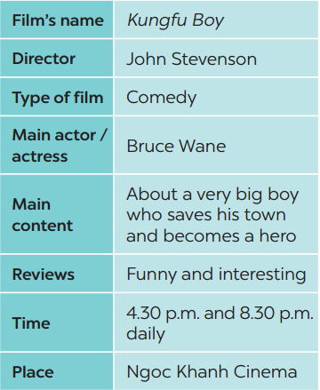  Example:  A: How about seeing a film this evening?  B: That’s a great idea. What film shall we see?  A: Kungfu Boy.  B: What kind of film is it?
WHILE-SPEAKING  To help students use what they practice to give a long talk about the film Kungfu Boy. | TASK 5: WORK IN GROUPS. TAKE TURNS TO TALK ABOUT THE FILM KUNGFU BOY. (p. 88)  * Teacher has students work in groups, talk about the film Kungfu Boy based on the information from Task 4.  ** Students work in groups to do the task.  *** Teacher goes around to help students.  **** After finishing, teacher can call some groups to give presentations in front of the class.  Example:  Kungfu Boy is on at … at … p.m. It’s a(n) … about …
POST-READING AND SPEAKING  - To help students improve next time.  - To help some students enhance their presentation skill. | * Teacher allows students to give comments for their friends and vote for the most interesting and informative presentation.  ** Students give comments for their friends and vote for the most interesting and informative presentation.  *** Teacher and students discuss the presentations.  **** Teacher gives feedback and comments.
WRAP-UP  To consolidate what students have learnt in the lesson. | Teacher asks students to talk about what they have learnt in the lesson.
HOMEWORK Prepare for the next lesson. | Prepare for the next lesson: Looking back and Project.

Date of planning:……/……./2023.
Date of teaching:……/……./2023.
UNIT 8: FILMS
Lesson 6: Skills 2

I. OBJECTIVES
By the end of this lesson, students will be able to:
- listen for special information about a comedy;
- write a short paragraph about your favorite film.
1. Knowledge:
- Vocabulary: adjectives to describe films, aspects of a film
- Grammar: review
2. Core competence:
- Develop communication skills and creativity
- Be collaborative and supportive in pair work and teamwork
- Actively join in class activities
3. Personal qualities
- Develop self-study skills

II. MATERIALS
- Grade 7 textbook, Unit 8, Skills 2
- Computer connected to the Internet
- Projector, loudspeaker
- sachmem.vn

Assumptions
Anticipated difficulties | Solutions
1. Students may lack of knowledge about how to summarise a film. | - Prepare some suggestions on vocabularies and structures to summarise a film.
2. Students may have underdeveloped listening, speaking and co-operating skills. | - Play the recording many times if any necessary.  - Encourage students to work in pairs, in groups so that they can help each other.  - Provide feedback and help if necessary.

Board Plan
Date of teaching
Unit 8: FILMS
Lesson 6: Skills 2

*Warm-up

Game: Name the comedy
I. Listening
Task 1: Work in pairs and discuss. (Ex.1)
Task 2: Prediction: Who stars in Naughty Twins?
→ Listen and check. (Ex. 2)
Task 3: Listen again and choose the correct answer. (Ex.3)
II. Writing
Task 4: Work in groups. Make notes about your favorite film. (Ex. 4)
Task 5: Work in groups, make a film review.
Task 6: Class gallery → Giving peer-reflection & evaluation.
*Homework:

III. PROCEDURES
Notes:
In each activity, each step will be represented as following:
* Deliver the task
** Implement the task
*** Discuss
**** Giving comments or feedback
Stage -Stage aim | Procedure
WARM-UP  To wake up students’ interest. | Game: Name the comedy  * Teacher divides the class into 2 groups and shows them a video of some comedies.  - After the video, teacher asks students to pass the chalk and take turns to run to the board and write down the name of the films that appeared in the video.  ** Students take turns to run to the board and write down the name of the films appeared in the video.  *** Teacher allows students to cross check first.  **** Teacher confirms the answers and gives feedback.
PRE-LISTENING  To lead in the lesson. | TASK 1: WORK IN PAIRS AND DISCUSS. (Exercise 1, p. 89)  * Teacher asks students what type of films are in the video in the previous activity.  ** Students quickly discuss with a partner.  *** Teacher asks what they like/ dislike comedies and why/ why not.  **** Teacher gives feedback.
WHILE-LISTENING  To draw students attention to listening skills: predicting, identifying keywords and listening for specific details.  To help students develop listening skills for specific information. | TASK 2: PREDICTION: WHO STARS IN NAUGHTY TWINS? LISTEN AND CHECK. (Exercise 2, p. 89)  * Teacher plays the recording.  ** Students listen and focus on the predicted keywords to find out the answer.  *** Teacher allows students to peer check first.  **** Teacher confirms the answers and gives feedback.  TASK 3: LISTENING AGAIN CHOOSE THE CORRECT ANSWER. (Exercise 3, p. 89)  * Teacher asks students to read the conversation and to focus on the key information and underline the keywords.  ** Teacher plays the recording again. Ask students to listen and choose the correct answer.  *** Teacher lets students peer-check with a partner.  **** Teacher calls some students to give the answers to the class and correct the mistakes where necessary, encourages students to explain their answers, and shares some tips on finding the information.
PRE-WRITING To prepare language material for students to write a film review. | TASK 4: WORK IN GROUPS. MAKE NOTES ABOUT YOUR FAVORITE FILM. (Exercise 4, p. 89)  * Teacher asks students to look at the table, and draws their attention to the information needed.  ** Students group up and decide on their favorite film.  - Students work in groups to ask and answer the questions and fill the table.  *** Teacher goes around and helps if needed.  **** Teacher confirms the answers and gives feedback.
WHILE-WRITING  To teach students how to write a film review. | TASK 5: WORK IN GROUPS, MAKE A FILM REVIEW. (Exercise 5, p. 89)  * Teacher shows a model of a short paragraph about a film review. Then recalls students’ knowledge on the structure of a paragraph.  ** Teacher tells students to make a film review about their agreed favorite movie in Task 4. Teacher gives students some time to arrange the work within the groups and give each group an A2 plain card with some colors.  - Teacher allows students time to write a paragraph (about 80 words) about their favorite film, using the suggested ideas/ information in Task 4.  - Teacher asks some students to decorate the card with the colors and stickers.  *** Teacher allows students to cross check first.  **** Teacher gives feedback.
POST-LISTEN  AND WRITE  To peer check, cross check and final check students’ writing. | TASK 6: CLASS GALLERY → GIVING PEER-REFLECTION & EVALUATION.  * Teacher asks students to stick their “productions” onto the board.  ** Students can go and see others’ work.  *** Students then give comments to each other.  **** Teacher then gives feedback as a class discussion.
WRAP-UP  To consolidate what students have learnt in the lesson. | Teacher asks students to talk about what they have learnt in the lesson.
HOMEWORK To allow students finalise their paragraph after being checked by friends and the teacher. | - Rewrite the film review in your notebook.  - Prepare for the next lesson (Unit 8 - Lesson 7: Looking back and Project).

Date of planning:……/……./2023.
Date of teaching:……/……./2023.
UNIT 8: FILMS
Lesson 7: Looking back & Project
I. OBJECTIVES
By the end of this lesson, students will be able to gain:
1. Knowledge
- Review the vocabulary and grammar of Unit 8
- Apply what they have learnt (vocabulary and grammar) into practice through a project
2. Core competence
- Develop communication skills and creativity
- Develop presentation skill
- Develop critical thinking skill
- Be collaborative and supportive in pair work and team work
- Actively join in class activities
3. Personal qualities
- Be more creative when doing the project
- Develop self-study skills

II. MATERIALS
- Grade 7 textbook, Unit 8, Looking back & Project
- Computer connected to the Internet
- Pictures, A0 paper
- Projector/ TV
- sachmem.vn

Assumptions
Anticipated difficulties | Solutions
1. Students may have underdeveloped speaking, writing and co-operating skills when doing the project. | - Encourage students to work in pairs, in groups so that they can help each other.  - Provide feedback and help if necessary.
2. Some students will excessively talk in the class. | - Define expectation in explicit detail.  - Have excessive talking students practise.  - Continue to define expectations in small chunks (before every activity).

Board Plan
Date of teaching
Unit 8: FILMS
Lesson 7: Looking back & Project
*Warm-up
Brainstorming: Types of films
I. Looking back
Task 1: Match the types of film in column A with their descriptions in column B.
Task 2: Give an example for every film type in the box.
Task 3: Choose the correct answer (A, B, or C) to complete each of the following sentences.
Task 4: Match the sentences or sentence halves in columns A and B.
II. Project
Posters exhibition:
*Homework

III. PROCEDURES
Notes:
In each activity, each step will be represented as following
* Deliver the task
** Implement the task
*** Discuss
**** Giving comments or feedback
Stage -Stage aim | Procedure
WARM-UP  - To revise the vocabulary related to the topic and lead in the next part of the lesson.  - To enhance students’ skills of cooperating with team mates. | Brainstorming  * Teacher divides the board, and divides the class into 2 teams.  ** Members of each team take turns and write as many types of films as possible in 2 minutes.  *** Students cross check their answers first.  **** Teacher confirms the answers and gives feedback. The group having more correct answers is the winner.
LOOKING BACK To help students revise  types of films.  To encourage students to give examples for types of films.  To help students revise adjectives describing films.  To help students revise the connectors: although/ though and however. | TASK 1: MATCH THE TYPES OF FILM IN COLUMN A WITH THEIR DESCRIPTIONS IN COLUMN B. (p. 90)  * Teacher encourages students to complete the task individually.  ** Students do the task individually.  *** Students exchange their textbooks with their partners.  **** Teacher gives feedback as a class discussion.  Answer key:  1. d  2. a  3. e  4. c  5. b  TASK 2: GIVE AN EXAMPLE FOR EVERY FILM TYPE IN THE BOX (p. 90)  * Teacher asks students to think of as many examples of different types of films as possible.  ** Students think of as many examples of different types of films as possible.  *** Teacher then asks some students to say out their examples in front of the class. Examples of Vietnamese films are fine.  **** Teacher gives feedback as a class discussion.  Example:  - a comedy: Mr Bean  TASK 3: CHOOSE THE CORRECT ANSWER (A, B, OR C) TO COMPLETE EACH OF THE FOLLOWING SENTENCES. (p. 90)  * Teacher encourages students to complete the task individually.  ** Students complete the task individually.  *** Students exchange their textbooks with their partners.  **** Teacher gives feedback as a class discussion.  Answer key:  1. C  2. B  3. C  4. A  5. B  6. A  TASK 4: MATCH THE SENTENCES OR SENTENCE HALVES IN COLUMNS A AND B. (p.90)  * Teacher asks students to do it individually first.  ** Students complete the task individually.  *** Teacher then asks them to check their answers with a partner before discussing the answers as a class.  **** Teacher reminds students to keep a record of their original answers so that they can use that information in their Now I can... statement.  Answer key:  1. d  2. e  3. a  4. b  5. c
PROJECT  To allow students to apply what they have learnt (vocabulary and grammar) into practice through  a project. | Posters exhibition:  * Teacher has students work in groups and gives instructions to students as follow:  1. Choose one of your favourite films and design a poster for it, including:  – name of the film  – type of film  – its director and main actors / actresses  – a short summary  – your overall opinion about the film  – the showtime and cinema  – pictures or photos to illustrate the film  2. Organise them into an exhibition.  3. Vote for the best poster.  ** Students do the project in groups.  *** Students vote for the best poster.  **** Teacher gives feedback.
WRAP-UP  To consolidate what students have learnt in the lesson. | Teacher asks students to talk about what they have learnt in the lesson.
HOMEWORK  To prepare for the next lesson. | Prepare for the next lesson: Unit 9 – Lesson 1: Getting Started.

Date of planning:……/……./2023.
Date of teaching:……/……./2023.
UNIT 9: FESTIVALS AROUND THE WORLD
Lesson 1: Getting started – A Tulip Festival
I. Objectives
By the end of this lesson, Ss will be able to gain:
1. Knowledge
- An overview about the topic “Festivals around the world”
- lexical items related to the topic “Festivals”: names of different festivals around the world
2. Core competence
- Develop communication skills and cultural awareness
- Be collaborative and supportive in pair work and teamwork
- Actively join in class activities
3. Personal qualities
- Develop self-study skills
II. Materials
- Grade 7 textbook, Unit 9, Getting started
- Computer connected to the internet
- Projector/ TV/ pictures and cards
- sachmem.vn

Language analysis
Form | Pronunciation | Meaning | Vietnamese equivalent
1. folk dance (n) | /ˈfəʊk ˌdɑːns/ | a popular dance, considered as part of the tradition or custom of a particular people. | điệu nhảy/ múa dân gian
2. costume (n) | /ˈkɒs.tʃuːm/ | the set of clothes typical of a particular country or period of history, or suitable for a particular activity | trang phục
3. float (n) | /fləʊt/ | a large vehicle with a flat surface that is decorated and used in festivals | xe diễu hành
4. parade (n) | /pəˈreɪd/ | a large number of people walking or in vehicles, all going in the same direction, usually as part of a public celebration of something | cuộc diễu hành
5. feast (n) | /fiːst/ | a special meal with very good food or a large meal for many people | bữa tiệc
6. fireworks display (n) | /ˈfɑɪərˌwɜrks dɪˈspleɪ/ | a public event at which fireworks are set alight | màn bắn pháo hoa

Assumptions
Anticipated difficulties | Solutions
1. Students may be lack of knowledge about festivals. | - Prepare some photos/posters of festivals.
2. Students may have underdeveloped listening, reading and co-operating skills. | - Play the recording many times if any necessary.  - Encourage students to work in pairs, in groups so that they can help each other.  - Provide feedback and help if necessary.

Board Plan
Date of teaching
Unit 9: FESTIVALS AROUND THE WORLD
Lesson 1: Getting started – A Tulip Festival
*Warm-up
Chatting and describing the picture.
I. Vocabulary
1. folk dance (n)
2. costume (n)
3. float (n)
4. parade (n)
5. feast (n)
6. fireworks display (n)

II. Practice
Task 1: Listen and read.
Task 2: Read the conversation again and tick the correct column.
Task 3: Write the correct word or phrase from the box under each picture.
* Game: Who is faster?
Task 4: Fill in each blank with a word from 3.
Task 5: Quiz. What festival is it? Match each description with a festival.

* Homework

Procedures
Notes
In each activity, each step will be represented as following
* Deliver the task
** Implement the task
*** Discuss
**** Giving comments or feedback

Stage -Stage aim | Procedure
Warm-up  To introduce and lead in the topic | Chatting  * Teacher shows the picture of the Tulip Festival and asks students some related questions:  - What can you see in the picture?  - Can you guess the name of the festival?  - Have you ever heard of this festival? If yes, what do you know about it?  ** Students raise hands to answer the questions.  *** Teacher and students discuss the questions.  **** Teacher accepts all students’ questions.
Presentation  (Vocab-  pre-teach)  - To provide students with vocabulary.  - To help students well-prepared for the listening and reading tasks. | Vocabulary:  * Teacher introduces the vocabulary by giving definitions/ examples/ pictures of the words.  ** Teacher writes all students’ answers on the board.  *** Teacher circles or highlights the following words and discuss the meanings of these words:  1. folk dance (n)  2. costume (n)  3. float (n)  4. parade (n)  5. feast (n)  6. fireworks display (n)  **** Teacher checks students’ pronunciation and gives feedback. Teacher reveals that these words will appear in the reading text and asks students to open their textbook to discover further.
Practice  - To have students get to know the topic.  - To have students get specific information of the text.  - To introduce some more vocabulary related to the topic festivals.  - To help Ss practise the words/phrases in 3.  To check Ss’ knowledge of some familiar festivals. | Task 1: Listen and read (p.92).  * Teacher can play the recording more than once.  ** Students listen and read.  *** Teacher invites some pairs of students to read aloud.  **** Teacher checks students’ pronunciation and gives feedback.  Task 2: Read the conversation again. Who did the following activities? Tick the correct column. Sometimes you need to tick both (p.93).  * Teacher tells students to read the conversation again and work independently to find the answers.  ** Students do the task individually.  *** Teacher allows students to share their answers before discussing as a class and encourages them to give evidence.  **** Teacher calls some students to give the answers and gives feedback.  Answer key:  Task 3: Write a word or phrase from the box under each picture (p.93).  Game: Who is faster?  * Teacher divides the class into 2 teams. Each team sends a leader to play the game on the board.  - Teacher explains the instructions of the game:  - Teacher gives each team a set of cards with word/phrases from the box.  - The two leaders of the teams come to the board and pin the cards under the correct pictures.  - Who can finish faster with more correct answers will be the winner.  ** Students play the games in team mode.  *** Teacher has students write down the correct answer.  **** Teacher confirms the answers and gives feedback. Teacher can ask for translation to check their understanding.  Answer key:  1. parade  2. costumes  3. feast  4. float  5. fireworks display  6. folk dance  Task 4: Fill in each blank with a word or phrase from 3. You may have to change the form of the word or phrase (p.93).  * Teacher asks students to work individually to complete the task. Remind them to change the form of the words/phrases of needed.  ** Students fill in the blanks with the most suitable form of word/phrase.  *** Teacher allows students to share answers before discussing as a class.  **** Teacher can ask for translation to check their understanding.  Answer key:  1. folk dances  2. fireworks display  3. feast  4. parades  5. floats; costumes  Task 5: Quiz. What festival is it? Match each description with a festival (p.93).  * Teacher lets Ss work in groups of 4-6.  ** Ss work in groups to find the answers.  *** Teacher can go around to help weaker students.  **** Teacher calls the first group to come up with the answers to share.  Answer key:  1. e  2. a  3. d  4. c  5. b
Wrap-up  To consolidate what students have learnt in the lesson. | Teacher asks students to talk about what they have learnt in the lesson.
Homework  To prepare vocabulary for the next lesson: A closer look 1. | Name at least 3 festivals around the world.

Date of planning:……/……./2023.
Date of teaching:……/……./2023.
UNIT 9: FESTIVALS AROUND THE WORLD
Lesson 2: A closer look 1
I. Objectives
By the end of this lesson, Ss will be able to gain:
1. Knowledge:
- Vocabulary: types of festivals and festival activities.
- Pronunciation: pronounce two-syllable words with correct stress.
2. Core competence
- Develop communication skills and creativity
- Be collaborative and supportive in pair work and teamwork
- Actively join in class activities
3. Personal qualities
- Develop self-study skills

II. MATERIALS
- Grade 7 textbook, Unit 9, A closer look 1
- Computer connected to the internet
- Projector/ TV/ pictures
- sachmem.vn

Language analysis
Form | Pronunciation | Meaning | Vietnamese equivalent
1. Cannes Film Festival | /kæn fɪlm fes.tɪ.vl/ | an annual film festival held in Cannes, France, which previews new films of all genres. | Liên hoan phim Cannes
2. Mid-Autumn Festival | /mɪd-ɔː.təm fes.tɪ.vl/ | he festival which is held on the 15th day of the 8th month of the lunar calendar with a full moon at night. | Tết Trung thu
3. Thanksgiving | /ˌθæŋksˈɡɪv.ɪŋ/ | a national holiday on the fourth Thursday in November in the US and on the second Monday in October in Canada, when families get together for a big meal and express their appreciation for life, health, etc. | Lễ Tạ ơn
4. Easter | /ˈiː.stər/ | a Christian religious holiday to celebrate Jesus Christ's return to life after he was killed. | Lễ Phục sinh
5. carve | /kɑːv/ | to make something by cutting into especially wood or stone, or to cut into the surface of stone, wood, etc. | chạm, khắc
6. perform | /pəˈfɔːm/ | to do an action or piece of work. | biểu diễn

Assumptions
Anticipated difficulties | Solutions
Students may have underdeveloped listening, speaking and co-operating skills. | - Encourage students to work in pairs, in groups so that they can help each other.  - Provide feedback and help if necessary.

Board Plan
Date of teaching
UNIT 9: FESTIVALS AROUND THE WORLD
Lesson 2: A closer look 1
*Warm-up: Pass the secret
I. Vocabulary
- Cannes Film Festival
- Mid-Autumn Festival
- Thanksgiving (n)
- Easter (n)
- carve (v)
- perform (v)

II. Practice
Task 1: Write under each picture a festival name from the box.
Task 2: Complete the table below with the phrases from the box.
Task 3: Fill in each blank with a word or phrase from the box.
Task 4: Listen and repeat. Then underline the stressed syllable in each word.
Task 5: Listen and repeat the sentences. Underline the stressed syllables in the bold words.

* Homework:

Procedures
Notes
In each activity, each step will be represented as following
* Deliver the task
** Implement the task
*** Discuss
**** Giving comments or feedback

Stage -Stage aim | Procedure
Warm-up  - To review the previous lesson and activate students’ knowledge. | Game: Hot seat  * Teacher divides the class into 2 teams. Each team will send a leader to play the game on the board.  - Teacher explains the instructions of the game:  - Each leader stands against the board.  - Teacher shows/ writes the names of the festivals (exercise 5 – page 93).  - Other members from each team describe the festivals and let the leader guess the names of the festivals.  - The team with more correct answers is the winner.  ** Students play in teams.  *** Students give the correct answers.  **** Teacher confirms the answers and gives feedback.
Presentation  (Vocab-  pre-teach)  To introduce new words. | Vocabulary:  * Teacher introduces the vocabulary.  ** Teacher introduces the vocabulary by:  - providing the pictures  - providing the definition/example of the words.  - Cannes Film Festival  - Mid-Autumn Festival  - Thanksgiving (n)  - Easter (n)  - carve (v)  - perform (v)  *** Teacher asks students to repeat.  **** Teacher rubs out and checks.
Practice  To present some types of festivals  To present some festival activities  To give Ss further practice with words related to festivals and festivals activities.  To help Ss identify how to pronounce two-syllable words with correct stress.  To help Ss pronounce two-syllable words with correct stress in sentence. | Task 1: Write under each picture a festival name from the box (p.94).  * Teacher has students to look at the pictures and asks them if they know the names of the festivals.  ** Teacher gets students to do the exercise in individuals.  *** Ask them to share their answers in pairs before checking the answers as a class.  **** Teacher then encourages students to explain their answers. Correct if necessary.  Answer key:  1. Halloween  2. Christmas  3. Mid-Autumn Festival  4. Cannes Film Festival  5. Easter  6. Thanksgiving  Task 2: Complete the table below with the phrases from the box (p.94).  * Teacher tells Ss that people celebrate festivals with different food and activities.  ** Teacher asks them to do the task individually.  *** Teacher asks students to share their answers in pairs before checking the answers as a class.  **** Teacher then encourages students to explain their answers. Correct if necessary.  Answer key:  Task 3: Fill in each blank with a word or phrase from the box (p.94).  * Teacher asks Ss to work in pairs to complete the sentences with the words/ phrases given.  ** Ss work in pairs.  *** Teacher allows students to cross check first.  **** Teacher invites some pairs to share their answers and gives feedback.  Answer key:  1. Christmas  2. painting eggs  3. candy apples  4. Cannes Film Festival  5. Mid-Autumn Festival  6. turkey  Task 4: Listen and repeat. Then underline the stressed syllable in each word. (p.94).  Pronunciation: Stress in two-syllable words  * Teacher helps Ss to understand what a syllable is. Explain to them that a syllable is a unit of pronunciation having one vowel sound, with or without surrounding consonants, forming the whole part of a word. Give some examples of one-, two- and three-syllable words.  - Tell them that in this lesson, they just focus on two-syllable words and their common stress pattern. Have Ss name some more two-syllable words.  ** Teacher has Ss listen and repeat out the words in the table. Play the recording again for them to underline the stressed syllable in each word.  *** Teacher allows students to cross check first.  **** Teacher lets Ss share their answer and gives feedback. Ask Ss if they recognize any rules related to stress in two-syllable words. Share with them the most common rules.  Answer key:  Task 5: Listen and repeat the sentences. Underline the stressed syllables in the bold words (p.94).  * Teacher has Ss read quickly the sentences and plays the recording. Ask them to pay attention to the bold words and underline the stressed syllables.  ** Students practice in pairs or in groups.  *** Teacher goes around to offer help or correct pronunciation, if necessary.  **** Teacher calls some students to say the sentences in front of the class. Check their pronunciation if necessary.
Production  To test students' quick reaction to the targeted sounds. | Game: “Up and down”  *Teacher explains the rules:  Teacher says 1-15 words containing two-syllable words. Students stand up for the ones with first main stress pattern, sit down for the second main stress pattern.  ** Students play the game in teams.  *** Teacher helps students in the game.  **** Teacher gives feedback.
Wrap-up  To consolidate what students have learnt in the lesson. | Teacher asks students to talk about what they have learnt in the lesson.
Homework  To review the lesson. | Do exercises in workbook.

Date of planning:……/……./2023.
Date of teaching:……/……./2023.
UNIT 9: FESTIVALS AROUND THE WORLD
Lesson 3: A closer look 2
I. Objectives
By the end of this lesson, Ss will be able to:
1. Knowledge:
- Practice Yes/No questions
2. Core competence:
- Develop communication skills and creativity
- Be collaborative and supportive in pair work and teamwork
- Actively join in class activities
3. Personal qualities
- Develop self-study skills

II. MATERIALS
- Grade 7 textbook, Unit 9, A closer look 2
- Computer connected to the internet
- Projector/ TV/ pictures and cards
- sachmem.vn

Language analysis
Form | Meaning
Yes/No questions | Yes / No questions are used to check information or ask for confirmation.  These questions need either a Yes or No answer.  We form a Yes/No question with an auxiliary verb (be, do or have) or with a modal verb. We put the auxiliary verb or modal verb before the subject.  Examples:  Did you go to bed late yesterday?  Are you tired now?

Assumptions
Anticipated difficulties | Solutions
1. Students may find confused when to use the yes/no questions with auxiliary verbs/ modal verbs. | - Give short and clear explanations/ structures with legible examples for each case.
2. Students may have underdeveloped speaking and co-operating skills. | - Give clear instructions, give examples before letting students work in groups.  - Provide feedback and help if necessary.

Board Plan
Date of teaching
Unit 9: FESTIVALS AROUND THE WORLD
Lesson 3: A closer look 2
* Warm-up
Game: Sentence puzzling

I. Grammar focus
Yes/No questions

II. Practice
Task 1: Fill in each blank with a correct auxiliary verb or modal verb.
Task 2: Change the sentences into Yes/No questions.
Task 3: Match the questions in column A with their answers in column B.
Task 4: Mark is talking to Trang about the Mid-autumn Festival. Fill in the blanks with Trang’s answers below.

III. Production
Task 5: Game. Festival mystery. Work in groups. One student thinks of a festival he/she likes. Other students ask Yes/No questions to find out what the festival is.

* Homework

Procedures
Notes
In each activity, each step will be represented as following
*Deliver the task
** Implement the task
*** Discuss
**** Giving comments or feedback

Stage -Stage aim | Procedure
Warm-up  - To activate students’ prior knowledge related to the targeted grammar: Yes/No questions.  - To increase students’ interest.  - To enhance students’ skills of cooperating with team mates. | Game: Sentence puzzling  * Teacher divides the class into 4 groups.  - Teacher delivers different sets of word cards to each group.  - Each group has to arrange the word cards to make meaningful sentences.  - 1 point for each correct answer.  ** Students play the game in groups.  *** Teacher and students discuss the answers.  **** Teacher confirms the answers and gives feedback.  Set 1:  Are you eating moon cakes?  Set 2:  Did they eat moon cakes at the festival last year?  Set 3:  Can he eat all these moon cakes?
Lead in  To introduce the targeted grammar: Yes/No questions. | - Teacher draws students’ attention to the Yes/No questions.  - Teacher introduces the target of the lesson: Yes/No questions.
Presentation  - To have students get to know about the Yes/No questions. | * Teacher asks students to study the Grammar box.  - Teacher draw students’ attention to the use and how to form a Yes/No question with an auxiliary verb or with a modal verb.  ** Teacher then asks some more able students to give some more examples.  Yes/No questions  We use put the auxiliary verb or modal verb before the subject.  Examples:  - Are you tired?  - Did you get many Christmas presents?  - Can you eat all the cakes?  *** Teacher and students discuss the answers.  **** Teacher confirms the answers and gives feedback.
Practice  - To check students’ understanding of the Yes/No questions.  - To help Ss practise making Yes/No questions.  - To give further practice with Yes/No questions.  - To give further practice with Yes/No questions. | Task 1: Fill in each blank with a correct auxiliary verb or modal verb (p.95).  * Teacher has students work individually.  ** Students work individually to complete the sentences.  *** Teacher lets students work in pairs and exchange the answers before checking with the whole class (explain each sentence if necessary).  **** Teacher confirms the answers and gives feedback.  Answer key:  1. Do  2. Did  3. Are  4. Can  5. Does  Task 2: Change the sentences into Yes/No questions (p.95).  * Teacher has students work individually.  ** Students work individually to complete the sentences.  *** Teacher lets students work in pairs and exchange the answers before checking with the whole class (explain each sentence if necessary).  **** Teacher confirms the answers and gives feedback.  Answer key:  1. Can your mother make a costume for you?  2. Will she bake a birthday cake for him?  3. Are the dragon dances interesting?  4. Does the Rio Carnival take place every year in Brazil?  5. Did they see a fireworks display on New Year’s Eve?  Task 3: Match the questions in column A with their answers in column B (p.95).  * Teacher asks students to read the instruction.  ** Teacher asks students to do the exercise individually and match the questions in column A with the answers in column B.  *** Teacher then has them work in pairs, comparing their sentences. Teacher can go around to help students.  **** Teacher confirms the answers and gives feedback.  Task 4: Mark is talking to Trang about the Mid-autumn Festival. Fill in the blanks with Trang’s answers below (p.95).  Game: Who is faster?  * Teacher divides the class into 2 teams. Each team will send a leader to play the game on the board.  - Teacher explains the instructions of the game:  - Teacher gives each team a set of cards with phrases from the box.  - The two leaders of the teams come to the board and pin the cards under the correct number.  - Who can finish faster with the correct answer will be the winner.  ** Students play the games in team mode.  *** Teacher has students to write down the correct answer.  **** Teacher confirms the answers and gives feedback. Teacher can ask for translation to check their understanding.  Answer key:  1. b  2. e  3. a  4. c  5. d
Production  To help Ss practice producing Yes/No questions. | Task 5: Game. Festival mystery. Work in groups. One student thinks of a festival he/she likes. Other students ask Yes/No questions to find out what the festival is (p.95).  * Teacher has students work in groups.  ** One student thinks of a festival that he/she likes. Other students ask Yes/No questions to find out what the festival is.  The group leader keeps a record of the group’s performance.  *** Teacher move around to observe and pays attention to Ss’ yes/no questions.  **** Teacher asks some groups to perform in front of the class, confirms the answers and gives feedback.  Example:  A: Do many countries celebrate the festival?  B: Yes, they do.  A: Do children like the festival?  B: Do they paint eggs?  A: Yes, they do.  C: Is it Easter?  B: Yes, it is.
Wrap-up  To consolidate what students have learnt in the lesson. | Teacher asks students to talk about what they have learnt in the lesson.
Homework  Reactivate the knowledge that students have gained. | Teachers asks students to prepare for project.

Date of planning:……/……./2023.
Date of teaching:……/……./2023.
UNIT 9: FESTIVALS AROUND THE WORLD
Lesson 4: Communication
I. Objectives
By the end of this lesson, Ss will be able to:
- Express disappointment
- Understand the concept of festival symbols and their meanings
- Talk about the concept of festival symbols and their meanings
1. Knowledge:
a. Vocabulary: revise vocabulary on types of festivals and festival activities
b. Grammar: structures to express disappointment
2. Core competence:
- Develop communication skills and creativity
- Be collaborative and supportive in pair work and teamwork
- Actively join in class activities
3. Personal qualities
- Develop self-study skills

II. MATERIALS
1. Textbooks, plan
2. Equipment: computer accessed to the Internet, projector, loudspeaker
3. sachmem.vn

Language analysis
 | Examples
Expressing disappointment | * It was disappointing!  * It was a big disappointment.  Other expressions:  * That’s too bad!  * What a disaster!  * That’s so disappointing!

Assumptions
Anticipated difficulties | Solutions
1. Students may be lack of knowledge about festival symbols and meanings. | - Prepare some photos/posters of festival symbols and give suggestions of their meanings.
2. Students may have underdeveloped listening, speaking and co-operating skills. | - Encourage students to work in pairs, in groups so that they can help each other.  - Provide feedback and help if necessary.

Board Plan
Date of teaching
Unit 9: FESTIVALS AROUND THE WORLD
Lesson 4: Communication
*Warm-up
Name the festivals

I. Everyday English
Task 1: Listen and read the conversation. Pay attention to the highlighted sentences.
Task 2: Work in groups. Make a similar conversation for each situation below.

II. Festival symbols
Task 3: Listen to Mark talking about festival symbols. Fill in each blank with ONE word.
Task 4: Work in pairs. Match each festival with its symbol and meaning.
Task 5: Work in groups. Choose a festival and talk about its symbol(s) and meaning.

* Homework:

Procedures
Notes
In each activity, each step will be represented as following
* Deliver the task
** Implement the task
*** Discuss
**** Giving comments or feedback

Stage -Stage aim | Procedure
Warm-up/ Lead in To activate students’ knowledge and interest. | Game: Name the festivals  * Teacher divides the class into 2 teams. Teacher shows pictures of some festivals on the slides.  ** Ss give the correct names of the festivals as fast as possible. The one with more correct answers is the winner.  *** Students work in team mode  **** Teacher checks and gives feedback.
Presentation  To help students get to know the ways to express disappointment. | Task 1: Listen and read the conversation. Pay attention to the highlighted sentences.  * Teacher lets students listen to the examples in Ex. 1 in the book.  ** Teacher draws their attention to the form of ways to express disappointment.  *** Teacher and students discuss the form of ways to express disappointment, and give some other expressions.  **** Teacher confirms the answers and gives feedback.
Practice  To help students practice the ways to express disappointment. | Task 2: Work in groups. Make a similar conversation for each situation below.  * Teacher has students work in groups to discuss and make similar conversation for each situation.  ** Students work in groups to discuss.  *** Teacher then asks students to exchange their answer among class.  **** Teacher moves around to observe, provides help and gives feedback.
To help Ss understand the concept of festival symbols.  To provide Ss with some Christmas symbols and their meanings.  To help Ss understand the symbols and meanings of other festivals.  To let students practice talking about festival symbols and their meanings. | Task 3: Listen to Mark talking about festival symbols. Fill in each blank with ONE word.  * Teacher asks Ss what they think of when they talk about Christmas, i.e. Christmas symbols. Elicit answers from students.  Have Ss read the sentences given. Ask them to predict what word to use to fill in each blank. Write their answers on the board.  ** Students work individually. Then listen to the recording and check the answers.  *** Teacher invites some Ss to share their answers.  **** Teacher gives feedback and correction (if needed)  Answer key:  1. think  2. meaning  3. life  4. happiness  Task 4: Work in pairs. Match each festival with its symbol and meaning.  * Teacher introduces some new words if necessary (prosperity, reunion).  ** Ss works in pairs to finish the task.  *** Teacher allows student to cross check first.  **** Teacher confirms the answers and gives feedback.  Answer key:  1. C-b  2. A-c  3. D-a  4. B-d  Task 5: Work in groups. Choose a festival and talk about its symbol(s) and meaning.  * Teacher lets students group up and spend 5 minutes on taking notes of a festival.  ** Students work in groups.  *** All group members choose a festival and talk about its symbols and meanings.  **** Teacher moves around to observe and offers help if needed.
Production  To let students practice talking about festival symbols and their meanings. | Task 6: Presentation  * Teacher invites some students to talk about festival symbols and their meanings.  ** Students share their group’s answer.  *** Teacher allows students to cross check first.  **** Teacher listens, gives comments or corrections if needed.
Wrap-up  To consolidate what students have learnt in the lesson. | Teacher asks students to talk about what they have learnt in the lesson.
Homework  Reactivate the knowledge that students have gained. | Teachers asks students to do exercises in their Workbook.

Date of planning:……/……./2023.
Date of teaching:……/……./2023.
UNIT 9: FESTIVALS AROUND THE WORLD
Lesson 5: Skills 1
I. Objectives
By the end of this lesson, Ss will be able to gain:
1. Knowledge:
- Develop reading skill about an unusual festival
- Develop speaking skill: talking about a festival they enjoy
2. Core competence:
- Develop communication skills and creativity
- Be collaborative and supportive in pair work and teamwork
- Develop presentation skill
- Actively join in class activities
3. Personal qualities
- Develop self-study skills
II. MATERIALS
- Grade 7 textbook, Unit 9, Skills 1
- Computer connected to the internet
- Projector/ TV/ pictures and cards
- sachmem.vn
Language analysis
Form | Pronunciation | Meaning | Vietnamese equivalent
join | /dʒɔɪn/ | to get involved in an activity or journey with another person or group | tham gia
feature | /ˈfiː.tʃər/ | to include someone or something as an important part | trình diễn đặc biệt
performance | /pəˈfɔː.məns/ | the action of entertaining other people by dancing, singing, acting, or playing music | màn biểu diễn

Assumptions
Anticipated difficulties | Solutions
1. Students may lack knowledge about some lexical items. | - Provide students with the meaning and pronunciation of words.
2. Students may have underdeveloped reading, speaking and co-operating skills. | - Let students read the text again (if needed).  - Create a comfortable and encouraging environment for students to speak.  - Encourage students to work in pairs, in groups so that they can help each other.  - Provide feedback and help if necessary.
3. Some students will excessively talk in the class. | - Define expectation in explicit detail.  Have excessive talking students practise.  - Continue to define expectations in small chunks (before every activity).

Board Plan
Unit 9: FESTIVALS AROUND THE WORLD
Lesson 5: Skills 1
* Warm-up
Game: Who is faster
I. Reading
Task 1: Work in pairs. Look at the pictures. Which events do you think happen at the Twins Day Festival?
Vocabulary
1. join (v)
2. feature (v)
3. performance (n)
Now quickly read the email below and check your answers.
Task 2: Match each word from the email in 1 with its meaning.
Task 3: Read the email again. Complete each sentence with no more than TWO words.
II. Speaking
Task 4: Match the questions and answer about a festival someone joined.
Task 5: Work in pairs. Ask and answer about a festival you and your friend joined, using the questions in 4 as cues. Tell the class about the festival your partner joined.
* Homework

Procedures
Notes
In each activity, each step will be represented as following
* Deliver the task
** Implement the task
*** Discuss
**** Giving comments or feedback

Stage -Stage aim | Procedure
Warm-up  - To introduce the topic of reading.  - To enhance students’ skills of cooperating with team mates. | Game: Who is faster?  * Teacher divides the class into 2 teams.  - Each team has to run in a relay to the board to write the correct types of festivals and their symbols and meaning under the posters.  - The team with more correct answers will be the winner.  ** Students play the game in team mode.  *** Teacher and students discuss the answers.  **** Teacher confirms the answers and gives feedback.
Pre-Reading  To lead in the reading skills. | Task 1: Work in pairs. Look at the pictures. Which events do you think happen at the Twins Day Festival? (p.97)  * Teacher has students work in pairs, look at the pictures in the book. Ask Ss to discuss what/who they see in the pictures and answer the questions.  ** Students works in pairs.  *** Teacher and students discuss the questions and answers.  **** Teacher accepts all students’ questions.
While-Reading  To provide students with some lexical items before reading the text.  To develop the skill of guessing the meanings of new words in context.  To develop reading skill for specific information (scanning). | Vocabulary  * Teacher introduces the vocabulary.  ** Teacher asks students to get the meaning in context and try to make up sentences with of the following words:  1. join (v)  2. feature (v)  3. performance (n)  *** Teacher and students discuss the answers.  **** Teacher confirms student’s answers and checks their pronunciation and gives feedback.  Now quickly read the email below and check your answers.  Answer key:  Pictures 1 + 3: Twins Day Festival  Task 2: Match each word from the email in 1 with its meaning (p.98)  * Teacher tells Ss what they are going to do. Ask Ss how to do the exercise and elicits answers from Ss.  If needed, tell them that to do the exercise they can follow these steps:  + Read the words in the left column  + Locate each word in the text  + Read around the word to get the general meaning  + Read the definitions in the right column, find the suitable meaning to match each word.  Ask Ss to repeat the steps (they can speak in Vietnamese).  ** Students read the text and do the task in individuals.  *** Teacher allows students to share their answers before discussing as a class and encourages them to give evidence.  **** Teacher calls some students to give the answer, explain which sentence give them the information.  Answer key:  1. b  2. d  3. a  4. c  Task 3: Read the email again. Complete each sentence with no more than TWO words (p.98).  * Teacher can set a longer time limit for students to read the text again and complete the sentences.  Briefly tell them the steps: read the sentences – underline key words – locate the key words in the text – find the words to complete the sentences.  ** Teacher asks students to work in individuals and find the answer.  *** Teacher allows students to share their answers before discussing as a class and encourages them to give evidence.  **** Teacher calls a student to write his/her answer on the board, then check sentence by sentence with class.  Answer key:  1. first weekend  2. countries  3. walked together  4. performance  5. Fun Run  6. exciting
Pre-Speaking  To help students identify how to ask and answer about a festival they attended. | Task 4: Match the questions and answer about a festival someone joined (p.98).  * Teacher tells Ss they are going to ask and answer about a festival they attended and that this activity can serve as a model for them to follow in the writing task.  ** Teacher asks students to work individually and then check in pairs.  *** Teacher can go around to help weaker students.  **** Teacher call on some pairs to give the answers and check as the whole class.  Answer key:  1. d  2. b  3. e  4. c  5. a
While-Speaking  To give Ss practice in asking and answering about a festival Ss attended. | Task 5: Work in pairs. Ask and answer about a festival you and your friend joined, using the questions in 4 as cues. Tell the class about the festival your partner joined.  * Teacher has students to work in pairs, ask and answer about a festival they attended.  ** Students work in pairs to do the task.  *** Teacher goes around to help students.  **** After finishing, teacher can call some pairs to give presentations in front of the class.
- Post-Reading and Speaking  - To help students improve next time.  To help some students enhance presentation skill | * Teacher allows students to give comments for their friends and vote for the most interesting dialogue.  ** Students give comments for their friends and vote for the most interesting dialogue.  *** Teacher and students discuss.  **** Teacher gives feed-back and comments.
Wrap-up  To consolidate what students have learnt in the lesson. | Teacher asks students to talk about what they have learnt in the lesson.
Homework  Prepare for the next lesson. | Prepare for the next lesson: Looking back and Project.

Date of planning:……/……./2023.
Date of teaching:……/……./2023.
UNIT 9: FESTIVALS AROUND THE WORLD
Lesson 6: Skills 2
I. Objectives
By the end of this lesson, Ss will be able to gain:
- Listen for special information about a festival
- Write an email to describe a festival
1. Knowledge:
a. Vocabulary: types of festivals, festival activities
b. Grammar: review
2. Core competence:
- Develop communication skills and creativity
- Be collaborative and supportive in pair work and teamwork
- Actively join in class activities
3. Personal qualities
- Develop self-study skills
II. MATERIALS
1. Textbooks, plan
2. Equipment: computer accessed to the Internet, projector, loudspeaker
3. sachmem.vn
Assumptions
Anticipated difficulties | Solutions
1. Students may be lack of information about a festival | - Prepare some suggestions on things related to a festival.  - Let students work in small groups to help each other.
2. Students may have underdeveloped listening, speaking and co-operating skills. | - Play the recording many times if any necessary.  - Encourage students to work in pairs, in groups so that they can help each other.  - Provide feedback and help if necessary.

Board Plan
Date of teaching
Unit 9: FESTIVALS AROUND THE WORLD
Lesson 6: Skills 2
Warm up
Bingo
I. Listening
Task 1: Look at the animal. Discuss the questions with a partner.
Task 2: Listen to Mark talking about how his family celebrates a festival. Check your answers.
Task 3: Listening again and decide whether the following statements are true or false.
II. Writing
Task 4: Think about a festival that your family usually celebrates. Fill in the blanks with your answers.
Task 5: Write an email of about 70 words to tell Mark about the festival. Use the notes in 4.
Task 6: Class gallery
* Homework:

Procedures
Notes
In each activity, each step will be represented as following
* Deliver the task
** Implement the task
*** Discuss
**** Giving comments or feedback

Stage -Stage aim | Procedure
Warm up  To warm up and get Ss’ interest. | * Teacher tells the rules of the game:  - Each student gets a piece of paper, draws a table with 3 rows and 3 columns, then fill in the table with names of some festivals randomly.  - Teacher calls out the names of some festivals. Each time the teacher calls out a word, the students search for the right square on their paper and mark.  - The student who has 3 words highlighted in a row yells “Bingo” and wins.  ** Students play the game in individuals  *** Teacher and students discuss the answers.  **** Teacher confirms the answers and gives feedback.
Pre-Listening  To prepare Ss for the listening text. | Task 1: Look at the animal. Discuss the questions with a partner.  * Teacher asks students to work in pairs, read the questions and answer.  ** Students quickly discuss with a partner.  *** Teacher allows Ss to cross check.  **** Teacher calls some Ss to give their answer on the board and elicits their answers.
While-Listening  To help Ss check their answer in Task 1.  To help students develop listening skills for specific information. | Task 2: Listen to Mark talking about how his family celebrates a festival. Check your answers.  * Teacher tells Ss what they are going to listen to and plays the recording.  ** Students listen and check their answers.  *** Teacher allows students to peer check first.  **** Teacher confirms the answers and gives feedback.  Answer key:  1. A turkey  2. Thanksgiving  Task 3: Listening again and decide whether the following statements are true or false.  * Teacher asks students to read through the statements, have a guess before they listen to the recording the second time and write their guesses on the board.  ** Teacher plays the recording again. Ask students to listen and choose the correct answer.  *** Teacher lets students peer-check with a partner.  **** Teacher calls some students to give the answers to the class and correct the mistakes where necessary, encourages students to correct the false statements.  Answer key:  1. F  2. F  3. T  4. F  5. T  6. T  Audio Script:  Hello everyone. I’m Mark. Today I’m going to talk about Thanksgiving, or Turkey Day. It’s a national holiday. People from Canada and the USA celebrate it every year to be thankful for successful harvests. In the USA, we celebrate it on the fourth Thursday of November. We usually prepare a feast for family and friends. Both adults and children take part in the food preparation. Some of the traditional foods are turkey, sweet potatoes, and cornbread. After the meal, we play board games together. My family usually takes this opportunity to help others. My parents volunteer to cook and serve food to homeless people. My sister and I read books to old people in a nursing home near our house.
Pre-Writing  To brainstorm ideas and make an outline for Ss’ writing. | Task 4: Think about a festival that your family usually celebrates. Fill in the blanks with your answers.  * Teacher asks students to work individually to complete the mind map.  ** Students in individuals and decide on their festival.  *** Teacher goes around and helps if needed.  **** Teacher calls some Ss to give their answer (if time allows) and gives feedback.
While-Writing  To practice how to write a paragraph about a festival | Task 5: Write an email of about 70 words to tell Mark about the festival. Use the notes in 4.  * Teacher shows a model of a short paragraph about a festival (T may use the audio script or reading passage-page 97). Then recalls students’ knowledge on the structure of an email.  ** T has Ss write their email in individuals based on the information in 4.  *** Teacher allows students to cross check first.  **** Teacher gives feedback.
Post-Writing  To peer check, cross check and final check students’ writing. | Task 6:  Class gallery  Giving peer-reflection & evaluation  * Teacher asks students read their “production”.  ** Students listen to each other’s work.  *** Students then give comments to each other.  **** Teacher then gives feedback as a class discussion.
Wrap-up  To consolidate what students have learnt in the lesson. | Teacher asks students to talk about what they have learnt in the lesson.
Homework  To allow students finalize their paragraph after being checked by friends and the teacher. | Rewrite the emails on your notebook.  Prepare for the next lesson (Unit 9-Lesson 7: Looking back and Project)

Date of planning:……/……./2023.
Date of teaching:……/……./2023.
UNIT 8: FESTIVALS AROUND THE WORLD
Lesson 7: Looking back & Project
I. Objectives
By the end of this lesson, Ss will be able to gain:
1. Knowledge
Review the vocabulary and grammar of Unit 9
Apply what they have learnt (vocabulary and grammar) into practice through a project
2. Core competence
- Develop communication skills and creativity
- Develop presentation skill
- Develop critical thinking skill
- Be collaborative and supportive in pair work and team work
- Actively join in class activities
3. Personal qualities
- Be more creative when doing the project
- Develop self-study skills
II. Materials
- Grade 7 textbook, Unit 9, Looking back & Project
Computer connected to the internet
Pictures, A0 paper
- Projector/ TV
- sachmem.vn
Assumptions
Anticipated difficulties | Solutions
1. Students may have underdeveloped speaking, writing and co-operating skills when doing the project. | - Encourage students to work in pairs, in groups so that they can help each other.  - Provide feedback and help if necessary.
2. Some students will excessively talk in the class. | - Define expectation in explicit detail.  Have excessive talking student’s practise.  - Continue to define expectations in small chunks (before every activity).

Board Plan
Date of teaching
Unit 9: FESTIVALS AROUND THE WORLD
Lesson 7: Looking back & Project
* Warm-up
Brainstorming: Types of festivals

I. Looking back
Task 1: Circle the correct words or phrases in brackets.
Task 2: Complete each sentence by filling in the blank with a word or phrase in the box.
Task 3: Choose the correct question A or B.
Task 4: Answer the following questions about yourself.

II. Project
Posters exhibition

* Homework

Procedures
Notes
In each activity, each step will be represented as following
* Deliver the task
** Implement the task
*** Discuss
**** Giving comments or feedback

Stage -Stage aim | Procedure
- Warm-up  - To revise the vocabulary related to the topic and lead in the next part of the lesson.  - To enhance students’ skills of cooperating with team mates. | Brainstorming  * Teacher divides the board, and divides the class into 2 teams.  ** Members of each team take turns and write as many types of festivals as possible in 2 minutes.  *** Students cross check their answers first.  **** Teacher confirms the answers and gives feedback. The group having more correct answers is the winner.
- Looking back  - To help students revise vocabulary items they have learnt in the Unit.  - To help students revise vocabulary items they have learnt in the Unit.  To help students revise Yes/No questions.  To help students revise Yes/No questions. | Task 1: Circle the correct words or phrases in brackets (p.100)  * Teacher encourages students to complete the task individually.  ** Students do the task individually.  *** Students exchange their textbooks with their partners.  **** Teacher gives feedback as a class discussion.  Answer key:  1. fireworks  2. Cannes Film Festival  3. painting  4. candy apples  5. Thanksgiving  Task 2: Complete each sentence by filling in the blank with a word or phrase in the box (p.100).  * Teacher encourages students to complete the task individually.  ** Students do the task individually.  *** Students exchange their textbooks with their partners.  **** Teacher gives feedback as a class discussion.  Answer key:  1. lion dances  2. floats  3. costumes  4. Bunny  5. gathering  Task 3: Choose the correct question A or B (p.100).  * Teacher encourages students to complete the task individually.  ** Students do the task individually.  *** Students exchange their textbooks with their partners.  **** Teacher calls some Ss to read aloud their answers and gives feedback.  Answer key:  1. A  2. B  3. A  4. B  5. B  Task 4: Answer the following questions about yourself.  * Teacher encourages students to complete the task individually.  ** Students do the task individually.  *** Students share their answer in groups of 3 of 4.  **** Teacher calls some Ss to read aloud their answers and gives feedback.
Project  To allow students to apply what they have learnt (vocabulary and grammar) into practice through  a project. | Posters exhibition:  * Teacher has students work in groups and gives instructions to students as follow:  1. Choose one of your favourite festivals and design a poster for it, including:  – name of the festival  – the time/ place it takes place  – its meanings  – its activities  – pictures or photos to illustrate the festival  2. Organise them into an exhibition.  3. Vote for the best poster.  * Students do the project in groups.  *** Students vote for the best poster.  **** Teacher gives feedback.
Wrap-up  To consolidate what students have learnt in the lesson. | Teacher asks students to talk about what they have learnt in the lesson.
Homework  To prepare for the next lesson. | Prepare for the next lesson: Unit 10 – Lesson 1. Getting started.

Date of planning:……/……./2023.
Date of teaching:……/……./2023.
UNIT 10: ENERGY SOURCES
Lesson 1: Getting started – Types of energy sources
I. Objectives
By the end of this lesson, Ss will be able to gain:
1. Knowledge
- An overview about the topic energy sources
- Vocabulary to talk about types of different energy sources.
2. Core competence
- Develop communication skills and cultural awareness
- Be collaborative and supportive in pair work and teamwork
- Actively join in class activities
3. Personal qualities
- Develop awareness of travelling in town/city
- Be concerned to the local traffice
II. Materials
- Grade 7 textbook, Unit 10, Getting started
- Computer connected to the internet
- Projector/ TV/ pictures and cards
- sachmem.vn
Language analysis
Form | Pronunciation | Meaning | Vietnamese equivalent
1. energy source (n.phr.) | /ˈenədʒi sɔːs/ | A source from which useful energy can be extracted or recovered. | nguồn năng lượng
2. coal (n) | /kəʊl/ | A hard black mineral that is found underground and burnt to produce heat. | than
3. renewable (a) | /rɪˈnjuːəbl/ | Can be replaced naturally and can be used without the risk of using it all up | có thể tái tạo
4. run out (phr v) | /rʌn aʊt/ | To use up or finish a supply of something | cạn kiệt

Assumptions
Anticipated difficulties | Solutions
- Students may not be able to recognise types of energy.  - Students may not know how to work in teams. | - Give specific examples and ask questions to activate students’ knowledge.  - Give short, clear instructions and help if necessary.

Board Plan
Date of teaching
Unit 10: Energy source
Lesson 1: Getting started – Types of energy sources
* Warm-up: BRAIN STORMING
I. Vocabulary
1. energy source (n.phr) /ˈenədʒi sɔːs/: nguồn năng lượng
2. coal (n) /kəʊl/: than
3. renewable (a) /rɪˈnjuːəbl/: có thể tái tạo
4. run out (phr v) /rʌn aʊt/: cạn kiệt
5. replace (v) / rɪˈpleɪs/: thay thế
II. Practice
Task 1: Read for main ideas: What are Lan and her father talking about?
Task 2: Read the conversation again and answer the questions.
Task 3: Match the words / phrases in the box with the correct pictures.
Task 4: Complete each of the sentences with the correct word from the conversation
* Homework

Procedures
Notes
In each activity, each step will be represented as following
* Deliver the task
** Implement the task
*** Discuss
**** Giving comments or feedback

Stage -Stage aim | Procedure
- Warm-up  - To activate students’ knowledge on the topic of the unit  - To enhance students’ skills of cooperating with team mates | BRAIN STORMING  * Teacher gives instructions  - One of the students in the group go to the board.  - Teacher secretly show 1 picture of a mean of transport to that student. He/She has to mime the picture and the other has to guess. Of course the other groups will also be allowed to guess.  - take turns go to the board until finish all the pictures.  **** Teacher checks and corrects if Ss pronounce the words incorrectly.
Vocabulary - pre-teach  To help students use key language more appropriately before they read and listen | VOCABULARY  * Teacher introduces the vocabulary by:  + Providing the synonym or antonym of the words.  + Providing the pictures of the words.  + Providing the definition of the words.  1. enery source (n)  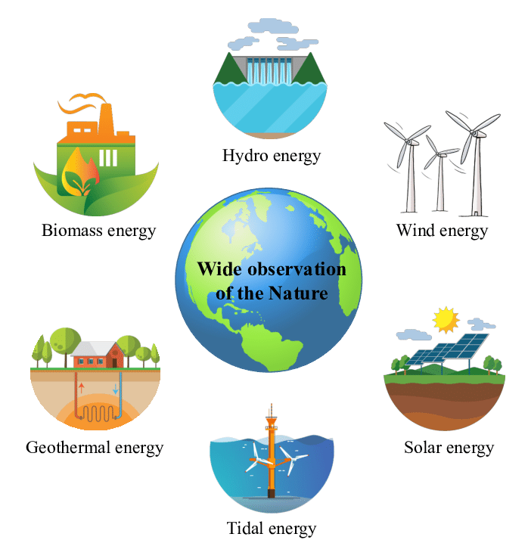  2. coal (n)    3. renewable (a): Can be replaced naturally and can be used without the risk of using it all up  4. run out (phr v): To use up or finish a supply of something  ** Ss say the words.  **** Teacher shows and says the words aloud and asks Ss to repeat them.  * Teacher asks Ss to translate the word into Vietnamese  Concept check: Yes/No questions
Lead-in/ pre-read and listen  - To get students interested in the topic  - To set the context  - To help Ss understand the main idea of the text | Task 1. Read for main ideas: What are Lan and her father talking about?  * Teacher asks Ss to look at the picture (p.107), answer the question:  What are Lan and her father talking about?  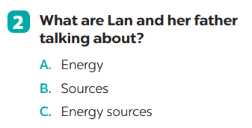  Answer: C
Controlled practice  - To practise reading and listening for specific information  - To practise scanning  - To develop Ss' knowledge of vocabulary | Task 2: Read the conversation again and answer the questions.  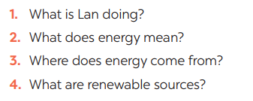  * Teacher asks Ss to work individually to read and listen to the conversation and answer the questions and then share their answers with their partners who sit next to them. (peer check)  ** Ss do exercise 3 individually  *** Ss share and discuss with their partners to write all answer down on the notebooks.  **** Teacher corrects their answers as a class.  Answers  1. Lan is doing a project on energy sources.  2. It’s power that we use to provide us with light, heat or electricity.  3. It comes from many different sources like coal, oil, natural gas, … and renewable sources  4. Renewable sources are those we can easily replace them such as: water, sun,…
- To help Ss gain more knowledge about the topic  - To help Ss practice using what they have learnt in sentences. | Task 3: Match the words / phrases in the box with the correct pictures.  *** Teacher nominates Ss to read the words aloud and  **** Teacher checks and gives the correct answers.  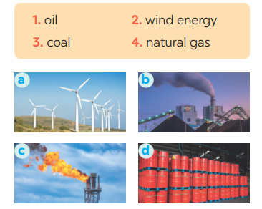  Suggested answers:  1. c 2. a 3. b 4. d  Task 4: Complete each of the sentences with the correct word from the conversation  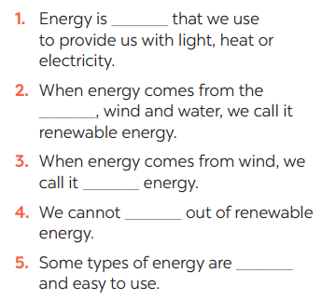  * Teacher asks Ss to work individually to find the words/phrases from the conversation and then share their answers with their partners who sit next to them. (peer check)  ** Ss do exercise 5 individually  **** Teacher corrects their answers as a class.  Answers  1. power  2. sun  3. wind  4. run  5. cheap
Less controlled practice  - To help Ss practising talking about energy  - To practise team working  - To give students authentic practice in using target language | Task 5: Group discussion    * Teacher gives Ss clear instructions in order to make sure Ss know what to do  - ask students to discuss within their groups to answer the questions:  1. What is the best source of energy?  2. Why do you think it is the best one?  + Students discuss with their partners and take notes  - observer Ss while they are talking, note their language errors  ** Ss do as instructed. Then present what they have discussed.  **** Teacher gives Ss feedback.  - choose some useful or excellent words/ phrases/ expressions/ word choices Ss have used to suggest other students use them  - choose some typical errors and correct as a whole class without nominating the students’ names.
Wrap up  To help Ss memorise the target language and skills that they have learned | - Vocabulary of sources of energy  - Talking about energy sources.
Homework  To help Ss practise the target language | Homework:  - Exercises in the workbook

Date of planning:……/……./2023.
Date of teaching:……/……./2023.
UNIT 10: ENERGY SOURCES
Lesson 2: A closer look 1
I. Objectives
By the end of this lesson, Ss will be able to gain:
1. Knowledge
- Vocabulary about sources of energy.
- Pronunciation: Stress in three-syllable words
2. Core competence
- Develop communication skills and cultural awareness
- Be collaborative and supportive in pair work and teamwork
- Actively join in class activities
3. Personal qualities
- Develop awareness of energy sources and energy saving.
II. Materials
- Grade 7 textbook, Unit 10, A closer look 1.
- Computer connected to the internet
- Projector/ TV/ small boards, markers.
- sachmem.vn
Language analysis
Form | Pronunciation | Meaning | Vietnamese equivalent
1. solar energy (n.phr.) | /ˈsōlər ˈenədʒi / | Energy that comes from the sun | năng lượng mặt trời
2. hydro energy (n.phr.) | / ˈhīdrō ˈenədʒi / | Energy that comes from the wind | năng lượng nước
3. nuclear (n) | / njuː.klɪər / | the power produced when the nucleus of an atom is divided or joined to another nucleus | hạt nhân

Assumptions
Anticipated difficulties | Solutions
- Students may not be able to recognise the energy sources and much knowledge about the topic  - Students may not know how to work in teams. | - Give specific examples and ask questions to activate students’ knowledge.  - Give short, clear instructions and help if necessary.

Board Plan
Date of teaching
Unit 10: ENERGY SOURCES
Lesson 2: A closer look 1
* Warm-up: Crossword
I. Vocabulary
1. solar energy (n.phr.) /ˈsōlər ˈenədʒi/: năng lượng mặt trời
2. hydro energy (n.phr.) /ˈhīdrō ˈenədʒi/: năng lượng nước
3. nuclear (n) /njuː.klɪər/: hạt nhân
II. Practice
Task 1: Match the types of energy in A with the energy sources in B
Task 2: Write the phrases to label the pictures
Task 3: Complete the sentences with the words and phrases from 1 or 2.
Task 4: Listen and repeat. Pay attention to the stressed syllables in the words.
Task 5: Listen and repeat, paying attention to the stressed syllables in the underlined words

* Homework

Procedures
Notes
In each activity, each step will be represented as following
* Deliver the task
** Implement the task
*** Discuss
**** Giving comments or feedback

Stage -Stage aim | Procedure
- Warm-up  - To activate students’ knowledge on the topic of the unit  - To enhance students’ skills of cooperating with team mates | CROSSWORDS  * Teacher gives instructions  ** Ss are divided into 2 groups  - Teacher show the crosswords onto the screen with hints/clues and students choose each line and take turn to answer.  - take turns to write until finish all the words or find out the key word.  Answers:  1- Sun  2- cOal  3- oiL  4- renewAble  5- natuRal gas  **** Teacher checks and corrects if Ss pronounce the words incorrectly.
Vocabulary - pre-teach  To help students use key language more appropriately | VOCABULARY  * Teacher introduces the vocabulary by:  + Providing the synonym or antonym of the words.  + Providing the pictures of the words.  + Providing the definition of the words.  1.    2.  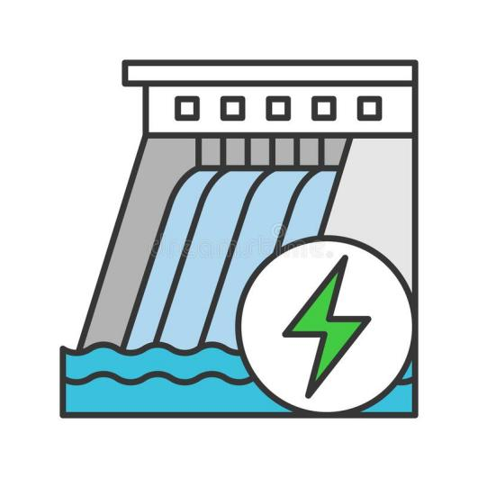  3.    ** Ss say the words.  **** Teacher shows and says the words aloud and asks Ss to repeat them.  * Teacher asks Ss to translate the word into Vietnamese
Lead-in/ pre-read and listen  - To get students interested in the topic  - To set the context  - To help Ss understand the main idea of the text | Task 1. Match the types of energy in A with the energy sources in B  * Teacher asks Ss to look at the table and match the energy with its source.  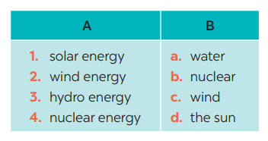  Answers:  1- D 2 – C 3 – A 4 – B  ** Ss work out and answer questions in pairs.  *** Ss share their answers as a whole class.  **** T asks them to to check their answers.  * Teacher asks students to make full sentences to tell about the sources of different energy. Then tell share them to share their sentences with a partner and correct for them.
- Controlled practice To practise identifying the meanings of road signs.  - To develop Ss' knowledge of vocabulary | Task 2: Write the phrases to label the pictures:  * Teacher asks Ss to look at the pictures and use the knowledge from Task 1 to guess the pictures.  Then work and share their answers with their partners who sit next to them. (peer check)  ** Ss do exercise 3 in pairs.  *** Ss share and discuss with their partners to write all words/ phrases down on the notebooks.  **** Teacher corrects their answers as a class.  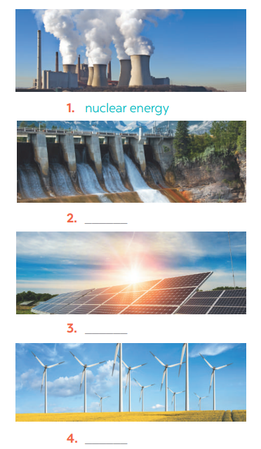  Answers  1. Nuclear energy  2. Hydro energy  3. Solar energy  4. Wind energy
- To help Ss deeply understand how to read the road signs  - To practise the targetted language in life context. | Task 3: Complete the sentences with the words and phrases from 1 or 2.  * Teacher gives students time to do the exercise individually, then share their sentences.  *** Teacher nominates Ss to say the sentences aloud.  **** Teacher checks and gives the corrections if they have mistakes.  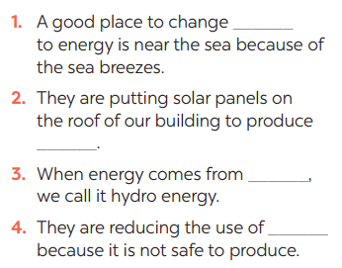  Answers  1. wind  2. solar energy  3. water  4. nuclear
Pronunciations  - To help Ss identify the and classify the sounds  - To give students authentic practice in using pronouncing sounds in common words | Task 4: Listen and repeat. Pay attention to the stressed syllables in the words.  * Teacher gives Ss time to listen and practice pronouncing the words with correct primary stress.  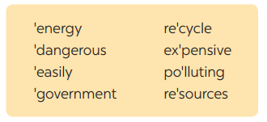  Task 5: Listen and repeat, paying attention to the stressed syllables in the underlined words.  ** Ss do as instructed  **** Teacher gives Ss feedback.  - choose some common mispronounced words and suggest students practise using them.  - choose some typical errors and correct as a whole class  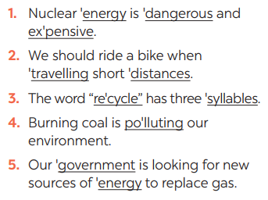
Wrap up  Homework  To help Ss memorise the target language and skills that they have learned | - Vocabulary about sources of energy.  - Pronunciation: Stress in three-syllable words  Homework:  - Exercises in the workbook

Date of planning:……/……./2023.
Date of teaching:……/……./2023.
UNIT 10: ENERGY SOURCES
Lesson 3: A closer look 2
I. Objectives
By the end of this lesson, Ss will be able to gain:
1. Knowledge
Know how to use: THE PRESENT CONTINUOUS

Structure | Examples
1. Affirmative sentences: S + be + Ving | She is playing basketball in the school yard.
2. Negative sentences: S + be not + Ving | They are not using solar energy.
3. Y/N questions: Be + S + Ving? | Are you working on your Project?
4. W questions: W + S + be + Ving? | Where is your brother studying?
2. Core competence
- Develop communication skills and cultural awareness
- Be collaborative and supportive in pair work and teamwork
- Actively join in class activities
3. Personal qualities
- Develop awareness of conserving the energy sources
II. Materials
- Grade 7 textbook, Unit 10, A closer look 2.
- Computer connected to the internet
- Projector/ TV/ pictures.
- sachmem.vn

Assumptions
Anticipated difficulties | Solutions
- Students may not know how to work in teams or fully understand the exercises and tasks. | - Give short, clear instructions and help if necessary.

Board Plan
Unit 10: ENERGY SOURCES
Lesson 3: A closer look 2
* Warm-up: JUMBLE SENTENCES
I. Grammar: THE PRESENT CONTINUOUS
II. Practice
Task 1: Work in pairs. Tell your partner what the people in the pictures are doing
Task 2: Complete the sentences, using the present continuous form of the verbs in brackets.
Task 3: Circle the correct form of the verb in each sentence.
Task 4: Write sentences about what the people are doing or not doing, using the suggestions
Task 5: Work in pairs. Ask and answer the following questions.
* Homework

Procedures
Notes
In each activity, each step will be represented as following
* Deliver the task
** Implement the task
*** Discuss
**** Giving comments or feedback

Stage -Stage aim | Procedure
- Warm-up  - To activate students’ knowledge on the topic of the unit  - To enhance students’ skills of cooperating with team mates | JUMBLE SENTENCES  * Teacher gives instructions  ** Teacher divides the class into 4 groups. Teacher delivers a set of word cards which are jumble sentences in present continuous to each group.  ** Students will have to work in groups to create as many correct sentences from the word cards as possible. The group with more correct sentences will be the winner.  Suggested answers:  1. She is learning English now.  2. They are not using solar energy.  3. Are you working on your Project?  4. Where is your brother studying?  5. She is playing basketball in the school yard.  **** Teacher checks and corrects if Ss make the sentences incorrectly.
Presentation  To introduce students the form of the key grammar and how to use them appropriately | the present continuous  - Teacher says: “This lesson today is going to tell you about “The present continuous”  * Teacher draws students’ attention to the grammar point and the example  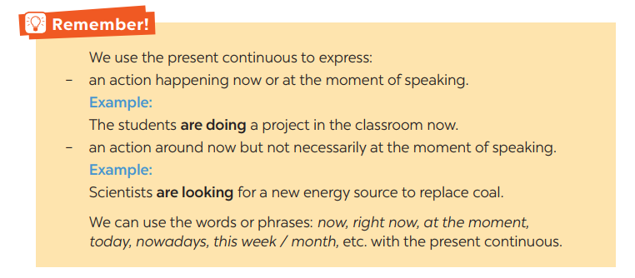  ** Ss read the grammar explicit and study the example.  *** Ss may discuss within groups/pairs before answering.  **** Teacher shows and says the sentences aloud and asks Ss to make similar sentences.
Practice/ Controlled practice  - To get students interested in the topic  - To set the context  - To help Ss understand the main idea of the text | Task 1. Work in pairs. Tell your partner what the people in the pictures are doing  * Teacher asks Ss to look at the pictures and work in pairs. Teacher asks them how would they ask and answer (using Present continuous)  ** Ss work out and answer questions with a partner.  *** Ss share their answers in pairs.  **** T asks them to to check their answers.  * Then tell share them to share their sentences as a whole in class and correct for them.  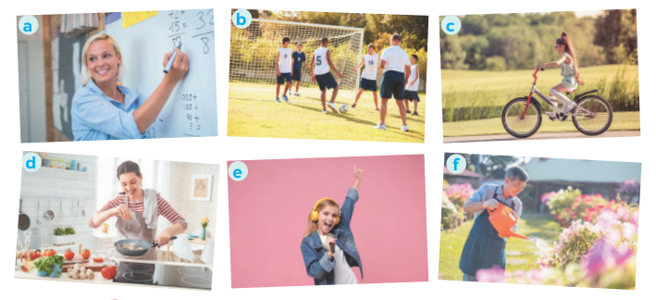  Answers:  a- She is teaching maths/ is writing on the board.  b- They are play football/soccer.  c- She is riding her bike/bicycle.  d- She is cooking.  c- She is singing.  f- He is watering the flowers/plans/is doing gardening.
Controlled practice  - To practise using the present continuous. | Task 2: Complete the sentences, using the present continuous form of the verbs in brackets.  * Teacher asks students to reaf the instructions carefully and do the exercise individually.  ** Ss do exercise then share with their partner.  *** Ss can check and correct for their partner  **** Teacher corrects their answers as a class.  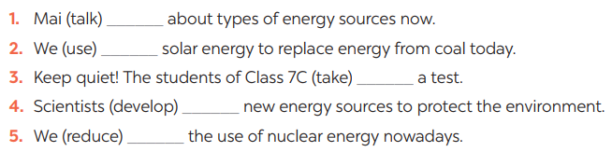Answer:  - is talking  - are using  - are taking  - are developing  - are reducing
- To practise the present continuous  - To practise making sentences using the present continuous  - To practise speaking using the present continuous | Task 3: Circle the correct form of the verb in each sentence  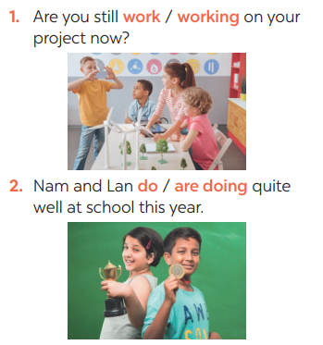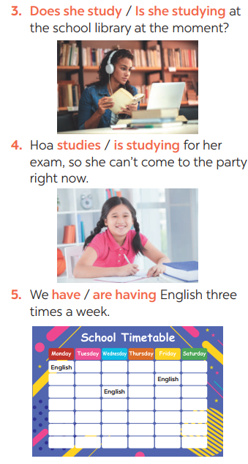*  * Teacher asks students questions to make sure students understand the instructions  *** Teacher nominates Ss to read aloud the correct sentences.  **** Teacher checks and gives the corrections if they have mistakes.  Task 4: Write sentences about what the people are doing or not doing, using the suggestions.  * Teacher gives Ss time to do the exercise individually and peer check with their partner.  *** Teacher nominates Ss to read aloud the sentences. Then asks them to underline the words/phrases that can be found in Present continuous sentences  **** Teacher checks and gives the corrections if they have mistakes.  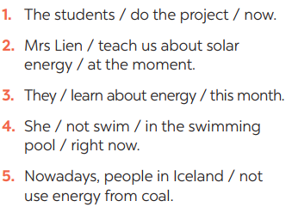  Answers:  1- The students are doing the project now.  2- Mrs. Lien is teaching us about solar energy at the moment.  3- They are learning about energy this month.  4- She isn’t swimming in the swimming pool right now.  5- Nowadays, people in Iceland aren’t using energy from coal.  Task 5: Work in pairs. Ask and answer the following questions.  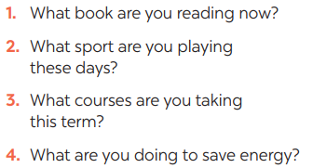  ** Ss work in pairs as instructed. Ss take note while doing the task.  **** Teacher walks around to give instructions and corrections (if nedded).  ***Teacher calls some students to report their partner’s answers using present continuous. Then gives Ss feedback  - choose some common mistakes and suggest students how to avoid them.  - choose some typical errors and correct as a whole class
Wrap up  Homework  To help Ss memorise the target language and skills that they have learned | - The present continuous  Homework:  - Exercises in the workbook

Date of planning:……/……./2023.
Date of teaching:……/……./2023.

UNIT 10: ENERGY SOURCES

Lesson 4: Communication
I. Objectives
By the end of this lesson, students will be able to:
1. Knowledge
- Everyday English: Asking for explanations
- Speaking skill: how well your partner saves energy.
2. Core competence
- Develop communication skills
- Be collaborative and supportive in pair work and team work
- Actively join in class activities
3. Personal qualities
- Be benevolent and responsible
II. Materials
- Grade 7 textbook, Unit 10, Communication
- Computer connected to the internet
- TV/ Pictures/ Projector
- sachmem.vn

Language analysis
Anticipated difficulties | Solutions
1. Students may lack knowledge about the topic. | Provide students with information about the knowledges they do not know.
2. Students may have underdeveloped reading, speaking and co-operating skills. | - Encourage students to work in pairs, in groups so that they can help each other.  - Provide feedback and help if necessary.
3. Some students might excessively talk in the class. | - Define expectation in explicit detail. Have excessive talking students practise.  - Continue to define expectations in small chunks (before every activity).

Board Plan

UNIT 10: ENERGY SOURCES
Lesson 4: Communication
*Warm-up
BRAINSTORMING
I. Everyday English:
Task 1: Listen and read the conversation. Pay attention to the highlighted questions.
Task 2: Work in pairs. Make similar conversations to ask for explanations.
II. Practice: Saving energy
Task 3: Work in pairs. Ask your partner the following questions and tick his or her answers in the boxes.
Task 4: Work in groups. Speech: how well your partner saves energy
Task 5: Answer the questions in 3 on your own. Speech: how well you save energy
* Homework

Procedures
Notes
In each activity, each step will be represented as following
* Deliver the task
** Implement the task
*** Discuss
**** Giving comments or feedback
Stage -Stage aim | Procedure
Warm-up  To introduce the lesson. | Game: BRAINSTORMING  TYPES OF ENERGY  * Teacher divides class into 2 teams and asks them to think of “TYPES OF ENERGY”  ** Ss have 1 min to think of the words related to the topic or they can discuss with their partners.  *** Each member from each team turn by turn run to the board and write one word.  **** Teacher corrects their answers.  - The team which has more correct words will be the winner  Suggested answers:  Solar, hydro, coal, natural gas, oil, wind,…
Lead in  To lead in the lesson. | Teacher leads students into the lesson by telling what they are going to learn: “We are going to learn how to ask and answer for explanations and find out how well we save energy”.
Presentation  To let students know the structure to ask and answer for explanation. | Task 1: Listen and read the conversation. Pay attention to the highlighted questions.  * Teacher plays the record for SS to listen and read the conversation.  ** Ss listen and practice saying with their partners.  *** Teacher calls some pairs to read aloud.  **** Teacher corrects pronunciation if needed.  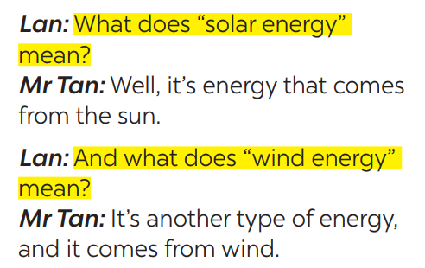  * Teacher asks Ss to pay attention to the highlighted parts and asks them some questions to elicit the new structure:  - Which tense do we use to ask and answer?  - Which question word and verb do we use?  - …..  ** Ss answer teacher’s questions to find out new structure to ask and answer for explanations.  *** Some students give the new structure to the teacher.  **** Teacher corrects and writes on the board:  - Structure:  to ask:  - What do/does + S + mean?  to answer:  - S + mean(s)/be …
Practice  To help students practise  on how to ask and answer for explanations. | Task 2: Work in pairs. Make similar conversations to ask for explanations.  * Teacher has SS look at the phrases in Ex 2 to make similar dialogue.  ** Ss work in pairs to make similar dialogue.  *** Teacher calls some pairs to present it in front of the class.  **** Teacher gives feedback and some comments.  Suggested answers:  A: What does hydro energy mean?  B: It’s energy that comes from the sun. What does nuclear energy mean?  A: It’s energy that comes from the nuclear power.
- Presentation  - To provide students with more awareness of ways to save energy and help them practice the skill of speaking. | Task 3: Work in pairs. Ask your partner the following questions and tick his or her answers in the boxes.  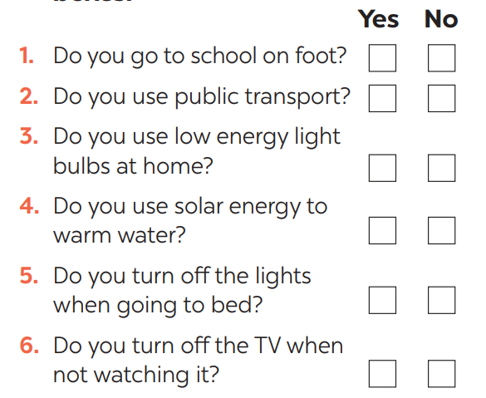  * Teacher asks Ss to work in pairs and tick.  ** Ss so the task in pairs  Task 4: Work in groups. Speech: how well your partner saves energy.  * Teacher gives students time to prepare. Meanwhile, teacher walks around the classroom to help students if they have difficulties find proper words/phrases/structures  *** Teacher calls some Ss to read aloud their work  **** Teacher let Ss listen and correct mistakes (if needed).  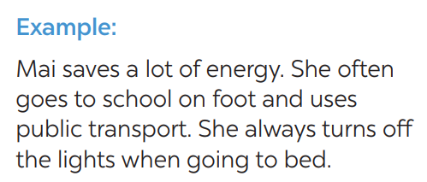
Practice  To help students practicing speaking about saving energy | Task 5: Answer the questions in 3 on your own. Speech: how well you save energy  * Teacher allows students time to answer the questions onto their notebooks and prepare.  ** Ss work individually.  *** Ss can practicing sharing to their partners  **** Teacher calls some students to read aloud their work. Teacher let Ss listen and correct mistakes (if needed).  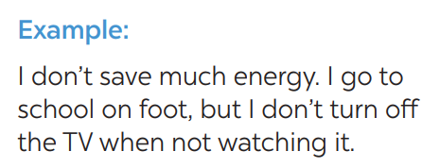
Consolidation  To consolidate what students have learnt in the lesson. | Teacher asks students to talk about what they have learnt in the lesson.
Homework  To prepare for the next lesson:  Skills 1. | Do exercises in the workbook.

Date of planning:……/……./2023.
Date of teaching:……/……./2023.

UNIT 10: ENERGY SOURCES

Lesson 5: Skills 1

I. Objectives
By the end of this lesson, students will be able to gain:
1. Knowledge
+ Reading:
- read for specific information about renewable and non-renewable sources of energy.
+ Speaking:
- talk about advantages and disadvantages of different sources of energy
2. Core competence
- Develop communication skills
- Be collaborative and supportive in pair work and team work
- Actively join in class activities
3. Personal qualities
Be benevolent and responsible
II. Materials
- Grade 7 textbook, Unit 10, Skills 1
- Computer connected to the internet
- TV/ Pictures, cards
- sachmem.vn

Language analysis
Form | Meaning | Pronunciation | Vietnamese equivalent
1. produce (v) | to make things, mostly in large quantity | /prəˈdjuːs/ | sản xuất
2. limited (a) | not very great in amount or extent | /ˈlɪmɪtɪd/ | bị hạn chế
3. available (a) | that you can get, buy or find | /əˈveɪləbl/ | có sẵn

Anticipated difficulties | Solutions
1. Students may lack knowledge about some lexical items. | Provide students with the meaning and pronunciation of words.
2. Students may have underdeveloped reading, speaking and co-operating skills. | - Let students read the text again  (if needed).  - Create a comfortable and encouraging environment for students to speak.  - Encourage students to work in pairs, in groups so that they can help each other.  - Provide feedback and help if necessary.
3. Some students will excessively talk in the class. | - Define expectation in explicit detail.  Have excessive talking students practise.  - Continue to define expectations in small chunks (before every activity).

Board Plan
Unit 10: Energy sources
Lesson 5: Skills 1
* Warm-up
HANGMAN
I. Reading:
1. Vocabulary
- produce (v) /prəˈdjuːs/ sản xuất
- limited (a) /ˈlɪmɪtɪd/ bị hạn chế
- available (a) /əˈveɪləbl/ có sẵn
2. Discussion: Ex 1: Look at the picture. Discuss
a, What are the main energy sources in Viet Nam?
B, What type(s) of energy sources will we use in the future?
3. Practice
Task 1: Read the text and choose the best option to complete the sentences.
Task 2: Read the text again and answer the questions:
II. Speaking:
Task 3: Work in groups. Discuss and put the following words or phrases in the appropriate columns.
Task 4: Work in pairs. Ask and answer questions about the advantages and disadvantages of different energy sources.
Task 5: Presentation
* Homework

Procedures
Notes
In each activity, each step will be represented as following
* Deliver the task
** Implement the task
*** Discuss
**** Giving comments or feedback

Stage -Stage aim | Procedure
Warm-up  To introduce the topic of reading. | Game: Hangman  R E N E W A B L E  * Teacher divides class into 2 teams and asks them to think of the word which has 9 letters in it related the topic “ENERGY SOURCES”.  ** Ss have 1 min to think of the words related to the topic or they can discuss with their partners.  *** Each member from each team turn by turn guesses the letter in the secret word.  **** Teacher corrects their answers.  - The team which can find or guess the secret first will be the winner.
Lead in  To lead in the lesson about Skills 1. | READING  - Teacher leads students into the lesson by telling what they are going to learn: “We are going to read a passage about renewable and non-renewable source of energy.”
Pre-Reading (Pre-teach vocabulary)  To provide students with some lexical items before reading the text  To introduce words related to skin conditions to Ss and help Ss have a general idea of what they are going to read. | Vocabulary  - Teacher introduces the vocabulary by:  + Providing the definition of the words and gives examples  - produce (v) /prəˈdjuːs/ sản xuất  = to make things, mostly in large quantity  Examples: Companies produce many toys for children before Christmas.  - limited (a) /ˈlɪmɪtɪd/ bị hạn chế  = not very great in amount or extent  Examples: coal, oil, …  - available (a) /əˈveɪləbl/ có sẵn  = that you can get, buy or find  Examples: The coal takes a long time to be available again.  Concept check: Rub out and Remember  DISCUSSION  * Teacher asks Ss to work in pairs to look at the Picture in Ex1 and discuss to answer the questions.  ** Ss work in pairs.  *** Teacher calls some Ss to check what they have discussed.  **** Teacher corrects  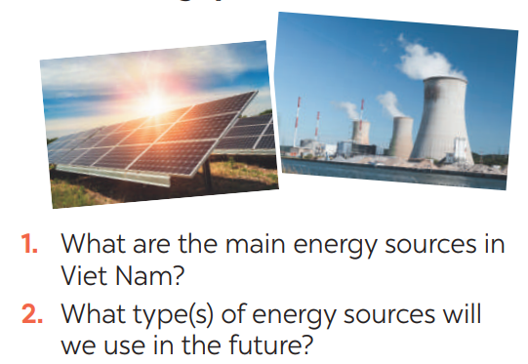  Suggested keys:  1. Coal, oil, hydro,…  2. Wind, solar,…
While-Reading  To help Ss develop their reading skill for details and specific information (skimming and scanning)  To help Ss further develop their reading skill for specific information (scanning). | Task 1: Read the text and choose the best option to complete the sentences.  * Teacher gives Ss time to: read each question, locate where the information appears in the text, read that part carefully and circle the correct answer.  ** Ss do the task independently  *** Teacher tells Ss to compare their answers in pairs before calling some of them to check.  **** Teacher confirms the correct answer and explains if needed.  1. Non-renewable sources are cheap  and ______.  A. available  B. easy to use  C. expensive  2. ______ come from the sun, wind or water.  A. Renewable sources  B. All energy sources  C. Non-renewable sources  3. When energy comes from water,  we call it ______.  A. wind energy  B. solar energy  C. hydro energy  4. Renewable energy sources are better  for ______.  A. the environment  B. our cars  C. hydro energy  Answer key:  1. B 2. A 3. C 3. A  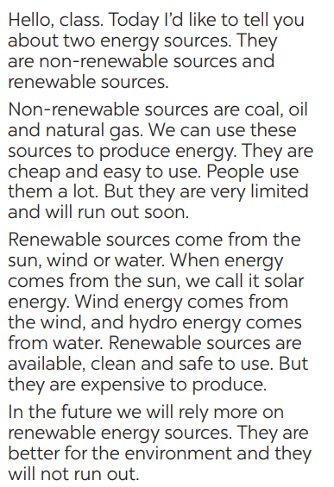  Task 2: Read the text again and answer  the questions  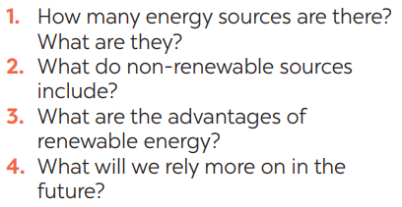  * Teacher asks Ss to do the exercise carefully and individually.  ** Ss do the task independently.  *** Teachers has Ss compare their answers in pairs and call some Ss to give their ideas.  **** Teacher checks and confirms the correct answers.  Answer key:  1. There are two energy sources. They  are non-renewable sources and renewable sources.  2. Non-renewable sources are coal, oil  and natural gas.  3. Renewable sources are available, clean and safe to use.  4. In the future, we will rely more on  renewable energy sources.
Post-Reading  & Pre-Speaking  - To check students’ reading comprehension.  - To help Ss talk about how they apply the rules in the reading to themselves. | Task 3: Work in groups. Discuss and put the following words or phrases in the appropriate columns.  * Teacher asks Ss to work in groups and tells them to focus on the table.  ** Ss work in groups. Teacher goes around and listens and gives help if needed.  *** Teacher calls on some Ss to share their answers with the class. Teacher encourages  **** Teacher listens and corrects if needed  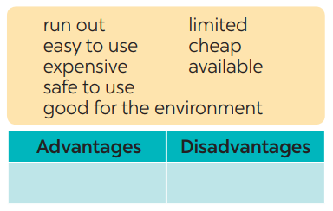  Answer key:  Advantages: easy to use, safe to use, good for environment, cheap, available  Disadvantages: run out, expensive, limited, cheap
While-Speaking  To provide Ss an opportunity to ask and answer questions about the advantages and disadvantages of different types of energy sources. | Task 4: Work in pairs. Ask and answer questions about the advantages and disadvantages of different energy sources  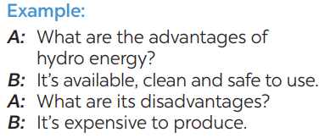  * Teacher has Ss work in pairs and asks them to take turns to ask and answer  ** Ss work in pairs to do the task. Teacher goes around, listens and gives help if needed.  *** Teacher calls on some pairs to share their answers with the class.  **** Teacher comments and correct
Post-Speaking  To help students practice presenting the advantages and disadvantages of different types of energy source | Task 5: Give the advices on dangerous situations on the road.  * Teacher has students work in groups to prepare a presentation (poster/pictures/notes…)  *** Teacher calls on some groups to share their answers with the class.  **** Teacher comments and corrects if needed.
Consolidation  To consolidate what students have learnt in the lesson. | Teacher asks students to talk about what they have learnt in the lesson.
Homework  To prepare for the next lesson Skills 2. | Do exercises in the workbook.

Date of planning:……/……./2023.
Date of teaching:……/……./2023.
UNIT 10: ENERGY SOURCES

Lesson 6: Skills 2

I. Objectives
By the end of this lesson, students will be able to:
1. Knowledge
+ Listening
- use the lexical items related to the topic Energy sources
- listen for main ideas and specific information about the topic how to save energy at home.
+ Writing: Write a paragraph of about 70 words about how you save energy at home.
2. Core competence
- Develop communication skills
- Be collaborative and supportive in pair work and team work
- Actively join in class activities
3. Personal qualities
Be benevolent and responsible
II. Materials
- Grade 7 textbook, Unit 10, Skills 2
- Computer connected to the internet
- Pictures
- sachmem.vn

Anticipated difficulties | Solutions
1. Students may lack knowledge and experiences about the topic. | Prepare some hand-outs.
2. Students may have underdeveloped listening, writing and co-operating skills. | - Play the recording many times if any necessary.  - Encourage students to work in pairs, in groups so that they can help each other.  - Provide feedback and help if necessary.
3. Some students might excessively talk in the class. | - Define expectation in explicit detail.  Have excessive talking students practise.  - Continue to define expectations in small chunks (before every activity).

Board Plan
Unit 10: Energy sources
Lesson 6: Skills 2
* Warm-up: PASS THE CHALK
I. Listening
Task 1: Work in pairs. Answer the questions
Task 2: Listen and circle the phrases you hear
Task 3: Listen again and tick T (True) or F (False) for each sentence
Task 4: Discuss: What is the most effective way to save energy.
II. Writing:
Task 5: Work in pairs. Read some ways to save energy at home. Choose three ways and write them in your notebook.
Task 6: Write a paragraph of about 70 words about how to save energy at home
Peer check and cross check
* Homework

Procedures
Notes
In each activity, each step will be represented as following
* Deliver the task
** Implement the task
*** Discuss
**** Giving comments or feedback

Stage -Stage aim | Procedure
Warm-up  To activate students’ prior knowledge and vocabulary related to the lesson | PASS THE CHALK  * Teacher writes on the board the word “HOW TO SAVE ENERGY” and and divide the class into 2 groups.  ** Ss take turns to go to the board  *** Teacher calls some students to give their answers.  **** Teacher listens and give comments.
Lead in  To introduce the new lesson. | - Teacher introduces students the content of the lesson: “In the lesson today, we are going to listen to a person talking about how to save energy at home.”
Pre-Listening  To help Ss brainstorm the topic and prepare for the listening text.  To help Ss develop their skill of listening for specific information | Task 1: What can you see in this picture? What is special about it?  * Teacher asks Ss to work in pairs to answer the questions in the picture.  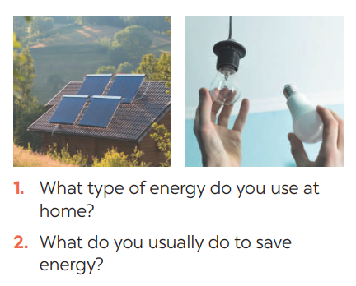  ** Ss work with their partner to do the task.  *** Teacher calls on some Ss to answer.  **** Teacher gives comments and leads Ss to task  Suggested answers:  - solar energy  - turn off the tap while brushing your teeth, use paper fan, …  Task 2: Listen and circle the phrases you hear  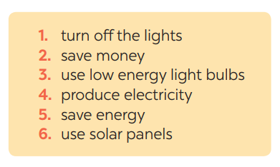  * Teacher asks Ss to read and underline the key words.  ** Ss work independently to guess then listen to the recording once to check their guess.  *** Teacher calls on some students to give the answers the have listened.
While-Listening To help students develop their skill of listening for details. | Task 3: Listen again and tick T (True) or F (False) for each sentence  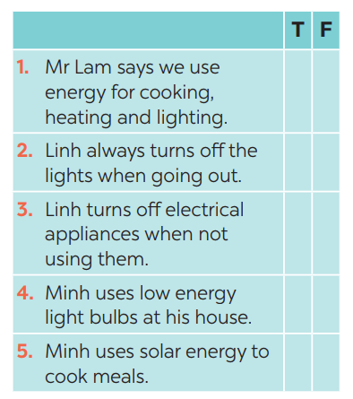  * Teacher asks Ss to read and underline the key words.  ** Ss work independently listen to the recording and tick T or F  *** Teacher calls on some students to give the answers the have listened.  Answer key:  1. 3. 5.  2. 4.
Post-Listening  To help Ss use what they have listened to life context. | Task 4: Discuss: What is the most effective way to save energy?  * Teacher tells Ss to work in groups to discuss and find out “What is the most effective way to save energy”. Write down onto the notebooks in full sentences  E.g. The most effective way to save energy is only read and write in day light  ** Ss work in groups. Teacher moves around and offers help if needed.  *** Teacher invites some Ss to share their answers.  **** Teacher corrects if needed.
Pre-Writing  To help Ss prepare ideas to write a passage. | Task 5: Work in pairs. Read some ways to save energy at home. Choose three ways and write them in your notebook.  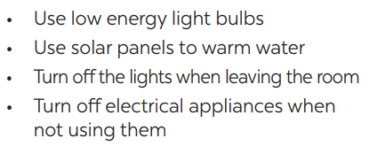  * Teacher asks Ss to write the methods they use to save energy at home then asks them to give out more if they can.  ** Ss think of it and can discuss with their partners.  *** Teacher calls on some Ss to raise their ideas.  **** Teacher listens and confirms.
While-Writing  To help Ss practise writing a passage about  70 words about how you save energy at home | Task 6: Write a paragraph of about 70 words about how you save energy at home.  * Teacher tells Ss that they are going to write a passage about how you save energy at home.  ** Teacher reminds Ss of the structure of a passage and steps to make an outline for the passage.  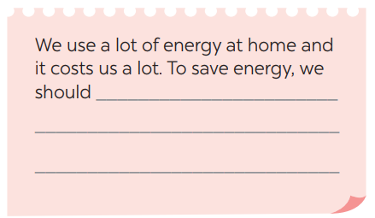  ** Ss work independently to do the task and try to use the notes from the previous tasks.  Teacher goes around and help if necessary.
Post-Writing  To peer check, cross check and final check students’ writing. | Peer check and cross check  *** Teacher asks Ss to share their writing with their partners. Then, call on some Ss to show their writing in front of the class.  **** Teacher checks ideas, grammar, vocabulary and gives comments.  Suggested answers:  We use a lot of energy at home and it costs us a lot. To save energy, we should try making use of natural light more instead of keep the lights unnecessarily in the morning and afternoons. Moreover, we should unplug your electrical gadgets when not in use. These devices consume at least 10% of electricity even when inactive. Therefore, unplug them to save electricity. Most importantly, installing solar panels can help you excessively. They are very economical and help in saving a lot of energy. This can help in getting cheap electricity and protect the environment.
Consolidation  To consolidate what students have learnt in the lesson. | Teacher asks students to talk about what they have learnt in the lesson.
Homework  To allow students finalize their passage after being checked by friends and the teacher. | Rewrite the passage on the notebook.

Date of planning:……/……./2023.
Date of teaching:……/……./2023.
Unit 10: Energy sources

Lesson 7: Looking back & Project

I. Objectives
By the end of this lesson, students will be able to:
1. Knowledge
- review the vocabulary and grammar of Unit 10
- apply what they have learnt (vocabulary and grammar) into practice through a project.
2. Core competence
- Develop communication skills and creativity
- Be collaborative and supportive in pair work and team work
- Actively join in class activities
3. Personal qualities
- Be benevolent and responsible
- Develop self-study skills
II. Materials
- Grade 7 textbook, Unit 10, Looking back & Project
- Computer connected to the internet
- TV/ Pictures, A0 cards and colours
- sachmem.vn
Anticipated difficulties | Solutions
1. Students may have underdeveloped speaking, writing and co-operating skills when doing project. | - Encourage students to work in pairs, in groups so that they can help each other.  - Provide feedback and help if necessary.
2. Some students might excessively talk in the class. | - Define expectation in explicit detail.  Have excessive talking students practise.  - Continue to define expectations in small chunks (before every activity).

Board Plan
Date of teaching
Unit 10: Energy sources
Lesson 7: Looking back & Project

* Warm-up
QUICK REVISION CHECK
I. Looking back
Task 1: Match the adjectives in A with the nouns in B to make phrases
Task 2: Complete the sentences, using the phrases in 1
Task 3: Complete the sentences by using the correct form of the present continuous or present simple of the verbs in brackets.
Task 4: Find ONE mistake in each sentence and correct it
II. Project
Saving energy at school
Task 5: Discussion: Which tips can be applied in your school.
Task 6: Poster presentation: How to save energy in your school
* Homework

Procedures
Notes
In each activity, each step will be represented as following
* Deliver the task
** Implement the task
*** Discuss
**** Giving comments or feedback

Stage -Stage aim | Procedure
Warm-up  To help students revise the vocabulary items they have learnt in the unit.  To enhance students’ skills of cooperating with team mates. | Quick revision check  * Teacher asks Ss to think of what they have learnt already in Unit 10.  ** Ss work in pairs to do the task.  ***Teacher calls some students to retell.  **** Teacher confirms and leads them to do all the exercises in books.
Looking back  To help Ss revise the vocabulary items (verbs) they have learnt in the unit.  To help Ss revise the vocabulary items (adjectives) they have learnt in the unit  To help Ss revise grammar points.  To help Ss revise the grammar points of the unit | Task 1: Match the adjectives in A with the nouns in B to make phrases  * Teacher has Ss work individually.  ** Ss do this activity individually, then compare their answers with their partners.  *** Teacher asks for Ss’ answers. **** Teacher confirms the correct ones and asks students to make sentences using the phrases.  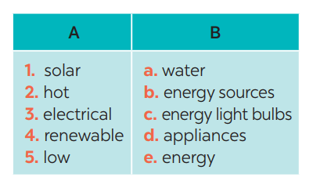  Answer keys:  1. e 2. a  3. d 4. b 5. c  Task 2: Complete the sentences, using the phrases in 1  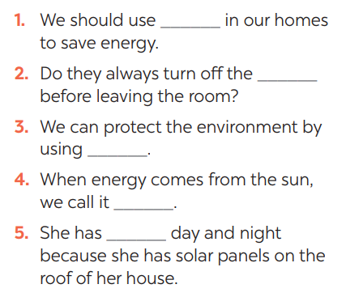  * Teacher has Ss work individually.  ** Ss do this activity then compare their answers with their partners.  *** Teacher asks for Ss’ answers. **** Teacher confirms the correct ones  Answer keys:  1. low energy light bulbs  2. electrical applicances  3. renewable energy sources  4. solar energy  5. hot water  Task 3: Complete the sentences by using the correct form of the present continuous or present simple of the verbs in brackets.  * Teacher asks Ss to recall the structures of “The present continuous”, and tell them to do Ex 3 in the book.  ** Ss do the exercise individually and swap with their partners.  *** Teacher calls some Ss to check their answer.  **** Teacher confirms the correct answer.  1. Look! It (rain) ______ heavily.  2. Normally they (start) ______ school at eight o’clock in the morning.  3. He hasn’t got a bike at the moment, so he (walk) ______ to school this week.  4. He always (do) ______ his homework in the evening.  5. I’m afraid I have no time to help just now. I (write) ______ an essay  Answer keys:  1- is raining  2- start  3- is walking  4- does  5- am writing  Task 4: Find ONE mistake in each sentence and correct it  * Teacher asks Ss to do the task.  ** Ss work individually to do the task.  *** Teacher calls Ss to give out their answers.  **** Teacher checks and confirms their answer.  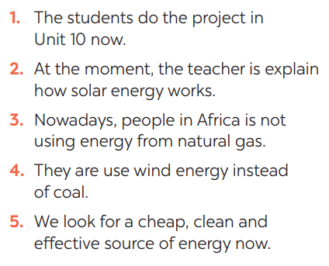  Answer keys:  1. do -> are doing  2. explain -> explaining  3. is -> are  4. use -> using  5. look -> are looking
Project  To help Ss develop team work skills and pratice using what they have learnt to make a poster | Task 5: Discussion: Which tips can be applied in your school.  * Teacher asks Ss to dicuss in groups of 4-6  * Teacher also has Ss spend some time to make their brainstorm, narrow down the ideas, make a poster out of these ideas and practise presenting within their groups.  ** Ss discuss with their group memebers.  *** Some students raise their ideas and explain their answers among groups  **** Teacher listens, correct (if needed) and confirms.  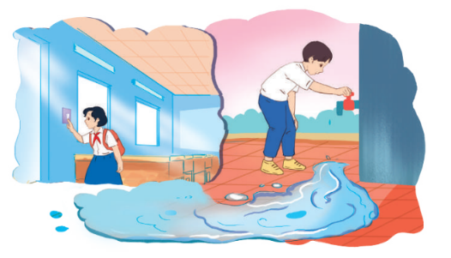  Task 6: : Poster presentation: How to save energy in your school  * Teacher asks Ss to work in groups of 4 – 6 to stick their posters onto the classroom’s wall and present about them.  ** Ss work in group to do the task.  *** Teacher calls some groups to present their poster to the class  **** Teacher confirms and corrects.
Consolidation  To consolidate what students have learnt in the lesson. | Teacher asks students to talk about what they have learnt in the lesson.
Homework  To prepare for the next lesson. | Prepare for the next lesson: Unit 11 – Getting started.

Date of planning:……/……./2023.
Date of teaching:……/……./2023.
UNIT 11: TRAVELLING IN THE FUTURE

Lesson 1: Getting started – I hope we will have a hyperloop soon!

I. Objectives
By the end of this lesson, students will be able to gain:
1. Knowledge
- An overview about the topic TRAVELLING IN THE FUTURE.
- Vocabulary to talk about future means of transport.
2. Core competence
- Develop communication skills and creativity
- Be collaborative and supportive in pair work and team work
- Actively join in class activities
3. Personal qualities
- Develop self-study skills
II. Materials
Grade 7 textbook, Unit 11, Getting started
Pictures, maps and CD player
sachmem.vn
Language analysis
Form | Meaning | Pronunciation | Vietnamese equivalent
1. eco – friendly (a) | Eco-friendly products have been designed to do the least possible damage to the environment | /ˈiː.kəʊˌfrend.li/ | thân thiện với môi trường
2. fume (n) | strong, unpleasant, and sometimes dangerous gas or smoke | /fjuːm/ | khói
3. hyperloop (n) | an extremely high-speed transportation system in which trains glide above a track inside a sealed tube or tunnel with very low air pressure, supported by magnetic repulsion and propelled by a linear motor | /ˈhaɪ.pərluːp/ | hệ thống giao thông tốc độ cao
4. teleporter (n) | an imaginary very fast form of transport that uses special technology or special mental powers | /ˈtel.ɪ.pɔː.tər/ | phương tiện di chuyển tức thời
5. campsite (n) | a piece of land where people on holiday can camp, usually with toilets and places for washing | /ˈkæmp.saɪt/ | địa điểm cắm trại

Anticipated difficulties | Solutions
1. Students may lack knowledge and experiences about the topic. Prepare some handouts. | Encourage students to work in pairs, in groups so that they can help each other.
2. Students may have underdeveloped listening, speaking and co-operating skills. Play the recording again if necessary. | Provide feedback and help if necessary.

Board Plan
UNIT 11: Travelling in the future
Lesson 1: Getting started – I hope we will have a hyperloop soon!
* Warm-up
Chitchatting
I. Vocabulary
1. eco – friendly (a) /ˈiː.kəʊˌfrend.li/: thân thiện với môi trường
2. fume (n) /fjuːm/: khói
3. hyperloop (n) /ˈhaɪ.pərluːp/: hệ thống giao thông tốc độ cao
4. teleporter (n) /ˈtel.ɪ.pɔː.tər/: phương tiện di chuyển tức thời
5. campsite (n) /ˈkæmp.saɪt/: địa điểm cắm trại
II. Practice
Task 1: Listen and read. What are Ann and Minh talking about? (Ex 1, 2, p. 114, 115)
Task 2: Read the conversation again and tick T (True) or F (False). (Ex 3, p. 115)
Task 3: Find the words and phrases that describe the means of transport in the conversation and write them in the correct columns. (Ex 4, p. 115)
Task 4: Quiz (Ex 5, p. 115)
* Homework

Procedures
Notes
In each activity, each step will be represented as following
* Deliver the task
** Implement the task
*** Discuss
**** Giving comments or feedback

Stage -Stage aim | Procedure
Warm-up  To set the context for the listening and reading text.  To introduce the topic of the unit. | Chitchatting:  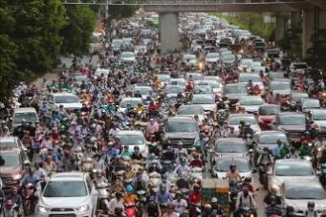  + How do you people travel every day?  + What do you think about the traffic in the picture?  + How about traffic in the future?  * Teacher has Ss to look at the picture and talk about it by answering these questions.  ** Ss work in pairs to do the task.  *** Teacher calls on some Ss to give their ideas about it.  **** Teacher listens, comments, then leads Ss to the new lesson.  Teacher says: “In the lesson today we are going to learn a new unit about “Travelling in the future”. Let’s start to see and find out more information related to our new topic”.
Presentation  (Vocab-  pre-teach)  To introduce the new words.  To set the context for the introductory conversation; | Vocabulary:  * Teacher introduces the vocabulary by:  + showing the pictures illustrating the words  + providing the synonym or antonym of the words  + providing the definition of the words  1. eco – friendly (a): [visual + explanation]  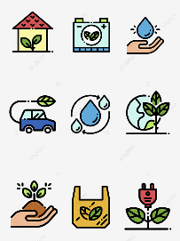  2. fume (n): [visual + explanation]    3. hyperloop (n): [visual + explanation]    4. teleporter (n): [visual + explanation]  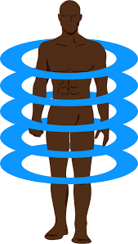  5. campsite (n): [visual + explanation]    ** Ss say the words.  *** Other Ss correct if the previous answers are incorrect.  **** Teacher shows and says the words aloud and asks Ss to repeat them.  Checking techniques: Rub out and Remember  GETTING STARTED  I HOPE WE WILL HAVE A HYPERLOOP SOON!  SET THE SCENE: PRE- QUESTIONS  * Teacher draws students’ attention to the pictures in the textbook and asks them some questions about the pictures. Teacher don’t confirm whether theirs are right or wrong.  + Who are they?  + Where are they?  + Where are they going?  + What can you see outside the coach?  + What can you see in the bubble?  + What could they be talking about?  Suggested answers:  + They are Minh and Ann.  + They are on a coach.  + They are going to the campsite.  + Outside the coach, we can see the crowded street. There is a traffic jam.  + In the bubble, there is a system of tubes. Minh is thinking about a means of transport.  ** Ss work out and answer questions in pairs.  *** Ss share their answers as a whole class.  **** T asks them to read and listen to the conversation to check their answers.
Practice  To practice the targeted language and the background knowledge  To help Ss read for specific information about Ann and Minh’s conversation.  – To help Ss recognize the words / phrases used to describe means of transport; – To help Ss further understand the text. | Task 1: Listen and read. What are Ann and Minh talking about?  (Ex 1, 2, p. 114, 115)  * Teacher plays the recording, asks students to underline the words related to the topic. (Teacher may check the meaning of some words if necessary.)  Teacher can play the recording more than once.  Students listen and read.  ** Teacher can invite some pairs of students to read aloud.  *** Teacher refers to the questions previously asked.  **** Then, teacher confirms the correct answer: “Ann and Minh are talking about future modes of travel.  Answer key: 2B  Task 2: Read the conversation again and tick T (True) or F (False). (Ex 3, p. 115)  * Teacher asks Ss to work in pairs to read the conversation again and underline the key words in each sentence.  ** Ss work in pairs to do the task.  *** Ss answer and point out where in the conversation they find the information for their answers.  **** Teacher checks the answers as a class.  Answer keys:  1. T 2. F 3. F 4. T 5. T  Task 3: Find the words and phrases that describe the means of transport in the conversation and write them in the correct columns. (Ex 4, p. 115)  * Teacher asks Ss to work in pairs to read the conversation again and to underline the words / phrases that describe means of transport: hyperloop and teleporter.  ** Ss work in pairs to pick out words / phrases they have found to write down in the correct column.  *** Teacher asks some Ss to read out words / phrases they have found in the conversation to put into each column.  **** Teacher checks the answers as a class  Answer keys:
Production  – To help Ss review vocabulary related to different means of transport;  – To give Ss a chance to develop creative thinking; | Task 4: Quiz (Ex 5, p. 115)  * Teacher asks Ss to work in pairs to discuss to find out the vehicles in these sentences.  ** Ss work in pairs to do the task  *** Teacher reads out loud each question and the pairs answer. The pair who correctly completes its first wins  **** Teacher confirms the answers.  Answer keys:  1. bicycle / bike  2. car  3. train  4. sailing boat  5. rocket / spaceship  * Then, teacher has Ss work in pairs again to discuss how the vehicles they have thought of will be like in 50 years.  ** Ss work in pairs to do the task.  *** Teacher calls SS give any description about future means of transport they can imagine.  **** Teacher corrects grammar or pronunciation mistakes if needed.
Consolidation  To consolidate what students have learnt in the lesson. | Ask one or two students to tell the class what they have learnt.  Ask students to say aloud some words they remember from the lesson. If there is an overhead projector in the classroom, show the dialogue, highlight the key words related to the topic.
Homework  To prepare vocabulary for the next lesson. | - Do Ex in WB

Date of planning:……/……./2023.
Date of teaching:……/……./2023.
UNIT 11: TRAVELLING IN THE FUTURE

Lesson 2: A closer look 1

I. Objectives
By the end of this lesson, students will be able to:
1. Knowledge
- Vocabulary:
+ use the lexical items related to the topic Travelling in the future.
Pronunciation: say sentences with correct stress
2. Core competence
- Develop communication skills .
- Be collaborative and supportive in pair work and teamwork.
- Actively join in class activities.
3. Personal qualities
- Be ready to know the words about future means of transport.
- Develop self-study skills.
II. Materials
Grade 7 textbook, Unit 11, A closer look 1
Computer connected to the internet
TV/ Projector/ Pictures/ Cards
sachmem.vn
Language analysis
Form | Meaning | Pronunciation | Vietnamese equivalent
1. bamboo - copter (n) | also known as the bamboo dragonfly or Chinese top, is a toy helicopter rotor that flies up when its shaft is rapidly spun. | /bæmˈbuːˈkɒp.tər/ | chong chóng tre
2. skyTran (n) | skyTran is a patented, high-speed, low-cost, elevated Personal Rapid Transit (PRT) system. | /skaɪtræn/ | hệ thống tàu điện trên không
3. solar- powered (a) | electricity produced by using the energy from the sun | /ˌsəʊ.lə -ˈpaʊər/ | chạy bằng năng lượng mặt trời
4. (to) sail | o control a boat that has no engine and is pushed by the wind: | /seɪl/ | lướt buồm

Anticipated difficulties | Solutions
1. Students may lack knowledge about some lexical items. | Provide students with the meaning and pronunciation of some lexical items.
2. Students may have underdeveloped listening, speaking and co-operating skills. | Play the recording many times if necessary.  Encourage students to work in pairs, in groups so that they can help each other.  Provide feedback and help if necessary.
3. Some students might excessively talk in the class. | Define expectation in explicit detail.  Have excessive talking student’s practice.  Continue to define expectations in small chunks (before every activity).

Board Plan
Unit 11: Travelling in the future
Lesson 2: A closer look 1
* Warm-up
Game: Miming
I. Vocabulary: Future means of transport
1. bamboo - copter (n) /bæmˈbuːˈkɒp.tər/: chong chóng tre
2. skyTran (n) /skaɪtræn/: hệ thống tàu điện trên không
3. solar- powered (a) /ˌsəʊ.lə -ˈpaʊər/: chạy bằng năng lượng mặt trời
4. (to) sail/seɪl/: lướt buồm
Task 1: Write the words or phrases under the correct pictures. Then listen, check, and repeat. (Ex. 1, p. 116)
Task 2: Write words or phrases from 1 in the correct columns. (Ex 2, p. 116)
Task 3: Complete the sentences, using the words from the box. (Ex 3, p. 116)
II. Pronunciation: Sentence stress
Task 4: Listen to the sentences and repeat. Pay attention to the bold syllables. (Ex 4, p. 116)
III. Production:
Task 5: Listen to the sentences and repeat. How many stresses are there in each sentence? (Ex 5, p.116)

* Homework

Procedures
Notes
In each activity, each step will be represented as following
* Deliver the task
** Implement the task
*** Discuss
**** Giving comments or feedback

Stage - Stage aim | Procedure
Warm-up  To help Ss review the previous lesson.  – To create a fun atmosphere in the class. | Game: Miming  * Teacher calls 1 student come to the board and whispers into Ss’ ears one means of transport.  ** Ss think of how to mine it, and the others are ready to guess  *** Ss mine the action for the others to guess the means of transport.  **** Teacher confirms the correct answer. The student who guesses correctly is the winner.  Suggested answers:  1. hyperloop  2. flying car  3. train  4. bike  5. motorbike  6. boat
Lead in  To lead in the lesson about vocabulary and pronunciation. | Teacher leads students into the lesson by telling them that “In today lesson, we are going to learn more words to talk about Future means of transport and how to say sentences with correct stress.”
Presentation  (Vocab-  pre-teach)  To introduce visually some words related to the topic | VOCABULARY  * Teacher introduces the vocabulary by:  + providing the synonym or antonym of the words  + providing the pictures of the words  - Teacher have students read the phrases aloud and correct their pronunciation if needed.  - Teacher asks students for the Vietnamese meanings of these phrases.  1. bamboo - copter (n): [visual + explanation]    2. skyTran (n): [visual + explanation]    3. solar - powered (a): [visual + explanation]  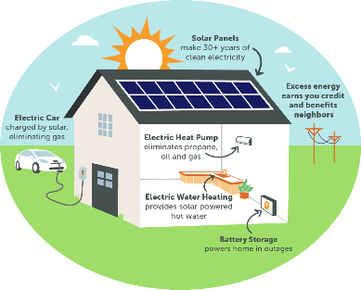  4. (to) sail: [visual + explanation]    ** Ss say the words.  *** Other Ss correct if the previous answers are incorrect.  **** Teacher shows and says the words aloud and asks Ss to repeat them  Checking techniques:  “Rub out and remember”
Practice/ Controlled practice  To introduce some modes of future travel.  To help Ss learn to use the right verbs for the appropriate mode of travel.  To help Ss practise using the learnt words in the right context. | Task 1: Write the words or phrases under the correct pictures. Then listen, check, and repeat. (Ex. 1, p. 116)  * Teacher asks students to choose the words and phrases in the box to write under the correct pictures with their partners.  ** Ss work in pairs to do the task.  *** Teacher calls on some students to read aloud the words and asks them why they think a word / phrase should go with a picture  **** Teacher plays the recording for Ss to check their answers, has them to repeat chorally and individually, corrects their pronunciation and explain the meaning of these words/ phrases if needed.  Answer keys:  1. solar-powered ship  2. flying car  3. bamboo-copter  4. hyperloop  5. skyTran  Task 2: Write words or phrases from 1 in the correct columns. (Ex 2, p. 116)  * Teacher asks students to look at Ex 2 to write words and phrases in 1 in the correct columns  ** Ss work independently to do the task.  *** Some Ss give their answers.  **** Teacher checks students ‘answers as a class.  Answer keys:  * Then, teacher asks Ss work in pair to add more words to each column.  ** Ss work in pairs to di the task.  *** Teacher calls on some Ss to give their answers.  **** Teacher confirms and corrects.  Suggested answers:  Task 3: Complete the sentences, using the words from the box. (Ex 3, p. 116)  * Teacher has Ss look at the box, practice saying the words, then work individually to complete the sentence.  ** Ss work individually to do the task.  *** Some Ss read aloud the complete sentences  **** Teacher confirms the correct answers.  Answer keys:  1. bamboo-copter  2. fly  3. ride  4. hyperloop  5. eco-friendly
Presentation  (Pre-teach the SENTENCE STRESS  To help Ss be aware of which words in a sentence should be stressed, which are not;  – To help Ss say sentences with correct stress | PRONUNCIATION  SENTENCE STRESS  * Teacher writes the words “Sentence stress” on the board and asks them “What is sentence stress?”. Then, teacher has Ss watch the video to understand more about it.  https://www.youtube.com/watch?v=d2SF3DHXeC8&t=228s  ** Ss work independently to do the task.  *** Teacher calls some Ss to check their understanding.  **** Teacher confirms, then asks them to read “Remember” in 1 minute.  + What are stressed words?  + What are unstressed words?
Practice/ Controlled practice  To help students practise pronouncing sentences with correct stress. | Task 4: Listen to the sentences and repeat. Pay attention to the bold syllables. (Ex 4, p. 116)  * Teacher has students read the sentences and underline the stressed words. Then, ask them to listen to the recording once first and pay attention to the stressed syllables.  ** SS do the task independently, try to listen and repeat sentences as many times as possible as a class, a group and individually  *** Teacher calls some students to read out the sentences.  **** Teacher corrects their pronunciation and stress if needed.  Suggested answers:
Production/ Less controlled practice To help Ss be aware of the words they have to stress in a sentence  – To help Ss practise saying sentences with correct stress | Task 5: Listen to the sentences and repeat. How many stresses are there in each sentence? (Ex 5, p.116)  * Teacher plays the recording for Ss to listen and repeat; then ask Ss to count the number of stresses in each sentence.  ** Ss do the task individually.  *** Teacher calls on some Ss to read the sentences in front of the class.  **** Teacher corrects their pronunciation if needed.  Suggested answers:
Consolidation  To consolidate what students have learnt in the lesson. | Teacher asks students to talk about what they have learnt in the lesson.
Wrap up  Homework  To revise what they have learnt. | Practice saying the sentences at home.

Date of planning:……/……./2023.
Date of teaching:……/……./2023.
UNIT 11: TRAVELLING IN THE FUTURE

Lesson 3: A closer look 2

The future simple: Will + Possessive pronouns
I. Objectives
By the end of this lesson, students will be able to:
1. Knowledge
know how to recognize “The future simple: Will”
a. We use will + V:
+ to talk about future activities
Eg: We will buy an electric scooter soon.
+ to make predictions
Eg: We will probably use electric cars because normal cars cause too much pollution.
b. Possessive pronouns
+ to demonstrate ownership
Eg: This is our house. It’s ours.
2. Core competence
- Develop communication skills
- Be collaborative and supportive in pair work and team work
- Actively join in class activities
3. Personal qualities
Be responsible and hard working
II. Materials
Grade 7 textbook, Unit 11, A closer look 2
Computer connected to the internet
TV/ Projector/Pictures, sets of word cards
sachmem.vn

Anticipated difficulties | Solutions
1. Students may lack knowledge and experiences about the topic. | Prepare some hand-outs.
2. Some students might excessively talk in the class. | Define expectation in explicit detail.  Have excessive talking student’s practice.  Continue to define expectations in small chunks (before every activity).

Board Plan
Unit 11: Travelling in the Future
Lesson 3: A closer look 2
* Warm-up
CHATTING
I. Grammar 1: The future simple
+ to talk about future activities
Eg: We will buy an electric scooter soon.
+ to make predictions
Eg: We will probably use electric cars because normal cars cause too much pollution.
Task 1: Complete the sentences with will or won’t. (Ex 1, p. 117)
Task 2: Rearrange the words and phrases to make sentences. (Ex 2, p. 117)
Task 3: Use the correct form of the verbs in brackets to complete the conversation. (Ex 3, p. 117)
II. Grammar 2: Possessive pronouns.
+ to demonstrate ownership
Eg: THIS IS YOUR BICYCLE. THAT BICYCLE IS HER BICYCLE. → HERS
Task 4: Replace the underlined phrases with possessive pronouns. (Ex 5, p. 118)
III. Production
Task 5: Look at the pictures and tell your partner if you will / won’t travel by these means of transport. Give reason(s). (Ex 4, p. 118)
* Homework

Procedures
Notes
In each activity, each step will be represented as following
* Deliver the task
** Implement the task
*** Discuss
**** Giving comments or feedback

Stage - Stage aim | Procedure
Warm-up  To activate students’ prior knowledge and vocabulary related to the targeted grammar | GAME: CHATTING  * Teacher asks Ss some questions to lead into the lesson.  + How does your father go to work every day?  + What color is it?  + How will you travel when you are 30?  ** Ss work in dependently to do the task.  *** Teacher calls on some Ss to answer.  **** Teacher confirms and write some key sentences on the board.  Mine is white  I will….
Lead in  To introduce the targeted grammar of the lesson. | Teacher says: “Today, we are going to learn how to use Will in the future and possessive pronouns.”
Presentation  To introduce students the form and the usage of the future simple. | GRAMMAR 1: THE FUTURE SIMPLE  * Teacher has Ss read “Remember box” in some minutes.  ** Ss work independently to read.  *** Teacher calls on some Ss to answer teacher’s questions to make sure they can understand how to use and form The Future Simple well.  + “Do we use The Future Simple to talk about past, present or future activities?”  + Teacher writes on the board: “People will go to school by solo wheel in 2030” and asks Ss: “In this situation, what do we use the future tense for?”  + “To make a negative form, do we say will not or not will?” (Just add NOT behind Will)  + “For questions, where we can put Will?” (Before subjects)  **** Teacher confirms, and corrects grammar if needed, then write on the board:  + Usage: to talk about future activities and to make predictions.  + Form: (+) S + will + V  (-) S + will + not (won’t)  (?) Will + S + V?  GRAMMAR 2: POSSESSIVE PRONOUNS (review)  * Teacher writes on the board an example then asks Ss some questions to remind them.  This is your bicycle.  That bicycle is her bicycle. → hers  + Do we use a possessive pronoun instead of a phrase? (hers = her bicycle)  + Does a possessive pronoun come before a noun?  + Let’s complete this table:  Personal pronouns Possessive adjectives Possessive pronouns  I my mine  You your yours  We our ours  They their theirs  He his his  She her hers  It its its  +** Ss work individually to answer teacher’s questions  *** Teacher calls on some Ss to give their ideas.  **** Teacher confirms and corrects.
Practice/ Controlled practice To help Ss use the right verb form to talk about future activities.  To help Ss practice making full sentences about future activities using prompts.  To help Ss use the correct forms of future simple to make predictions.  To review possessive pronouns. | Task 1: Complete the sentences with will or won’t. (Ex 1, p. 117)  * Teacher asks students to do the exercise individually and then compare their answers with a classmate.  ** Ss do the task individually.  *** Some Ss explain their choices.  ****Teacher confirms the correct answers.  Answer key:  1. won’t  2. will  3. will  4. won’t  5. Will  Task 2: Rearrange the words and phrases to make sentences. (Ex 2, p. 117)  * Teacher has students work individually to rearrange the words to make sentences.  ** Ss do the task individually.  *** Some Ss write their answer on the board.  ****Teacher confirms the correct answers.  Answer key:  1. We will have driverless cars in 2030.  2. Cities won’t allow cars in 2050.  3. Will electric cars be popular?  4. We will use solar-powered buses soon.  5. Will we have enough parking places in ten years?  Task 3: Use the correct form of the verbs in brackets to complete the conversation. (Ex 3, p. 117)  * Teacher asks Ss to work in pairs to complete the conversation.  ** Ss work in pairs to do the task.  *** Teacher calls on Ss to read aloud the complete conversation.  **** Teacher confirms the correct answers helps them to correct mistakes if needed.  Suggested answers:  1. will take  2. won’t have  3. Will ... have  4. won’t drive  5. won’t be  Task 4: Replace the underlined phrases with possessive pronouns. (Ex 5, p. 118)  * Teacher asks Ss to do the task individually to replace the underlined phrases with the correct possessive pronouns.  ** Ss do the task individually and compare with their partners.  *** Some Ss read aloud their answers on the board.  **** Teacher confirms the correct answers.  Suggested answers:  1. theirs  2. mine  3. His  4. Yours  5. Ours
Production/ Less controlled practice To help Ss practice talking about some future means of transport  – To help Ss learn reasoning skills by giving reasons for their choice. | Task 5: Look at the pictures and tell your partner if you will / won’t travel by these means of transport. Give reason(s). (Ex 4, p. 118)  * Teacher asks Ss to work in pairs to describe the picture.  ** SS work with their partners to do the task.  ***Some pairs talk about their choices and reasons why they will / won’t use those means of  travelling.  **** Teacher listens to Ss to correct common errors after Ss finish speaking.  Suggested answers:  - In picture 1, I can see a / an (electric) bus / coach. I can see many people on this bus / coach. I think I will go  to school by electric coach because it has no fumes, and it can carry many people at the same time.  - In picture 2, I can see a flying car. It is flying over a city. I think I will travel by flying car. It will be fun to fly in  one. I will be able to see the city below (or I can fly it when the roads are congested).  - In picture 3, I can see a ship. It has solar panels. I will travel on a solar-powered ship to visit some islands.  It will be comfortable / fun to travel by solar-powered ship.  - In picture 4, I can see a bamboo-copter. I will fly a bamboo-copter to work. It will be fun / fast. (or I won’t use a bamboo-copter to travel from one place to another. It will be dangerous. You might get hurt when it  is windy …).  - In picture 5, I can see a car with a lot of smoke behind it. I won’t go by car in the future. It pollutes the  environment.
Consolidation  To consolidate what students have learnt in the lesson. | Teacher asks students to talk about what they have learnt in the lesson.
Wrap up  Homework  To revise what they have learnt. | Do exercises in the workbook.

Date of planning:……/……./2023.
Date of teaching:……/……./2023.
UNIT 11: TRAVELLING IN THE FUTURE

Lesson 4: Communication

I. Objectives
By the end of this lesson, students will be able to:
1. Knowledge
- learn how to how to make predictions.
- practice using some grammar points and vocabulary related to the topic.
2. Core competence
- Develop communication skills
- Be collaborative and supportive in pair work and team work
- Actively join in class activities
3. Personal qualities
- Be benevolent and responsible
II. Materials
Grade 7 textbook, Unit 11, Communication
Computer connected to the internet
TV/ Pictures/ Projector
sachmem.vn
Language analysis
Anticipated difficulties | Solutions
1. Students may lack knowledge about the topic. | Provide students with information about the knowledges they do not know.
2. Students may have underdeveloped reading, speaking and co-operating skills. | Encourage students to work in pairs, in groups so that they can help each other.  Provide feedback and help if necessary.
3. Some students might excessively talk in the class. | Define expectation in explicit detail. Have excessive talking students practice.  Continue to define expectations in small chunks (before every activity).

Board Plan
Unit 11: Travelling in the future
Lesson 4: Communication
*Warm-up
Chatting
I. Everyday English:
Making predictions
  - Structure: to make predictions
- We certainly will/ won’t
- It probably won’t/ will
Task 1: Listen and read the conversation. (Ex 1, p. 119)
Task 2: Make similar conversation. (Ex 2, p. 119)
II. Practice: How will children go to school?
Task 3: Complete the conversation between Mark and Lan with the questions and answers from the box. (Ex 3, p, 119)
Task 4: Choose one means of transport below and make a similar conversation as in 3. (Ex 4, p. 119)
III. Production
Task 5: Choose one means of transport that you would like to use to travel to school. Give reasons. (Ex 5, p. 119)
* Homework

Procedures
Notes
In each activity, each step will be represented as following
* Deliver the task
** Implement the task
*** Discuss
**** Giving comments or feedback

Stage - Stage aim | Procedure
Warm-up  To revise the old lesson and introduce the new lesson. | CHATTING  * Teacher checks Ss’ knowledge of the previous lessons by asking them to make sentences using The Future Simple or possessive pronouns.  ** Ss think of a sentence individually.  *** Teacher calls on some Ss to read aloud their sentences.  **** Teacher confirms, corrects grammar and pronunciation if needed.
Lead in  To lead in the lesson. | Teacher leads students into the lesson by telling what they are going to learn: “We are going to learn how to make predictions and use the grammar and the vocabulary related to our topic Travelling in the future”
Presentation  To introduce to Ss how to make predictions  – To have Ss practice the conversation of making predictions | Task 1: Listen and read the conversation. (Ex 1, p. 119)  * Teacher plays the record for SS to listen and read the conversation  ** Ss listen and practice saying with their partners.  *** Teacher calls some pairs to read aloud.  **** Teacher corrects pronunciation if needed.  * Teacher asks Ss to pay attention to the highlighted parts and asks them some questions to elicit the new structure  ** Ss answer teacher’s questions to find out new structure to express preferences.  *** Some students give the new structure to the teacher.  **** Teacher corrects and writes on the board:  - Structure: to make predictions  - We certainly will/ won’t …  if you are sure about your predictions.  - It probably won’t/ will …  if you are not sure about your predictions.
Practice  To help Ss practise making predictions. | Task 2: Make similar conversation. (Ex 2, p. 119)  * Teacher has SS look at the situation in Ex 2 to make similar dialogue:  1. travelling long distances by hyperloop.  2. travelling to other planets for holidays.  ** Ss work in pairs to make similar dialogue.  *** Teacher calls some pairs to present it in front of the class.  **** Teacher gives feedback and some comments.  Suggested answers:  Situation 1:  A: Do you think we will travel long distances by hyperloop?  B: We certainly / probably will.  A: Will it allow us to travel to other planets?  B: It probably / certainly won’t.  Situation 2:  A: Do you think people will travel to other planets for their holidays?  B: They certainly / probably will.  A: Will holidays on other planets be expensive / interesting?  B: They certainly will (be).
Presentation  - To help Ss learn more about what information they can discover when talking about a means  of transport  – To help Ss practise asking and answering questions about a future means of transport. | Task 3: Complete the conversation between Mark and Lan with the questions and answers from the box. (Ex 3, p, 119)  * Teacher asks Ss to work in pairs to read the conversation and complete it with the questions and answers from  the box  ** Ss do the task in pairs  *** Teacher calls some Ss to give their answer and explain it.  **** Teacher confirms the correct answers.  Answer key:  1. B  2. A  3. D  4. C
Practice/ Controlled practice  To help Ss practise asking and answering questions about which means of transport they  would like to use to travel to school;  – To help Ss be aware of what information they should use when asking about a means of  transport. | Task 4: Choose one means of transport below and make a similar conversation as in 3. (Ex 4, p. 119)  * Teacher asks Ss to n pairs to ask and answer questions about which means of transport they would like to  use to travel to school. Ask them to use the example in 3. Elicit any other questions and answers they  can ask and answer about a means of transport.  ** Ss work in pairs.  *** Teacher invites some pairs to role-play, asking and answering the questions in front of the class  **** Teacher confirms and corrects if needed.  Suggested answer:  For the conversation about bamboo-copter, for example, T may guide Ss to ask questions:  1. So what means of transport will students use to go to school?  2. How many fans does it have?  3. How will it work?  4. What will it run on?  5. Why would you like to go to school by bamboo-copter?  – For the Solow heel, T instructs Ss to ask similar questions.
Production/ Less controlled practice  To help Ss practice talking about which means of transport they would like to use to travel to  school  – To help Ss practice giving reasons  – To help Ss practice reporting. | Task 5: Choose one means of transport that you would like to use to travel to school. Give reasons. (Ex 5, p. 119)  * Teacher asks Ss to work in group to discuss which means of transport they would like to use to travel to  school  ** Ss work in groups to take notes several means of transport for Ss to think of such as a bamboo-copter, a solo wheel, a scooter or a bicycle and reasons for them to use:  + It is safe / fast / green / fun / economical / convenient.  + It doesn’t cause noise or pollution.  + It doesn’t make fumes.  + It doesn’t pollute the environment.  - Teacher goes round the class to monitor and give support if necessary.  *** Ss from each group present their ideas to the class.  **** Teacher comments on their clarify, language, fluency, grammar, etc.
Consolidation To consolidate what students have learnt in the lesson. | Teacher asks students to talk about what they have learnt in the lesson.
Homework  To prepare for the next lesson:  Skills 1. | Do exercises in the workbook.

Date of planning:……/……./2023.
Date of teaching:……/……./2023.
UNIT 11: TRAVELLING IN THE FUTURE

Lesson 5: Skills 1

I. Objectives
By the end of this lesson, students will be able to gain:
1. Knowledge
+ Reading:
- read for general and specific information about a future car.
+ Speaking:
talk about why a means of transport will / won’t be popular
2. Core competence
- Develop communication skills
- Be collaborative and supportive in pair work and team work
- Actively join in class activities
3. Personal qualities
Be benevolent and responsible
II. Materials
Grade 7 textbook, Unit 11, Skills 1
Computer connected to the internet
TV/ Pictures, cards
sachmem.vn

Language analysis
Form | Meaning | Pronunciation | Vietnamese equivalent
1. (to) charge | to put electricity into an electrical device such as a battery. | /tʃɑːdʒ/ | sạc pin
2. passenger (n) | a person who is travelling in a vehicle but is not driving it, flying it, or working on it | /ˈpæs.ən.dʒər/ | hành khách
3. economical (a) | not using a lot of fuel, money, etc. | /ˌiː.kəˈnɒm.ɪ.kəl/ | tiết kiệm nhiên liệu
4. autopilot (adj, n) | a device that keeps aircraft, spacecraft, and ships moving in a particular direction without human involvement | /ˈɔː.təʊˌpaɪ.lət/ | lái tự động
5. function (n) | the natural purpose (of something) or the duty (of a person) | /ˈfʌŋk.ʃən/ | chức năng
6. (to) run on | If a machine runs on a particular type or supply of power, it uses that power to work | /rʌn ɒn/ | chạy bằng (nhiên liệu nào)

Anticipated difficulties | Solutions
1. Students may lack knowledge about some lexical items. | Provide students with the meaning and pronunciation of words.
2. Students may have underdeveloped reading, speaking and co-operating skills. | Let students read the text again  (if needed).  Create a comfortable and encouraging environment for students to speak.  Encourage students to work in pairs, in groups so that they can help each other.  Provide feedback and help if necessary.
3. Some students might excessively talk in the class. | Define expectation in explicit detail.  Have excessive talking students practice.  Continue to define expectations in small chunks (before every activity).

Board Plan
Unit 11: Travelling in the future
Lesson 5: Skills 1
* Warm-up
Networking
I. Reading:
1. Vocabulary
a. (to) charge /tʃɑːdʒ/: sạc pin
b. passenger (n) /ˈpæs.ən.dʒər/: hành khách
c. economical (a) /ˌiː.kəˈnɒm.ɪ.kəl/: tiết kiệm nhiên liệu
d. autopilot (adj, n) /ˈɔː.təʊˌpaɪ.lət/: lái tự động
e. function (n) /ˈfʌŋk.ʃən/: chức năng
f. (to) run on/rʌn ɒn/:chạy bằng (nhiên liệu nào)
2. Brainstorming: Look at the picture and find the words or phrases to describe it. (Ex 1, p. 120)
3. Practice
Task 1: Read the passage and answer the question. (Ex 2, p. 120)
Task 2: Read the passage again and complete the fact file with no more than two words or a number. (Ex 3, p. 120)
Task 3: Retelling
II. Speaking:
Task 4: Look at the fact file in 3 then ask and answer questions about it. (Ex 4, p. 120)
Task 5: Discuss why Roadrunner’s cars will or won’t become popular in the near future. Report your reasons to the class. (Ex 5, p. 120)
* Homework

Procedures
Notes
In each activity, each step will be represented as following
* Deliver the task
** Implement the task
*** Discuss
**** Giving comments or feedback

Stage - Stage aim | Procedure
Warm-up  To introduce the topic of reading. | Game: NETWORKING  * Teacher asks Ss to think of the forms of transport they have used and any that they would like to experience.  ** Ss in groups to share.  *** Teacher calls on groups to see how many different forms of transport they can list. The group which has more corrects ones will be the winner.  **** Teacher confirms and corrects.  Suggested answers:  tank, hot-air balloon, helicopter, yacht, bicycle, horse and carriage, Rolls-Royce, hang glider, mule, double – decker bus, elephant, spaceship, etc.
Lead in  To lead in the lesson about Skills 1. | READING  Teacher leads students into the lesson by telling what they are going to learn: “In the lesson today, we are going to read and find some information about a kind of means of transport.”
Pre-Reading (Pre-teach vocabulary)  To provide students with some lexical items before reading the text  Pre-Reading  To prepare Ss with some general ideas before they read. | 1. Vocabulary  Teacher introduces the vocabulary by:  + Providing the synonym or antonym of the words.  + Providing the pictures of the words.  + Providing the definition of the words.  a. (to) charge [ visual + explanation]  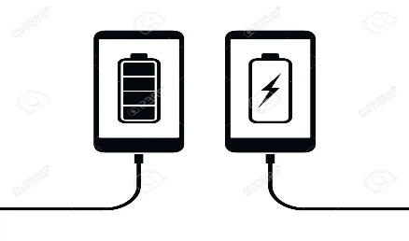  b. passenger (n) [ visual + explanation]    c. economical (a) [ visual + explanation]    d. autopilot (adj, n) [ visual + explanation]    e. function (n) [ visual + explanation]    f. (to) run on [ visual + explanation]    Concept check: Rub out and Remember  2. BRAINSTORMING: Look at the picture and find the words or phrases to describe it. (Ex 1, p. 120)  * Teacher asks SS to work in pairs to look at the picture and answer the question: “What can you see in the picture?”  ** Ss work with their partner to think of words to describe the car and the words or phrases about the driver.  *** Teacher calls on some Ss to read loud the listed words/ phrases.  **** Teacher writes on the board, corrects pronunciation or grammar if needed.  Suggested answer:  The car: convenient, safe, comfortable, modern, automatic, automated, autopilot, etc.  The driver: relaxing / isn’t driving, etc.
While-Reading To improve Ss’ skills of reading for the general idea.  To improve Ss’ skills of reading for details. | Task 1: Read the passage and answer the question. (Ex 2, p. 120)  * Teacher tells Ss to read the text quickly and find out the main idea of the paragraph individually.  ** Ss work independently to read.  *** Some Ss read out their answer and explain their choices.  **** Teacher confirms, corrects, and explains that B and C are just facts.  Answer key: A  Task 2: Read the passage again and complete the fact file with no more than two words or a number. (Ex 3, p. 120)  * Teacher tells Ss that they are going to read to passage again to complete the table about the company and its car. Teacher also reminds Ss to look at the information on the left first before doing the task to guess what types of information they need to scan.  ** Ss work independently to do the task.  *** Teacher calls on some Ss to give their answers and points out where they can find the information.  **** Teacher corrects and confirms.  Answer key:
Post-Reading To check students’ reading comprehension. | Task 3: Retelling  * Teacher asks Ss to close their books and just look at the table in task 2 to retell what they have read about “Roadrunner”.  ** Ss work on pairs, take turns to retell.  *** Some Ss retell all the information about “Roadrunner”.  **** Teacher listens and corrects if needed
Pre-Speaking To enable Ss to ask and answer questions about a car company | Task 4: Look at the fact file in 3 then ask and answer questions about it. (Ex 4, p. 120)  * Teacher asks Ss to work in pairs to look at the table once more times to make questions about Roadrunner and its car based on the fact file in 3.  ** Ss work in pairs to make questions, then answer these questions.  *** Teacher calls on some pairs to role – play it in front of the class.  **** Teacher corrects Ss’ grammar and pronunciation mistakes if needed.  Suggested questions:  * When was Speed introduced? / When did they introduce Speed?  • What do you know about Safety? / What is special about Safety?  • What functions do these models have?  • What do these models run on?  • What can passengers do when they are travelling in the car?
While-Speaking  To help Ss practice reasoning skill | Task 5: Discuss why Roadrunner’s cars will or won’t become popular in the near future. Report your reasons to the class. (Ex 5, p. 120)  * Teacher writes on the board: “Why Roadrunner’s cars will or won’t become popular in the near future?” and asks Ss to work in groups to discuss it.  ** Ss work in groups to do the task. Teacher goes around to help them if needed.  *** Teacher invites one representative of each group to report the answers of their own group to the class  Suggested answers:  + Roadrunner’s cars will become popular in the near future, because they are fast / safe / comfortable /  modern.  + Roadrunner’s cars run on electricity, so they are eco-friendly / green / they do not pollute the  environment.  + Roadrunner’s cars have an autopilot function, so they are very comfortable and modern
Post-Speaking To help students improves next time. | Have students give comments on their friends and vote for the most interesting and informative presentation.  Teacher gives feedback and comments.
Consolidation To consolidate what students have learnt in the lesson. | Teacher asks students to talk about what they have learnt in the lesson.
Homework  To prepare for the next lesson Skills 2. | Do exercises in the workbook.

Date of planning:……/……./2023.
Date of teaching:……/……./2023.
UNIT 11: TRAVELLING IN THE FUTURE

Lesson 6: Skills 2
I. Objectives
By the end of this lesson, students will be able to:
1. Knowledge
+ Listening
listen for general and specific information about some future means of transport;
+ Writing: write about the advantages of a future means of transport.
2. Core competence
- Develop communication skills
- Be collaborative and supportive in pair work and team work
- Actively join in class activities
3. Personal qualities
Be benevolent and responsible
II. Materials
Grade 7 textbook, Unit 11, Skills 2
Computer connected to the internet
Pictures
sachmem.vn
Language analysis
Form | Meaning | Pronunciation | Vietnamese equivalent
1. bullet train (n.phr.) | a very fast train with a smooth, pointed shape, especially one used in Japan: | /ˈbʊl.ɪt ˌtreɪn/ | tàu cao tốc
2. (to) use up | to use all of something, so that nothing is left | /juz up/ | sử dụng hết
3. comfortable (a) | Comfortable furniture and clothes provide a pleasant feeling and do not give you any physical problems | /ˈkʌm.fə.tə.bəl/ | thoải mái

Anticipated difficulties | Solutions
1. Students may lack knowledge and experiences about the topic. | Prepare some hand-outs.
2. Students may have underdeveloped listening, writing and co-operating skills. | Play the recording many times if any necessary.  Encourage students to work in pairs, in groups so that they can help each other.  Provide feedback and help if necessary.
3. Some students might excessively talk in the class. | Define expectation in explicit detail.  Have excessive talking students practise.  Continue to define expectations in small chunks (before every activity).

Board Plan
Unit 11: Travelling in the future
Lesson 6: Skills 2

* Warm-up
Discussion (Ex 1, p.121)
I. Listening
Vocabulary
1. bullet train (n.phr.) /ˈbʊl.ɪt ˌtreɪn/: tàu cao tốc
2. (to) use up/juz up/: sử dụng hết
3. comfortable (a) /ˈkʌm.fə.tə.bəl/: thoải mái
Task 1: Listen to a talk between Mr Ha and his students. How many means of transport are they talking about? Circle the correct answer. (Ex 2, p. 121)
Task 2: Listen to the talk again and complete each sentence with ONE word. (Ex 3, p. 121)
Task 3: True or False statements.
II. Writing: the advantages of a future means of transport
Task 4: Choose one future means of transport in 3 and tick (✓) the words and phrases that describe its advantages. Can you add more words and phrases? (Ex 4, p. 121)
Task 5: Write a paragraph of about 70 words about the advantages of the means of transport you’ve chosen. (Ex 5, p. 121)
* Homework

Procedures
Notes
In each activity, each step will be represented as following
* Deliver the task
** Implement the task
*** Discuss
**** Giving comments or feedback

Stage -Stage aim | Procedure
Warm-up  To prepare Ss for the listening by focusing them on some words / phrases | DISCUSSION  * Teacher asks Ss to look at the words or phrases in Ex 1 (p. 121) and think of which ones are used to describe the future means of the transport.  ** Ss thinks of it individually, then discuss with their partners. Teacher encourages Ss to give reasons for their answers.  *** Teacher calls some students to give their answers.  **** Teacher listens and give comments.
Lead in  To introduce the new lesson. | Teacher introduces students the content of the lesson: “In the lesson today, we are going to listen to a talk between Mr. Ha and his students about future means of transport.”
Pre-Listening (Pre-teach vocabulary)  To provide students with some lexical items before listening the text  Pre-Listening  To activate Ss’ knowledge of the topic of the listening text  To improve Ss’ skills of listening for general information | Vocabulary  - Teacher introduces the vocabulary by:  + Providing the synonym or antonym of the words.  + Providing the pictures of the words.  + Providing the definition of the words.  1. bullet train (n) [visual + explanation]    2. (to) use up [visual + explanation]    3. comfortable (a) [visual + explanation]    Concept check: Rub out and Remember  Task 1: Listen to a talk between Mr Ha and his students. How many means of transport are they talking about? Circle the correct answer. (Ex 2, p. 121)  * Teacher asks Ss to guess how many means of transport they are talking about before listening.  ** Ss do the task individually to guess. Then teacher plays the recording once for Ss to listen and circle the correct answer.
While-Listening  To improve Ss’ listening comprehension and note taking skills. | Task 1: Listen to a talk between Mr Ha and his students. How many means of transport are they talking about? Circle the correct answer. (Ex 2, p. 121 - cont)  *** After listening once, T calls on some Ss to give their answer.  **** Teacher plays the recording again and confirms the correct answer.  Answer key: C  Task 2: Listen to the talk again and complete each sentence with ONE word. (Ex 3, p. 121)  * Teacher asks Ss to read the sentences and to predict the words they need to fill in each blank.  ** Ss works in pairs to do the task. Then teacher plays the recording for Ss to listen and fill in the blank.  *** Teacher calls on some Ss to give theirs answers and writes them on the board.  **** Teacher plays the recording again as many times as needed for Ss to check their answers and clearly understand the conversation.  Answer key:  1. accidents  2. autopilot  3. expensive  4. Bamboo-copters  5. eco-friendly  Audio script – Tracks 80 + 81:  - Mr Ha: Now, let’s turn to future means of transport. How do you think people will travel in 2050, Tom?  - Tom: I think people will use bullet trains. Bullet trains will be faster and safer than cars and they can help avoid traffic accidents.  - Lan: I think skyTrans will also be popular, too. They will not use up much space and will be safe because they run on autopilot. - Tom: But skyTrans may be too expensive for students to use. Bamboo-copters will be cheaper and easier for them to use. They will just put on their bamboo-copters and fly to school.  - Mr Ha: Sounds interesting. How about travelling on sea?  - Lan: I think people will use solar-powered ships to travel on sea. They will be eco-friendly and comfortable …
Post-Listening To check Ss’ memory about what they have listened. | Task 3: True or False statements.  Statements True False  1. Tom thinks that bullet trains will be the fastest transport in the future.  2. Lan said that SkyTrans would not use up much space.  3. It may be too expensive for students to use SkyTrans  4. Students will use bamboo – copters to fly to school.  5. Lan thinks solar – power ships will be eco- friendly and uncomfortable.  * Teacher asks to look at these statements, read, and decide them are True or False without listening again.  ** Ss do the task individually.  *** Teacher calls on some Ss to check.  **** Teacher confirms the correct answers.  Answer keys:  1. F  2. F  3. T  4. T  5. F
Pre-Writing  To prepare Ss for the writing activity | Task 4: Choose one future means of transport in 3 and tick the words and phrases that describe its advantages. Can you add more words and phrases? (Ex 4, p. 121)  * Teacher asks Ss to choose a future means of transport in Ex 3 and discuss with their partner by ticking the boxes or add as many words/ phrases as possible.  ** Ss do the task in pairs.  *** Teacher calls on some Ss to read out loud and encourages Ss to make sentences with the words/ phrases.  **** Teacher corrects and confirms.  Suggested answers: economical, carrying many passengers, avoiding traffic jams, having an autopilot function, driverless, etc.
While-Writing To help Ss practice writing. | Task 5: Write a paragraph of about 70 words about the advantages of the means of transport you’ve chosen. (Ex 5, p. 121)  * Teacher tells Ss that they are going to write about the advantages of the means of transport they ‘ve chosen. Teacher reminds them to start their writing as shown below.  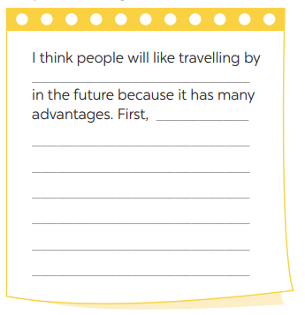  ** Ss do the task independently.
Post-Writing  To peer check, cross check and final check students’ writing. | Task 5: Class gallery  *** Teacher asks Ss to share their writing with their partners. Then, call on some Ss to show their writing in front of the class.  **** Teacher checks ideas, grammar, vocabulary and gives comments.
Consolidation To consolidate what students have learnt in the lesson. | Teacher asks students to talk about what they have learnt in the lesson.
Homework  To allow students finalize their letter after being checked by friends and the teacher. | Rewrite the letter on the notebook.

Date of planning:……/……./2023.
Date of teaching:……/……./2023.
UNIT 11: TRAVELLING IN THE FUTURE

Lesson 7: Looking back & Project
I. Objectives
By the end of this lesson, students will be able to:
1. Knowledge
review the vocabulary and grammar of Unit 11
apply what they have learnt (vocabulary and grammar) into practice through a project.
2. Core competence
- Develop communication skills and creativity
- Be collaborative and supportive in pair work and team work
- Actively join in class activities
3. Personal qualities
- Be benevolent and responsible
- Develop self-study skills
II. Materials
Grade 7 textbook, Unit 11, Looking back & Project
Computer connected to the internet
TV/ Pictures, A0 paper
sachmem.vn

Anticipated difficulties | Solutions
1. Students may have underdeveloped speaking, writing and co-operating skills when doing project. | Encourage students to work in pairs, in groups so that they can help each other.  Provide feedback and help if necessary.
2. Some students might excessively talk in the class. | Define expectation in explicit detail.  Have excessive talking students practise.  Continue to define expectations in small chunks (before every activity).

Board Plan
Unit 11: Travelling in the future
Lesson 7: Looking back & Project
* Warm-up
Mind map
I. Looking back
Task 1: Write three adjectives or phrases to describe each picture. (Ex. 1, p. 122)
Task 2: Complete the sentences with the words and phrases from the box. (Ex. 2, p. 122)
Task 3: Find one mistake in each sentence and correct it. (Ex. 3, p. 122)
Task 4: Read the passage and put the verbs in brackets in the correct future form. (Ex 4, p. 122)
II. Project
OUR FUTURE MEANS OF TRANSPORT
Task 5: Discussion
Task 6: Posters exhibition
* Homework

Procedures
Notes
In each activity, each step will be represented as following
* Deliver the task
** Implement the task
*** Discuss
**** Giving comments or feedback

Stage -Stage aim | Procedure
Looking back  To help students revise the vocabulary items they have learnt in the unit.  Unit 11  Vocabulary  Grammar  Pronunciation  To enhance students’ skills of cooperating with team mates. | Mind map  * Teacher writes on the board “Unit 11” asks Ss to think of what they have learnt already in this unit.  ** Ss work in pairs to do the task.  ***Teacher calls some students to retell.  **** Teacher confirms and leads them to do all the exercises in books.
Looking back  To help Ss revise the learnt vocabulary.  – To help Ss use the right adjectives / phrases to describe the appropriate means of transport  To help Ss review the words / phrases about music and arts used in the context of a passage;  – To give Ss some information of the Louvre Museum - the world’s largest art museum.  – To help Ss revise the learnt vocabulary  – To help Ss use the right words and phrases in the right contexts.  To help Ss revise the possessive pronouns.  To help Ss revise the future simple | Task 1: Write three adjectives or phrases to describe each picture. (Ex. 1, p. 122)  * Teacher asks Ss to work individually to look at the three pictures and think of the words or phrases they have learnt to describe means of transport.  ** Ss do the task independently.  *** Teacher asks for Ss’ answers. **** Teacher confirms the correct ones  Answer keys:  1. fast, green, carrying many passengers  2. fast, convenient, autopilot function  3. electric, green, convenient  Task 2: Complete the sentences with the words and phrases from the box. (Ex. 2, p. 122)  * Teacher has Ss work individually to put the right words / phrases into the correct blanks.  ** Ss do this activity individually, then compare their answers with their partners.  *** Teacher asks for some Ss to read aloud the sentences.  **** Teacher confirms the correct answer.  Answer keys:  1. eco-friendly  2. runs on  3. bamboo-copter  4. driverless  5. Bullet trains  Task 3: Find one mistake in each sentence and correct it. (Ex. 3, p. 122)  * Teacher asks Ss to find one mistake in each sentence and correct it  ** Ss do the exercise individually and swap with their partners.  *** Teacher calls some Ss to check their answers.  **** Teacher confirms the correct answer.  Answer keys:  1. Her → Hers  2. Our → Ours  3. My → Mine  4. its → his  5. yours → your  Task 4: Read the passage and put the verbs in brackets in the correct future form. (Ex 4, p. 122)  * Teacher asks Ss to put the verbs in brackets in the correct form  ** Ss work individually to do the task.  *** Teacher calls 1- 2 Ss to read out the passage.  **** Teacher checks and confirms their answers.  Answer keys:  1. will travel  2. won’t go  3. will need  4. won’t carry  5. Will … come
Project  – To help Ss revise vocabulary about various future means of transport and their advantages  – To improve Ss’ creativity, teamwork and public speaking skills | Task 5: Discussion  * Teacher asks Ss to look at the picture and imagine a future means of transport they would like to see in the future. Teacher tells SS that they can draw pictures or pin the pictures or photos on A0 paper to illustrate their ideas.  ** Ss do the task in group. Teacher goes around to help if necessary and check their progress.  Task 6: Posters exhibition  *** Teacher calls some groups to present their poster to the class  **** Ss in other groups comment. Teacher confirms and corrects.
Consolidation  To consolidate what students have learnt in the lesson. | Teacher asks students to talk about what they have learnt in the lesson.
Homework  To prepare for the next lesson. | Prepare for the next lesson: Unit 5 – Getting started.
* Pictures' source: From Internet

Date of planning:……/……./2023.
Date of teaching:……/……./2023.
UNIT 12: ENGLISH-SPEAKING COUNTRIES
Lesson 1: Getting started – A holiday in Australia.
I. Objectives
By the end of this lesson, Ss will be able to gain:
1. Knowledge
- an overview about the topic “English-speaking countries”
- lexical items related to people and places in English-speaking countries
2. Core competence
- Develop communication skills and cultural awareness
- Be collaborative and supportive in pair work and teamwork
- Actively join in class activities
3. Personal qualities
- Develop self-study skills
- Raise students’ awareness of the need to learn English.
II. Materials
- Grade 7 textbook, Unit 12, Getting started
- Computer connected to the internet
- Projector/ TV/ pictures and cards
- sachmem.vn
Language analysis
Form | Pronunciation | Meaning | Vietnamese equivalent
- island (n) | /ˈaɪ.lənd/ | a piece of land completely surrounded by water | Hòn đảo
- sunset (n) | /ˈsʌn.set/ | the time in the evening when you last see the sun in the sky | Hoàng hôn
- landscape (n) | /ˈlænd.skeɪp/ | a large area of land, especially in relation to its appearance | Phong cảnh
- penguin (n) | /ˈpeŋ.ɡwɪn/ | a black and white bird that cannot fly but uses its small wings to help it swim | Chim cánh cụt

Assumptions
Anticipated difficulties | Solutions
1. Students may lack knowledge about facts and cultures of English-speaking countries. | - Provide suggestions on vocabularies and structures to describe people and places in English-speaking countries.
2. Students may may not have sufficient listening, speaking and co-operating skills. | - Play the recording, the replay depends on student’s need.  - Encourage students to work in pairs, in groups so that they can help each other.  - Provide feedback and help if necessary.

Board Plan
UNIT 12: ENGLISH-SPEAKING COUNTRIES
Lesson 1: Getting started – A holiday in Australia.
*Warm-up
Flags matching
I. Vocabulary
1. island (n)
2. sunset (n)
3. landscape (n)
4. penguin (n)
II. Practice
Task 1: Listen and read (p. 124).
Task 2: What are Phong and Mark talking about? (p. 125).
Task 3: Read again and tick the information you can find in the conversation. (p. 125)
Task 4: Complete the sentences with the words and phrases from the box. (p. 125)
Task 5: Matching game: What’s its capital city? (p. 125)
* Homework
Find more English-speaking countries.

Procedures
Notes
In each activity, each step will be represented as following
* Deliver the task
** Implement the task
*** Discuss
**** Giving comments or feedback

Stage - Stage aim | Procedure
Warm-up  To introduce the topic of the unit. | Flags matching  * Teacher divides the class into 2 big groups and asks them to match the flag illustrations with names of the countries.  ** Students work in groups to discuss and do the matching.  *** Teacher allows students to share their answers before discussing as a class and encourages them to pronounce the names of the countries correctly.  **** Teacher asks students to explain their choice, checks the answers as a class, gives feedback then introduces the similarity of these countries “English-speaking countries”.  The USA Canada The UK  New Zealand Australia
- Lead in  - To lead in the topic of the lesson.  - To set the context for the introductory conversation. | * Teacher draws students’ attention to the picture in the textbook and asks them some questions about it:  - What activities are they talking about?  surfing  penguin watching  - In what English-speaking country can they do these activities?  Australia  ** Students raise hands to answer the questions.  *** Students discuss and give comments to their friends’ answers.  **** Teacher confirms the correct answers: They are Phong and Mark. They are talking about Phong’s holiday in Australia. They mention Phong’s use of English in real life, his travels, and Australia’s people and landscapes.
Presentation  (Vocab-  pre-teach)  - To provide students with vocabulary.  - To help students well-prepared for the listening and reading tasks. | Vocabulary:  * Teacher introduces the vocabulary.  ** Teacher introduces the vocabulary by:  - providing the pictures  - eliciting the definition of the words  *** Teacher rubs out and checks  **** Teacher checks students’ pronunciation and gives feedback. Teacher reveals that these four words will appear in the reading text and asks students to open their textbook to discover further.  island sunset  landscape penguin
Practice  - To have students get to know the topic.  - To help students get the main idea of the conversation.  - To draw students’ attention to the key information of the text and see how much they can remember about the text.  - To introduce some key words related to the topic. | Task 1: Listen and read (p. 124).  * Teacher can play the recording more than once.  ** Students listen and read.  *** Teacher can invite some pairs of students to read aloud.  **** Teacher check students’ pronunciation ad give feedback.  Task 2: What are Phong and Mark talking about? (p. 125).  * Teacher asks to answer the question without reading the conversation again.  ** Students choose the most suitable option A B or C.  *** Teacher allows students to share their answers before discussing as a class and encourages them to pronounce the words / phrases correctly.  **** Teacher asks students to explain their choice and checks the answers as a class and gives feedback.  Answer key: A  Task 3: Read again and tick the information you can find in the conversation. (p. 125)  * Teacher asks students to work individually to complete tick the information they can find in the conversation.  ** Students work individually to read the sentences and do the task without referring to the text.  *** Teacher allows students to share answers before discussing as a class.  **** Teacher calls on some students to give the answers and asks them where they find the information.  Answer key:  1. In Australia, Phong used English in real life.  4. Australia is beautiful.  5. Australians love outdoor activities.  Task 4: Complete the sentences with the words and phrases from the box. (p. 125)  * Teacher asks students to read the words and phrase in the box and work on their meanings. These words have appeared somewhere in the previous units (except the word Australians).  ** Students fill in the blanks with the most suitable words/phrases.  *** Teacher allows students to share answers before discussing as a class.  **** Teacher can ask students to read aloud the full sentences and correct their pronunciation if needed.  Answer key:  1. landscape  2. penguin watching  3. island  4. sunset  5. Australians
- Production  - To introduce the names of five English-speaking countries and their capital cities through a game.  - To create a fun atmosphere in the class. | Task 5: Matching game: What’s its capital city? (p. 125)  * Teacher writes the countries and the capital cities on the board (like in the book).  ** Students discuss in their groups and do the task.  *** Teacher can go around to help weaker students.  **** Teacher stops the game when time is up. The first group to find all the correct answers wins.  Answer key:  1. Washington D.C.  2. Ottawa  3. London  4. Canberra  5. Wellington
Wrap-up  To consolidate what students have learnt in the lesson. | - Teacher refers to the unit title again then together with students, orally list the names of English-speaking countries and their capital cities in the lesson.
Homework  To prepare vocabulary for the next lesson: A closer look 1. | Find more English-speaking countries.
Date of planning:……/……./2023.
Date of teaching:……/……./2023.
UNIT 12: ENGLISH-SPEAKING COUNTRIES
Lesson 2: A closer look 1.
I. Objectives
By the end of this lesson, students will be able to gain:
1. Knowledge:
- Vocabulary: Use words related to people and places in the English-speaking countries.
- Pronunciation: ask questions with the correct rising and falling intonation.
2. Core competence
- Develop communication skills and creativity
- Be collaborative and supportive in pair work and teamwork
- Actively join in class activities
3. Personal qualities
- Develop self-study skills
- Raise students’ awareness of the need to keep their neighbourhood green.
II. MATERIALS
1. Textbooks, Unit 12, A closer look 1
2. Equipment: computer accessed to the Internet, projector, loudspeaker
3. Slides
Language analysis
Form | Pronunciation | Meaning | Vietnamese equivalent
- native (adj) | /ˈneɪ.tɪv/ | something is native to a place = a place is the home of something | Bản ngữ, nguyên quán
- amazing (adj) | /əˈmeɪ.zɪŋ/ | = wonderful, beautiful | Tuyệt vời
- unique (adj) | /juːˈniːk/ | = rare, not many | Độc nhất
- local (adj) | /ˈləʊ.kəl/ | = belonging to a place | Thuộc về địa phương
- ancient (adj) | /ˈeɪn.ʃənt/ | = very, very old | Cổ, xưa

Assumptions
Anticipated difficulties | Solutions
- Students may lack knowledge about facts and cultures of English-speaking countries. | - Provide suggestions on vocabularies and structures to describe people and places in English-speaking countries.
2. Students may not have sufficient listening, speaking and co-operating skills. | - Play the recording, the replay depends on student’s need.  - Encourage students to work in pairs, in groups so that they can help each other.  - Provide feedback and help if necessary.

Board Plan
Date of teaching
Unit 12: ENGLISH-SPEAKING COUNTRIES
Lesson 2: A closer look 1.
*Warm-up
Homework checking: How many English-speaking countries can you find?

I. Vocabulary
* New words:
1. native (adj)
2. amazing (adj)
3. unique (adj)
4. local (adj)
5. ancient (adj)
Task 1: Write the words or phrases under the correct pictures. (p. 126)
Task 2: Use the words in the box to complete the sentences. (p. 126)
Task 3: Work in pairs. Discuss and write the word or phrase in the box next to its explanation. (p. 126)
II. Pronunciation
* Rising and falling intonation for questions
Task 4: Listen and repeat, paying attention to the intonation of the following questions. (p. 126)
Task 5: Circle the correct intonation. Then listen and repeat. (p. 126)
Game: Up or Down?

* Homework:
Choose a favorite English-speaking country. Find the information about its location and attractions.

Procedures
Notes
In each activity, each step will be represented as following
* Deliver the task
** Implement the task
*** Discuss
**** Giving comments or feedback

Stage - Stage aim | Procedure
Warm-up  To recall students’ vocabulary on community activities. | Homework checking:  * Teacher divides the class into groups of four and asks them to share their homework.  ** Students work in groups to:  - discuss and share names of English-speaking countries.  - list all the names of English-speaking countries in a piece of paper.  *** Teacher asks the groups to swap their pieces of paper and do cross checking. The group with the most correct names of English-speaking countries will be the winner.  **** Teacher confirms the answers and give compliments to the winner.  
Vocabulary  To introduce the new words.  To introduce some key words (nouns) related to people and places through pictures.  To introduce some key words (adjectives) to describe people and places in context.  To introduce some more nouns and phrases through explanations. | Vocabulary pre-teach:  * Teacher introduces the vocabulary.  ** Teacher introduces the vocabulary by:  - providing the pictures  - providing the definition of the words.  1. native (adj)  2. amazing (adj)  3. unique (adj)  4. local (adj)  5. ancient (adj)  *** Teacher asks students to repeat.  *** Teacher rubs out and checks  Task 1: Write the words or phrases under the correct pictures. (p. 126)  * Teacher has students read aloud the words in the box and and asks them to match the words with the pictures illustrating them within 3 - 4 minutes.  ** Students read the words and phrases in the box and match them with the pictures.  *** Teacher asks them to share their answers in pairs before checking the answers as a class.  **** Teacher invites students to take turns to read out their answers and corrects their pronunciation if needed.  Answer key: (Chú ý: SGV sai key ở những câu bôi đỏ)  1. kangaroo  2. island country  3. tattoo  4. Scottish kilt  5. castle  6. coastline  Task 2: Use the words in the box to complete the sentences. (p. 126)  * Teacher asks to read the words in the box first, explains their meanings if needed then allows students 5 minutes to do the task.  ** Students do the task individually.  *** Teacher allows students to swap their textbooks to peer check first.  **** Teacher confirms the answers and gives feedback, if necessary.  Ask Ss to read the words in the box first. Explain their meanings if needed.  Answer key:  1. amazing  2. ancient  3. unique  4. local  5. native  Task 3: Work in pairs. Discuss and write the word or phrase in the box next to its explanation. (p. 126)  * Teacher asks students to work in pairs to read the words and phrase first and see if they know any of them.  ** Students have 4 - 5 minutes to discuss and complete the task.  *** Teacher asks students to work in pairs to swap their answers and peer check.  **** Teacher checks their answers as a class.  Answer key:  1. tower  2. symbol  3. capital  4. boat ride
Pronunciation  To help students recognise and practise the rising and falling intonation with questions.  To provide students with more practice in the intonations of questions. | Pronunciation: Rising and falling intonation for questions  Task 4: Listen and repeat, paying attention to the intonation of the following questions. (p. 126)  * Teacher writes two short questions on the board: a yes / no question and a wh-question. Have some Ss say aloud the questions first, then ask other students to pay attention to the intonation at the end of the questions.  - Can you speak English?  - What is the capital of Scotland?  ** Students look at the questions with the rising and falling already marked, listen and repeat as a class, a group, and finally as individuals.  *** Teacher plays the recording for Ss to listen once, then listen and repeat as a class, a group, and finally as individuals. Teacher can play the recording as many times as necessary.  **** Teacher elicits the pattern from students: use rising intonation for yes / no questions and falling intonation for wh-questions.  Audio script  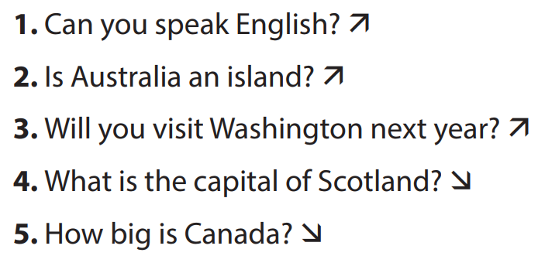  Task 5: Circle the correct intonation. Then listen and repeat. (p. 126)  * Teacher has students circle the correct intonation individually, based on what they have learnt in Task 4.  ** Teacher plays the recording for students to listen and repeat each question and check their answers.  *** Teacher corrects them if needed and calls on some students to read the questions aloud.  **** Teacher plays the recording again and ask students to repeat each question after the recording. Teacher confirms the answers.  Audio script  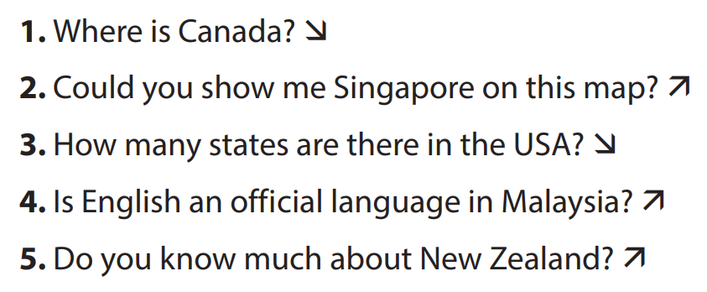
Production  To test students' quick reaction to the targeted intonation. | Game: Up or Down?  * Teacher explains the rules:  - Teacher divides the class into 2 teams.  - Students will listen to questions which are made up from the words in the lesson.  - Students will have to stand up if it is a yes / no question and sit down if it is a wh-question.  - The team will receive minus points equivalent to the number of students who pose incorrect actions (stand up or sit down).  - The team with less minus points will be the winner.  ** Students play the game.  *** Teacher helps students in the game.  **** Teacher gives feedback.
Wrap-up  To consolidate what students have learnt in the lesson. | Teacher asks students to summarise what they have learnt in the lesson.
Homework  To review the vocabulary in this lesson and prepare for the incoming Project lesson. | Choose a favorite English-speaking country. Find the information about its location and attractions.

Date of planning:……/……./2023.
Date of teaching:……/……./2023.
Unit 12: ENGLISH-SPEAKING COUNTRIES
Lesson 3: A closer look 2.

I. Objectives
By the end of this lesson, students will be able to gain:
1. Knowledge:
- Understand the use of use articles
- Practice using articles correctly
2. Core competence:
- Develop communication skills and creativity
- Be collaborative and supportive in pair work and teamwork
- Actively join in class activities
3. Personal qualities
- Develop self-study skills
- Raise students’ awareness of the need to learn languages
II. MATERIALS
- Grade 12 textbook, Unit 3, A closer look 2
- Computer connected to the internet
- Projector/ TV/ pictures and cards
- sachmem.vn
Language analysis
Form: We use “the” …… | Examples
- with superlatives | The largest city in Australia is Sydney.
- with the names of some places | My son is studying in the USA.
- if one of the words in the place name is a common noun (island, bridge, river, tower, ...). | The Tower Bridge in London is over one hundred years old.

Assumptions
Anticipated difficulties | Solutions
1. Students may find confused when to use the articles | - Give short and clear explanations with legible examples for each case.
2. Students may have underdeveloped speaking and co-operating skills. | - Give clear instructions, give examples before letting students work in groups.  - Provide feedback and help if necessary.

Board Plan
Date of teaching
Unit 12: ENGLISH-SPEAKING COUNTRIES
Lesson 3: A closer look 2.
* Warm-up
Picture describing
I. Grammar focus

II. Practice
Task 1: Complete the sentences with “a / an” or “the” (p. 127)
Task 2: Put in "the" where necessary. (p. 127)
Task 3: Put in “a / an” or “the”. (p. 127)
Task 4: Complete the sentences with “a / an”, or “the” (p. 128)

III. Production
Task 5: Game – Faster detective.

* Homework

Procedures
Notes
In each activity, each step will be represented as following
* Deliver the task
** Implement the task
*** Discuss
**** Giving comments or feedback

Stage - Stage aim | Procedure
Warm-up  - To activate students’ prior knowledge related to the targeted grammar: the past simple. | Picture describing  * Teacher asks students to describe the picture.    ** Students look at the picture and describe it.  *** Teacher and students discuss some sentences used to describe the picture:  - I see a clock. The clock is The Big Ben Clock Tower.  - I see two buses. The buses are double-decker ones.  **** Teacher corrects students answers if needed and confirms the use of articles “a/an” or “the”
Presentation  To teach students the use of articles “a/an” or “the” | * Teacher lets students watch the following video and asks them to summarise the use of articles “a/an” or “the”:  https://www.youtube.com/watch?v=drTyYqbz6Xk  ** Teacher then asks students to study the grammar box and give some more examples.  *** Teacher and students discuss the examples.  **** Teacher confirms the answers and gives feedback.  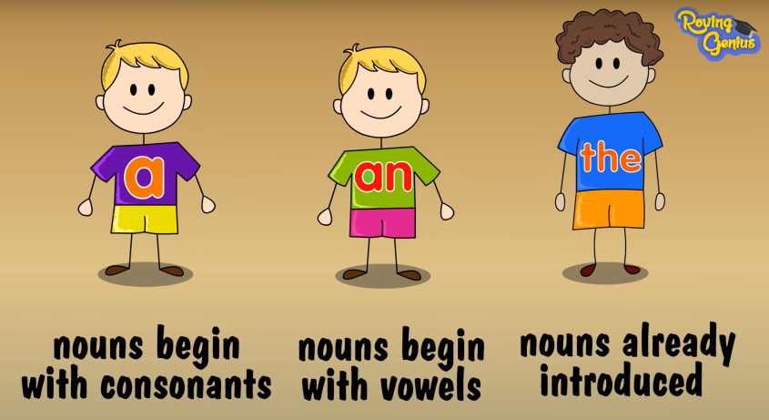
Practice  To help students revise the uses of articles they have learnt in Grade 6.  To help students practise the uses of the as presented in the Remember! box.  To teach students the use of articles with nationalities.  To give students further practice in articles. | Task 1: Complete the sentences with “a / an” or “the” (p. 127)  * Teacher has students work individually.  ** Students work individually to complete sentences with the articles.  *** Teacher lets students work in pairs and exchange the answers before checking with the whole class (explain each sentence if necessary).  **** Teacher confirms the answers and gives feedback.  Answer key:  1. the  2. an  3. a  4. a  5. the  Task 2: Put in "the" where necessary. (p. 127)  * Teacher has students work individually.  ** Students work individually to complete the sentences.  *** Teacher lets students work in pairs and exchange the answers before checking with the whole class (explain each sentence if necessary).  **** Teacher confirms the answers and gives feedback.  Answer key:  1. The – x  2. x – the  3. the – the  4. the (SGV sai key)  5. the – the  Task 3: Put in “a / an” or “the”. (p. 127)  * Teacher allows students some time to read the table first, then do the exercise.  ** Students work in pairs to complete the task.  *** Teacher then has students compare their sentences. Teacher can go around to help students.  **** Teacher confirms the answers and gives feedback. (Note: The English, the Japanese, the French, but Australians, Canadians, Russians.)  Answer key:  1. a  2. an  3. an  4. the  5. a  Task 4: Complete the sentences with “a / an”, or “the” (p. 128)  * Teacher has students do this exercise individually.  ** Students complete the exercise individually.  *** Teacher lets students work in pairs and exchange the answers before checking with the whole class (explain each sentence if necessary).  **** Teacher confirms the answers and gives feedback.  Answer key: (SGV sai key)  1. an  2. The  3. the  4. the  5. an  6. the
Production  To provide students with more advanced practice in articles. | Task 5: Game – Faster detective.  * Teacher introduces the rules of the game:  - The class will be divided into 2 teams.  - Each team will have to detect errors in some sentences (if any) then make correction as fast as possible.  - The team with more correct answers will be the winner.  ** Students play the games.  *** Teacher lets the 2 teams discuss and give comments to their answers.  **** Teacher confirms the corrects answers and gives compliments to the winner.  Answer key:  1. “What do you call a person from England?” – “The Englishman.”  Correct  - Edinburgh is a capital city of Scotland.  the  3. Queenstown is a amazingly beautiful town.  an  4. Are ancient castles an attraction of Scotland? BTV xem lại câu này.  5. Where can you see a red telephone box? SGV sai đáp án
Wrap-up  To consolidate what students have learnt in the lesson. | - Teacher asks students to summarise what they have learnt in the lesson.  - Teacher has them say out loud the past forms of the verbs they.
Homework  Reactivate the knowledge that students have gained. | Teachers asks students to do exercises in their Workbook.
Date of planning:……/……./2023.
Date of teaching:……/……./2023.
Unit 12: ENGLISH-SPEAKING COUNTRIES
Lesson 4: Communication.
I. Objectives
By the end of this lesson, Ss will be able to:
- express amazement
- know interesting facts about English-speaking countries
1. Knowledge:
a. Vocabulary: vocabulary on the topic “English-speaking countries”.
b. Grammar: structures to express amazement.
2. Core competence:
- Develop communication skills and creativity
- Be collaborative and supportive in pair work and teamwork
- Actively join in class activities
3. Personal qualities
- Develop self-study skills
- Raise students’ awareness of the need to learn languages.
II. MATERIALS
1. Textbooks, Unit 12 – Lesson 4: Communication
2. Equipment: computer accessed to the Internet, projector, loudspeaker
3. sachmem.vn
Language analysis
Form | Meaning
Expressing amazement | Wow ... I didn’t know that!  Amazing!

Assumptions
Anticipated difficulties | Solutions
1. Students may lack knowledge about facts and cultures of English-speaking countries. | - Provide suggestions on vocabularies and structures to describe people and places in English-speaking countries.
2. Students may not have sufficient listening, speaking and co-operating skills. | - Play the recording, the replay depends on student’s need.  - Encourage students to work in pairs, in groups so that they can help each other.  - Provide feedback and help if necessary.

Board Plan
Unit 12: ENGLISH-SPEAKING COUNTRIES
Lesson 4: Communication.
*Warm-up
Guessing the remaining of the picture
I. Everyday English
Task 1: Listen and read the conversations, paying attention to the highlighted parts. (p. 128)
2 ways to express amazement:
- Wow ... I didn’t know that!
- Amazing!
Task 2: Work in pairs. Make similar dialogues with the following situations, using expressions of amazement. (p. 128)

II. Interesting facts about English-speaking countries
Task 3: Work in groups. Discuss and write the name of the country next to the fact. (p. 129)
Task 4: Work in pairs. Read some facts about English-speaking countries and tick the column true for you. Then role play by one person saying one statement aloud and the other responding to it. (p. 129)
Task 5: Work in groups. Share with your group some interesting facts you know about English-speaking countries. The group takes notes and presents its findings to the class. (p. 129)
* Homework:
Prepare some photos of your favourite English-speaking country.

Procedures
Notes
In each activity, each step will be represented as following
* Deliver the task
** Implement the task
*** Discuss
**** Giving comments or feedback

Stage - Stage aim | Procedure
Warm-up  To introduce the topic of the lesson. | Guessing the remaining of the picture  * Teacher asks students to guess the remaining of the picture:  - Who are wearing these skirts?  - Do you know the name of this kind of skirt?    ** Students answer the questions.  *** Teacher and students discuss the answers.  **** Teacher confirms the answers, reveals the remaining of the picture and provide more information on the Scottish kilts.
Presentation  To introduce two ways to express amazement. | Giving compliments  Task 1: Listen and read the conversations, paying attention to the highlighted parts. (p. 128)  * Teacher plays the recording for students to listen and read the conversations and asks students to pay attention to the highlighted parts.  ** Students pay attention to the highlighted parts.  *** Teacher elicits the expressions of amazement.  **** Teacher confirms the answers and gives feedback.  2 ways to express amazement:  - Wow ... I didn’t know that!  - Amazing!
Practice  To introduce to students two ways to express amazement and to provide them some practice.  To help students learn some facts about English-speaking countries through a quiz.  To provide students with more facts about English-speaking countries and encourage interaction through responding. | Task 2: Work in pairs. Make similar dialogues with the following situations, using expressions of amazement. (p. 128)  * Teacher has students work in pairs to make similar dialogues.  ** Students work in pairs to make similar dialogues, using the contexts given:  - New Zealand has the cleanest and safest air on the planet.  - There are no snakes in New Zealand.  - More than half of all the lakes in the world are in Canada.  *** Teacher asks some pairs to practice the dialogue so that the whole class can give comments.  **** Teacher gives feedback as a class.  Interesting facts about English-speaking countries  Task 3: Work in groups. Discuss and write the name of the country next to the fact. (p. 129)  * Teacher has students work in groups to read the facts, discuss, and do the matching.  ** Students work in groups to complete the task.  *** Teacher has the groups cross check and discuss.  **** Teacher gives feedback and correction (if needed)  Answer key: (SGV chưa viết hoa)  1. Australia  2. The USA  3. Canada  4. The UK  5. New Zealand  Task 4: Work in pairs. Read some facts about English-speaking countries and tick the column true for you. Then role play by one person saying one statement aloud and the other responding to it. (p. 129)  * Teacher asks students to read the instructions, then the example to know what they have to do.  ** Students work in pairs read the facts and tick the column true for them, then take turns with one saying a fact aloud and the other responding with his / her answer.  *** Teacher calls on 2 - 3 pairs to role-play in front of the class.  **** Teacher corrects any grammar or pronunciation mistakes if necessary.  Example:  A: New York is the biggest city but not the capital of the USA.  B: I know this.  A: The state of Alaska in the USA has over 2,600 islands.  B: This is new to me.
Production  To encourage students to share what they know about English-speaking countries with the class. | Task 5: Work in groups. Share with your group some interesting facts you know about English-speaking countries. The group takes notes and presents its findings to the class. (p. 129)  * Teacher asks students work in groups and allows them time to think about a fact they know and how to say it.  ** Students share the facts in the group. The group leader takes notes of the facts. Some Ss may repeat facts which have previously appeared in the unit. This is also a revision activity.  *** Teacher calls on group representatives to share the facts with the class.  **** Teacher gives feedback on their reports.
Wrap-up  To consolidate what students have learnt in the lesson. | Teacher asks students to talk about what they have learnt in the lesson.
- Homework  - To review what students have learnt in this lesson.  - To prepare for the Project lesson. | Prepare some photos of your favorite English-speaking country.

Date of planning:……/……./2023.
Date of teaching:……/……./2023.
Unit 12: ENGLISH-SPEAKING COUNTRIES
Lesson 5: Skills 1.
I. Objectives
By the end of this lesson, Ss will be able to gain:
1. Knowledge:
- Develop reading skill for specific information about New Zealand
- Develop speaking skill: talk about Scotland
2. Core competence:
- Develop communication skills and creativity
- Be collaborative and supportive in pair work and teamwork
- Develop presentation skill
- Actively join in class activities
3. Personal qualities
- Develop self-study skills
- Raise students’ awareness of the need to learn languages.
II. MATERIALS
- Grade 7 textbook, Unit 12, Skills 1
- Computer connected to the internet
- Projector/ TV/ pictures and cards
- sachmem.vn

Language analysis
Form | Pronunciation | Meaning | Vietnamese equivalent
- shining (adj) | /ˈʃaɪ.nɪŋ/ | sending out or reflecting light | lấp lánh, tỏa sáng
- historic (adj) | /hɪˈstɒr.ɪk/ | important or likely to be important in history | có tính chất lịch sử, nổi tiếng trong lịch sử
- rich (adj) | /rɪtʃ/ | having or containing a large amount of something desirable or valuable | có nhiều

Assumptions
Anticipated difficulties | Solutions
1. Students may lack knowledge about some lexical items. | - Provide students with the meaning and pronunciation of words.
2. Students may not have sufficient reading, speaking and co-operating skills. | - Let students read the text again (if needed).  - Create a comfortable and encouraging environment for students to speak.  - Encourage students to work in pairs, in groups so that they can help each other.  - Provide feedback and help if necessary.
3. Some students may excessively talk in the class. | - Define expectation in explicit detail.  - Encourage students’ practice  - Continue to define expectations in small chunks (before every activity).

Board Plan
Date of teaching
Unit 12: ENGLISH-SPEAKING COUNTRIES
Lesson 5: Skills 1.
* Warm-up
Guessing: What country is it?
NEW ZEALAND

I. Reading
* Vocabulary:
1. shining (adj)
2. historic (adj)
3. rich (adj)
Task 1: Work in pairs. Discuss and choose the correct answer A, B, or C. (p. 130).
Task 2: Read the passage and match the words in bold from the passage (1-4) with their meanings (a-d). (p. 130)
Task 3: Read the passage again and choose the correct answer A, B, or C. (p. 130)
II. Speaking
Task 4: Work in pairs. Note two things you like about New Zealand. Share them with your partner. (p. 130)
Task 5: Work in groups. Prepare a short introduction of Scotland and present it to the class. (p. 130)

* Homework
Prepare short phrases/sentences to describe the photos of your favourite English-speaking country.

Procedures
Notes
In each activity, each step will be represented as following
* Deliver the task
** Implement the task
*** Discuss
**** Giving comments or feedback

Stage - Stage aim | Procedure
Warm-up  To introduce the topic and to lead in the lesson. | Guessing: What country is it?  * Teacher asks students to watch a video about the introduction of a country and ask them to guess the name of the country.  ** Students watch the video and raise hands to answer the question.  *** Teacher and students discuss the answers.  **** Teacher confirms the answers and gives feedback.  Video link: https://www.youtube.com/watch?v=jP3x7pcKIPY  (download video, cắt phần có chữ New Zeland ở giây 0:05-0:06)
Pre-Reading  To provide students with some lexical items before reading the text.  To lead in the text about New Zealand | Vocabulary  * Teacher introduces the vocabulary.  ** Teacher asks students to get the meaning in context and try to make up sentences with of the following words:  1. shining (adj)  2. historic (adj)  3. rich (adj)  *** Teacher and students discuss the answers.  **** Teacher confirms student’s answers and checks their pronunciation and gives feedback.  Task 1: Work in pairs. Discuss and choose the correct answer A, B, or C. (p. 130).  * Teacher students to work in pairs to discuss and answer the questions.  ** Students work in pairs to complete the task.  *** Students discuss the answers.  **** Teacher asks some pairs to share their answers. (Don’t confirm the answers. Leave them till the end of the reading.)  Answer key:  1. A 2. B
While-Reading  To help students develop their reading skill of guessing the meaning of a word by using its context.  To help students develop their reading skill for specific information (scanning). | Task 2: Read the passage and match the words in bold from the passage (1-4) with their meanings (a-d). (p. 130)  * Teacher asks students to work individually to read the passage and find the highlighted words.  ** Students read the text in detail, paying attention to the words in bold.  *** Teacher asks students to read the sentences where the words appear, and before and after it.  **** Teacher calls some students hare their answers then check the answers as a class.  Answer key:  1. c 2. d 3. a 4. b  Task 3: Read the passage again and choose the correct answer A, B, or C. (p. 130)  * Teacher asks some students to do the task individually: read each question, locate where it appears in the text, read that part carefully and circle the correct answer.  ** Students work individually to complete the task.  *** Teacher allows students to share their answers before discussing as a class and encourages them to give evidence.  **** Teacher calls a student to write his/her answer on the board, then check the answers as a class.  Answer key:  1. C 2. B 3. B 4. A 5. C
Pre-Speaking  To give students an opportunity to express their own feelings about what they personally like about New Zealand. | Task 4: Work in pairs. Note two things you like about New Zealand. Share them with your partner. (p. 130)  * Teacher allows students to work individually first, referring (if necessary) to the text and list the two things they like most about New Zealand.  ** Students work in pairs to to share their ideas with their partners, using use the suggested opening provided.  *** Students should give some reasons for their choice.  **** Teacher listens and passes positive comments.  Suggestion for the opening:  There are two things I like about New Zealand. They are ...
While-Speaking  To provide an opportunity for students to practise introducing a country. | Task 5: Work in groups. Prepare a short introduction of Scotland and present it to the class. (p. 130)  * Teacher asks students to read the facts about Scotland first. Teacher explains that the introduction consists of four parts (as shown in the box).  ** Students work in groups, refer to the reading to see how the ideas are used to discuss, then form complete sentences from the information given.  *** Teacher goes around to help students.  **** Teacher calls on some groups to share their answers with the class.  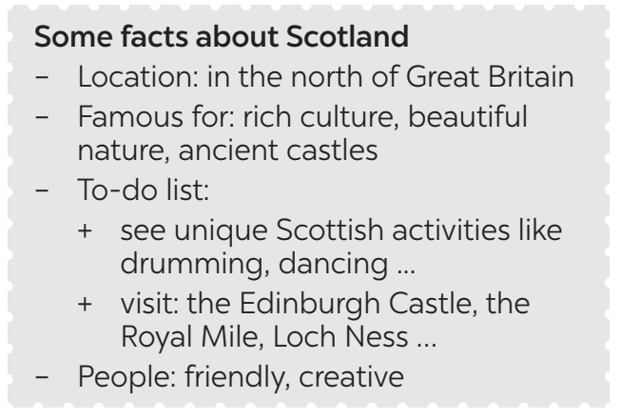
- Post-Reading and Speaking  - To help students improve next time.  - To help some students enhance presentation skill | * Teacher allows students to give comments for their friends and vote for the most interesting and informative presentation.  ** Students give comments for their friends and vote for the most interesting and informative presentation.  *** Teacher and students discuss the presentations.  **** Teacher gives feed-back and comments.
Wrap-up  To consolidate what students have learnt in the lesson. | Teacher asks students to talk about what they have learnt in the lesson.
Homework  Prepare for the Project lesson. | Prepare short phrases/sentences to describe the photos of your favourite English-speaking country.

Date of planning:……/……./2023.
Date of teaching:……/……./2023.
Unit 12: ENGLISH-SPEAKING COUNTRIES
Lesson 6: Skills 2.
I. Objectives
By the end of this lesson, Ss will be able to:
1. Knowledge:
- listen for specific information about a tour of a city;
- write a diary entry about a tour of a city.
2. Core competence:
- Develop communication skills and creativity
- Be collaborative and supportive in pair work and teamwork
- Actively join in class activities
3. Personal qualities
- Develop self-study skills
- Raise students’ awareness of the need to learn languages.
II. MATERIALS
1. Textbooks, Unit 12 – Lesson 6: Skills 2
2. Equipment: computer accessed to the Internet, projector, loudspeaker
3. sachmem.vn
Assumptions
Anticipated difficulties | Solutions
1. Students may may lack knowledge about how to brainstorm keywords/phrases for listening. | - Prepare some suggestions on vocabularies and listening techniques to instruct students.
2. Students may have underdeveloped listening, speaking and co-operating skills. | - Play the recording, the replay depends on ss’ need.  - Encourage students to work in pairs, in groups so that they can help each other.  - Provide feedback and help if necessary.

Board Plan
Date of teaching
Unit 12: ENGLISH-SPEAKING COUNTRIES
Lesson 6: Skills 2
*Warm-up
Guessing game: What city is it?
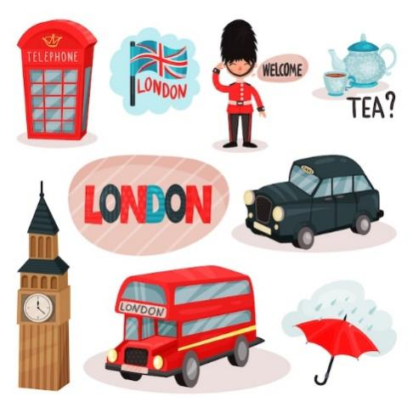
I. Listening
Task 1: Work in groups. Match the phrases to the pictures (p. 131)
Task 2: A tour guide is talking about the schedule for a day trip in London. Listen and fill in the times. (p. 131)
Task 3: Listen again and complete each sentence with ONE word. (p. 131)

II. Writing
Task 4: Work in pairs. Fill in the table with information about the London tour. (p. 131)
Task 5: Imagine that you took the tour of London. Write a diary entry of about 70 words about your tour, based on the table in 4 or use your imagination. (p. 131)

* Homework:
Prepare for the next lesson: Looking back & Project

Procedures
Notes
In each activity, each step will be represented as following
* Deliver the task
** Implement the task
*** Discuss
**** Giving comments or feedback

Stage - Stage aim | Procedure
Warm-up  To lead in the topic of the lesson. | Guessing game: What city is it?  * Teacher divides the class into 2 teams. Each team will guess the the name of the city based on pictures given gradually by the teacher.  ** Students play the guessing game.  *** The team with correct answer will be the winner.  **** Teacher introduces the topic of the listening task: A tour around London.
- Pre-Listening  - To prepare students for the listening by introducing two key phrases visually. | Task 1: Work in groups. Match the phrases to the pictures (p. 131)  * Teacher asks students work in groups to read the phrases and match them to the pictures.  ** Students discuss with partners.  *** Teacher elicits as many learnt vocabularies as possible and asks one or two students to re-describe the pictures to the class.  **** Teacher gives feedback and introduces the topic of the listening task: A tour around London.  Answer key:  1. Changing of the Guard  2. Buckingham Palace
- While-Listening To help students develop their skill of listening for specific information, in this case: times.  To help students further develop their listening skill for specific information. | Task 2: A tour guide is talking about the schedule for a day trip in London. Listen and fill in the times. (p. 131)  * Teacher helps students revise the use of time in the listening and note taking skills by saying 3 - 4 different times for students to write down.  ** Teacher has students read the questions quickly. This helps students get some ideas of what they are going to listen to as well as determine the information they need for answering the questions.  *** Teacher has students exchange answers in pairs, invites some pairs to read their answers and confirm the correct ones  **** Teacher confirms the answers and gives feedback.  Answer key:  1. 11:30 a.m.  2. 1:00 p.m.  3. 3:15 p.m.  4. 5:00 p.m.  Task 3: Listen again and complete each sentence with ONE word. (p. 131)  * Teacher has students read the questions and determine what information they need for answering the questions, reminds them that the questions ask for one-word answers.  ** Teacher plays the recording again twice for students to listen and complete the sentences.  *** Teacher has students exchange answers in pairs, invites some pairs to say their answers and confirm the correct ones.  **** Teacher plays the recording again if needed, stopping at each place where the answers appear.  Answer key:  1. Queen  2. garden  3. Clock  4. photos  5. attractions
- Pre-Writing  - To help students summarize the content of the listening in notes. | Task 4: Work in pairs. Fill in the table with information about the London tour. (p. 131)  * Teacher asks students to work in pairs, lets them read the table and decide what information they need to complete the table.  ** Students do the task within 4-5 minutes.  *** Teacher invites some pairs to share their answers with the class  **** Teacher gives feedback and provides suggested answers.    Suggested answers:  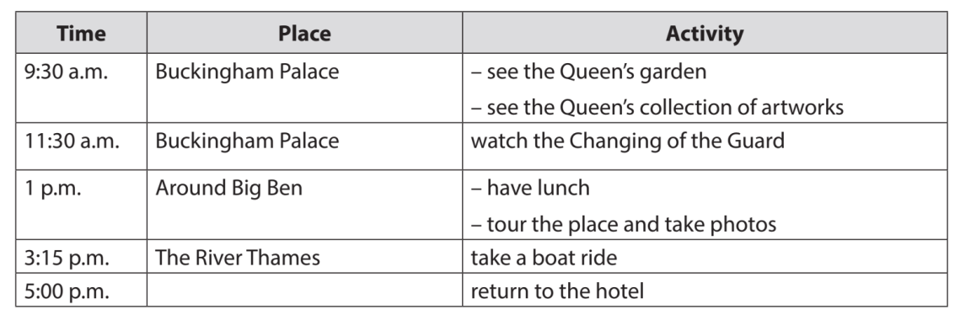
While-Writing  To teach students how to write a diary entry about a tour they have taken. | Task 5: Imagine that you took the tour of London. Write a diary entry of about 70 words about your tour, based on the table in 4 or use your imagination. (p. 131)  * Teacher explains to students what a diary entry is: It is a description of what you do during a tour and how you feel about it.  ** Students refer to the table in 4 for information. They can write about everything or just choose the activities they like most.  *** Teacher allows students to peer check first.  **** Teacher goes around to help (if necessary).  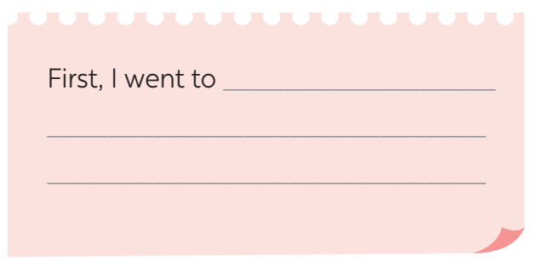  Suggested answers:  The tour of London began at 9:30 a.m. First, we went to Buckingham Palace. We visited the Queen’s Garden and saw her collection of artworks. At 11:30 a.m. we watched the Changing of the Guard. We then went to Big Ben. We took a lot of photos there. At 3:15 p.m., we took a boat ride on the River Thames. We saw many historic attractions along the river. I enjoyed the tour very much.
Post-Writing  To peer check, cross check and final check students’ writing. | Giving peer-reflection & evaluation  * Teacher asks students to work in groups of four and swap the entries to their group members.  ** Students can give comment to others’ work.  *** Students then give comments to each other.  **** Teacher then gives feedback as a class discussion.
Wrap-up  To consolidate what students have learnt in the lesson. | Teacher asks students to talk about what they have learnt in the lesson.
Homework  To allow students finalize their paragraph after being checked by friends and the teacher. | Rewrite the diary on your notebook.  Prepare for the next lesson (Unit 3-Lesson 7: Looking back and Project)

Date of planning:……/……./2023.
Date of teaching:……/……./2023.
UNIT 12: ENGLISH-SPEAKING COUNTRIES
Lesson 7: Looking back & Project.
I. Objectives
By the end of this lesson, Ss will be able to gain:
1. Knowledge
Review the vocabulary and grammar of Unit 12
Apply what they have learnt (vocabulary and grammar) into practice through a project
2. Core competence
- Develop communication skills and creativity
- Develop presentation skill
- Develop critical thinking skill
- Be collaborative and supportive in pair work and team work
- Actively join in class activities
3. Personal qualities
- Be more creative when doing the project
- Develop self-study skills
II. Materials
- Grade 7 textbook, Unit 12, Looking back & Project
Computer connected to the internet
Pictures, A0 paper
- Projector/ TV
- sachmem.vn
Assumptions
Anticipated difficulties | Solutions
1. Students may not have sufficent speaking, writing and co-operating skills when doing the project. | - Encourage students to work in pairs, in groups so that they can help each other.  - Provide feedback and help if necessary.
2. Some students may excessively talk in the class. | - Define expectation in explicit detail.  - Encourage excessive talking students’ pratice  - Continue to define expectations in small chunks (before every activity).
Board Plan
Date of teaching
Unit 12: ENGLISH-SPEAKING COUNTRIES
Lesson 7: Looking back & Project.
* Warm-up
Video watching:
How many English-speaking countries are there? What are they?
I. Looking back
* Vocabulary:
Task 1: Look at the pictures and write the correct words or phrases to complete the sentences. (p. 132)
Task 2: Choose the best answer A, B, or C to complete each sentence. (p. 132)
* Grammar:
Task 3: Complete the sentences with "a / an" or "the". (p. 132)
Task 4: Underline and correct the article mistakes in the sentences below. (p. 132)
II. Project
Design a poster introducing a place in an English-speaking country
* Homework
Procedures
Notes
In each activity, each step will be represented as following
* Deliver the task
** Implement the task
*** Discuss
**** Giving comments or feedback

Stage - Stage aim | Procedure
Warm-up  - To revise the vocabulary related to the topic and lead in the next part of the lesson. | Video watching:  How many English-speaking countries are there? What are they?  * Teacher lets students watch a video and ask them the questions:  - How many English-speaking countries are there in the video?  - What are they?  ** Students watch the video, note down the names and the number of English-speaking countries.  *** Teacher and students discuss the answers.  **** Teacher confirms the answers as a class.  Video link: https://ejoy-english.com/go/intl/vi/video/6-english-speaking-countries/60729  (Nhờ BTV download video)  Answer key:  1. There are 6 English-speaking countries in the video.  2. They are:  - The Philippines  - Australia  - Republic of Ireland  - Canada  - The USA  - The UK
Looking back  To help students revise the vocabulary (nouns showing things and places) they have learnt in the unit.  To help students revise more key vocabulary they have learnt in the unit.  To help students revise the use of articles.  To help students recognise mistakes in the use of the articles and correct them. | VOCABULARY  Task 1: Look at the pictures and write the correct words or phrases to complete the sentences. (p. 132)  * Teacher asks students to work in pairs, has students read the sentences and see if they can find the equivalent words illustrated by the pictures.  ** Students do the task in pairs.  *** Students exchange their answers with their partners.  **** Teacher gives feedback as a class discussion.  Answer key:  1. island  2. castle  3. boat ride  4. tattoos  5. coastline  Task 2: Choose the best answer A, B, or C to complete each sentence. (p. 132)  * Teacher asks students to to complete the task individually.  ** Students do the task individually complete the sentences.  *** Students exchange their textbooks with their partners.  **** Teacher gives feedback as a class discussion.  Answer key:  1. A  2. B  3. B  4. C  5. A  GRAMMAR  Task 3: Complete the sentences with "a / an" or "the". (p. 132)  * Teacher encourages students to complete the task individually.  ** Students complete the passage with "a / an" or "the".  *** Students exchange their textbooks with their partners.  **** Teacher gives feedback as a class discussion.  Answer key:  1. the – the  2. A – a  3. the – the  4. a – the  5. An – an  Task 4: Underline and correct the article mistakes in the sentences below. (p. 132)  * Teacher asks students to do this exercise in pairs.  ** Students read each sentence carefully and discuss to find out which article is incorrect, then correct it.  *** Teacher then asks them to check their answers with a partner before discussing the answers as a class.  **** Teacher confirms the answers and explains if necessary.  Answer key:  1. Ottawa is a capital of Canada. → the  2. He’s the Englishman. He lives in Oxford. → an  3. When people travel, they use an map to find their ways round. → a  4. Can you see a Big Ben from where you are standing? → the  5. Canadians love ice hockey, the winter sport. → a
. Project  To guide students how to find information for a poster introducing a place in an English-speaking country. | Posters exhibition:  * Teacher has students work in groups and gives instructions to students as follow:  - Discuss and choose a place in an English-speaking country.  - Find information about it, including:  - its name  - its location  - its attractions  ** Students do the project in groups.  *** Students vote for the best poster.  **** Teacher gives feedback.  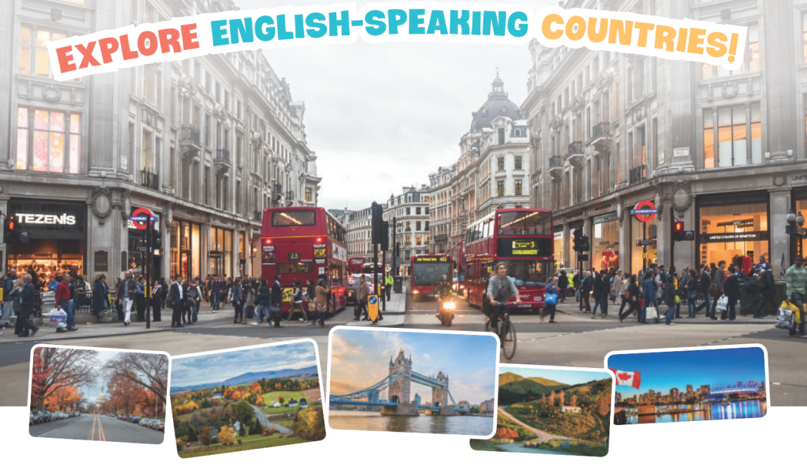
Wrap-up  To consolidate what students have learnt in the lesson. | Teacher asks students to talk about what they have learnt in the lesson.
Homework  To prepare for the next lesson. | Prepare for the Second Term Test.

